Press release
EUREKA Innovation Week, 27 April

ITEA 2 project DIAMONDS wins EUREKA Innovation Award 2016
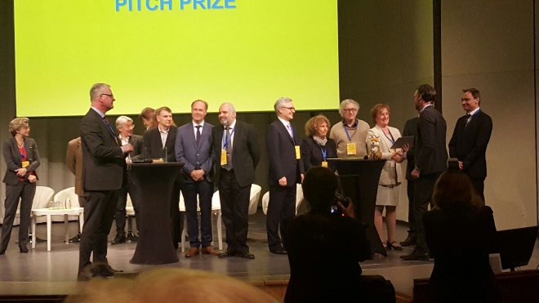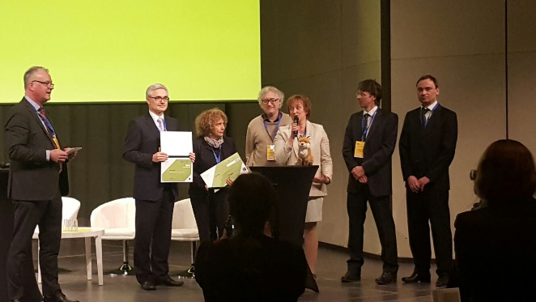
ITEA 2 project DIAMONDS won the prestigious EUREKA Innovation Award 2016 in the category ‘Added Value’ and the Project Pitch Prize during the EUREKA Innovation week in Stockholm on 27 April. DIAMONDS project leader Ina Schieferdecker received the award from Per Tervahauta, Chairman of the EUREKA High Level Group.
In the morning of 27 April, the ITEA 2 project DIAMONDS was announced as the winner of the EUREKA Innovation Award 2016 in the category ‘Added Value’. A winning project was announced for each of the three categories ‘Competitiveness’, ‘Added Value’ and ‘Innovators of tomorrow’. These three finalists then took part in a contest for the best project pitch, ultimately won by the DIAMONDS project.
The DIAMONDS (Development and Industrial Application of Multi-Domain Security Testing Technologies) project, led by the Fraunhofer FOKUS (business unit System Quality), was carried out by a consortium of 21 industrial and scientific partners from Austria, Finland, France, Germany, Luxembourg and Norway from October 2010 to May 2013. In several industry case studies, DIAMONDS has evaluated efficient and automated security testing methods of industrial relevance for highly secure systems in multiple domains (e.g. banking, transport or telecommunication).
Prof. Dr.-Ing. Ina Schieferdecker, Project Coordinator of DIAMONDS and Director of the Fraunhofer-Institute FOKUS: "We are honoured to receive this prestigious EUREKA Innovation Award. I would like to thank all the 21 project partners from 6 different countries, working on model-based security testing within DIAMONDS. I hope there will be much more research and development in security testing as it is an important topic. Thank you also to ITEA and the EUREKA Network for their support.”
Zeynep Sarilar, ITEA Chairwoman: “We are proud of DIAMONDS winning the EUREKA Innovation Award 2016; another prestigious recognition. DIAMONDS increases the global security of our digital society, providing a full methodology for model-based testing for security weaknesses. These tools are already exploited the market in many different products and services”.
Sources / More information:
https://itea3.org/project/diamonds.html
https://www.fokus.fraunhofer.de/go/en_diamonds
http://www.eurekanetwork.org/

Note for editors, not for publication:
For interview requests, questions and additional information about ITEA, please contact:

ITEA Contact person:
Kay van Ham, Tel: +31 88 003 6136, kay.van.ham@itea3.org

About ITEA
ITEA is the EUREKA Cluster programme supporting innovative, industry-driven, pre-competitive R&D projects in the area of Software-intensive Systems & Services (SiSS). SiSS are a key driver of innovation in Europe’s most competitive industries, such as automotive, communications, healthcare and aerospace
There is a wide consensus that from now to 2030 change and disruption will be permanent features in society, with the way of living and doing business becoming fundamentally different from what it is today. Digital Technology has a major role to play in mastering the changes. And it is within this domain of Digital Technology that ITEA is addressing innovation in Software, IT Services, Internal IT and Embedded Software, collectively denoted as ‘Software innovation’. For Europe, an industry strong in Software Innovation is a prerequisite for maintaining global competitiveness and in securing high-value jobs in Digital Technology and in other, more traditional industries that are dependent on Digital Technology.
ITEA stimulates projects in an open community of large industry, SMEs, universities, research institutes and user organisations. As ITEA is a EUREKA Cluster, the community is founded in Europe based on the EUREKA principles and is open to participants worldwide.
Each year, ITEA issues a Call for projects starting with a two-day brokerage event. Each Call follows a two-step procedure, in which the quality of the project proposal is evaluated and improved, finally leading to a selection of high quality project proposals that receive the official ITEA label.
ITEA’s mission is to be the recognised partner for European industry, optimising support for companies and R&D actors active in ITEA projects in the area of SISS, thus making best use of funding made available by the ITEA supporting countries. Following the EUREKA structure, each ITEA project partner can apply for national funding in their own country – allowing a project idea to attract funding from all participating countries.
More information: https://itea3.org

