D2.3 Usability of ESTABLISH solutions

Deliverable ID: | D 2.3
Deliverable Title: | Usability of ESTABLISH solutions
Revision #: | 1.0
Dissemination Level: | Public
Responsible beneficiary: | VTT
Contributing beneficiaries: | Salla Muuraiskangas, VTT; Kaisa Vehmas, VTT; Alexandra Rosca, SIVECO; Iacob Crucianu, SIVECO; Petr Kocian, DEKPROJEKT; Jiri Havlic, IMA
Contractual date of delivery: | 30.11.2019
Actual submission date: | 26.11.2019

Table of Content

Table of Content 2
Acronyms 3
1. Introduction 4
2. Usability of ESTABLISH solutions 5
2.1 Self-reporting application 5
2.1.1 Description of the self-reporting application 5
2.1.2 Usability study 5
2.1.3 Results from the usability study 6
2.1.4 Future of the self-reporting application 7
2.2 ESTABLISH GUI 8
2.2.1 Description of the GUI 8
2.2.2 Usability study 8
2.2.3 Results from the usability study 8
2.2.4 Future of the GUI 9
2.3 Window opener 10
2.3.1 Description of the window opener 10
2.3.2 Usability study 12
2.3.3 Results from the usability study 14
2.3.4 Future of the window opener solution 15
2.4 Sensor management and configuration 17
2.4.1 Description of the sensor management and configuration tool 17
2.4.2 Usability study 20
2.4.3 Results from the usability study 20
2.4.4 Future of the sensor management and configuration tool 21
3. Conclusions 22

Acronyms

AQI | Air Quality Index
AHU | Air Handling Unit
CO2 | Carbon Dioxide
GUI | Graphical User Interface
HVAC | Heating, Ventilation and Air Conditioning
IoT | Internet of Things
LoRaWAN | Long Range Low Power Wide Area Network
SUS | System Usability Scale

Introduction
This document (deliverable D2.3 Usability of ESTABLISH solutions) presents the results from the usability studies implemented for certain ESTABLISH solutions; Self-reporting application, ESTABLISH GUI, Window opener, and Sensor management and configuration tool, IoTLoRaWAN. The major goal of this work package (WP) 2 is to provide definitions, requirements and specifications needed for the implementation of the ESTABLISH system. WP2 has collected and analyzed the use case specific requirements to understand the motivation, interests, priorities and abilities of various stakeholders, establishing a context and concrete reference framework for the design and development of the technical solutions of the project. User needs and expectations towards defined use cases have been explored via usability studies.
This deliverable describes the usability of certain ESTABLISH solutions. The deliverable is divided in three sections. After Introduction, in section 2, the ESTABLISH solutions and the methods of the usability studies have been described followed by the results. In addition, some ideas of the future of each of the solution has been defined - a brief overview of the next steps to be taken in order to gain fruitfull results from the technical development of different solutions. Section 3 includes the conclusions for the results.

Usability of ESTABLISH solutions

2.1 Self-reporting application

2.1.1 Description of the self-reporting application
The self-reporting application is designed for collecting self-reports of the facility users related to indoor air quality, perceived symptoms, perceived stress, productivity and pupil restlessness. The self-reporting application has been used in the pilot at school environment. At the beginning of the pilot, the self-reporting application was installed into each teachers’ personal work mobile phone and they were able to start reporting the perceived air quality and possible symptoms. Notifications for predefined morning and afternoon questionnaires were timed individually according to the school timetable. The first one was to appear when the teacher came to the school and the afternoon questionnaire couple of hours before leaving the school.
The questionnaire can be easily modified via assests sheet in Google Drive and therefore it is possible to use it for any domain in the future when necessary. Example of the screenshots are presented in Figure 1.

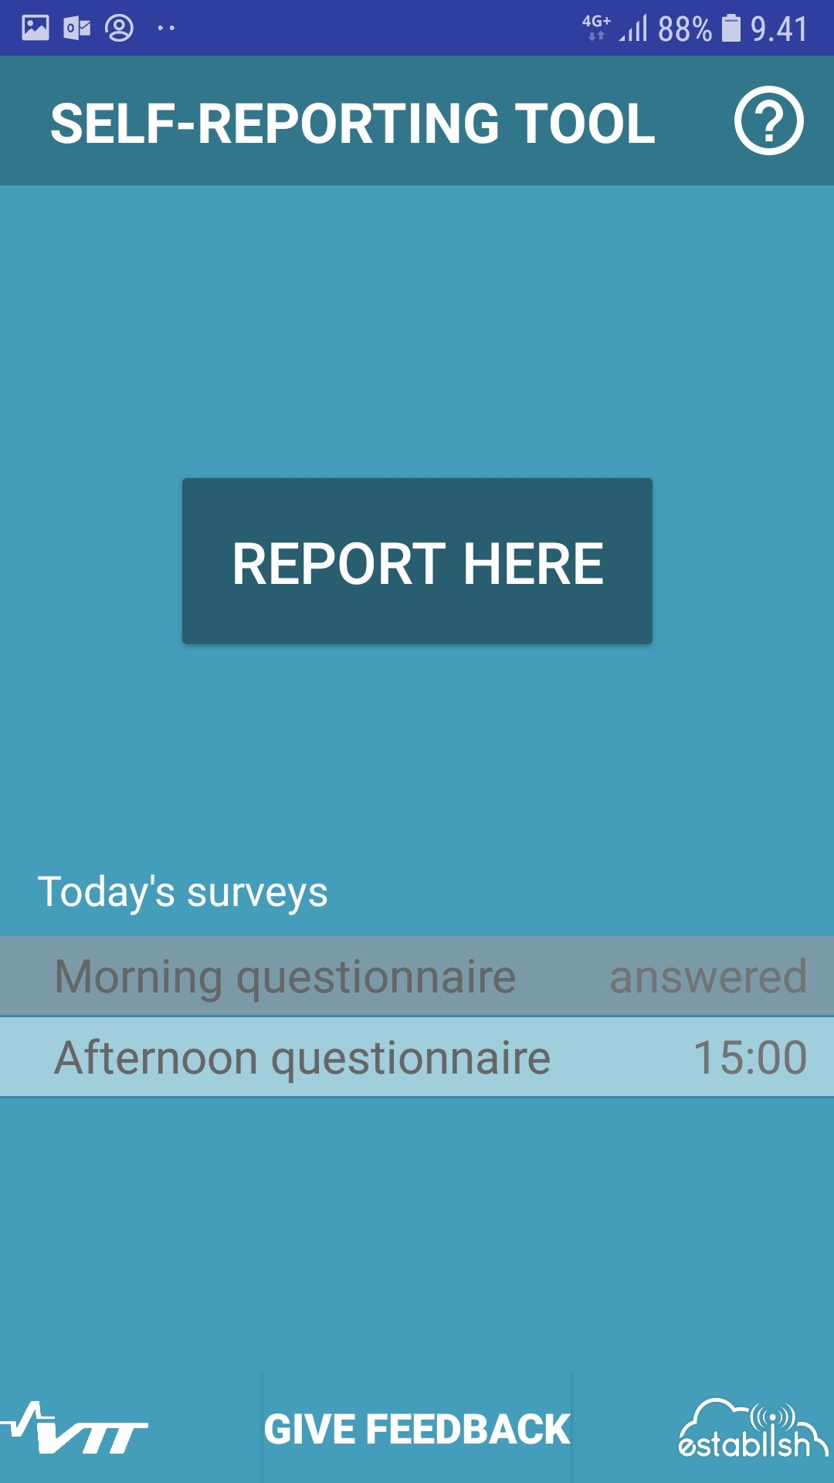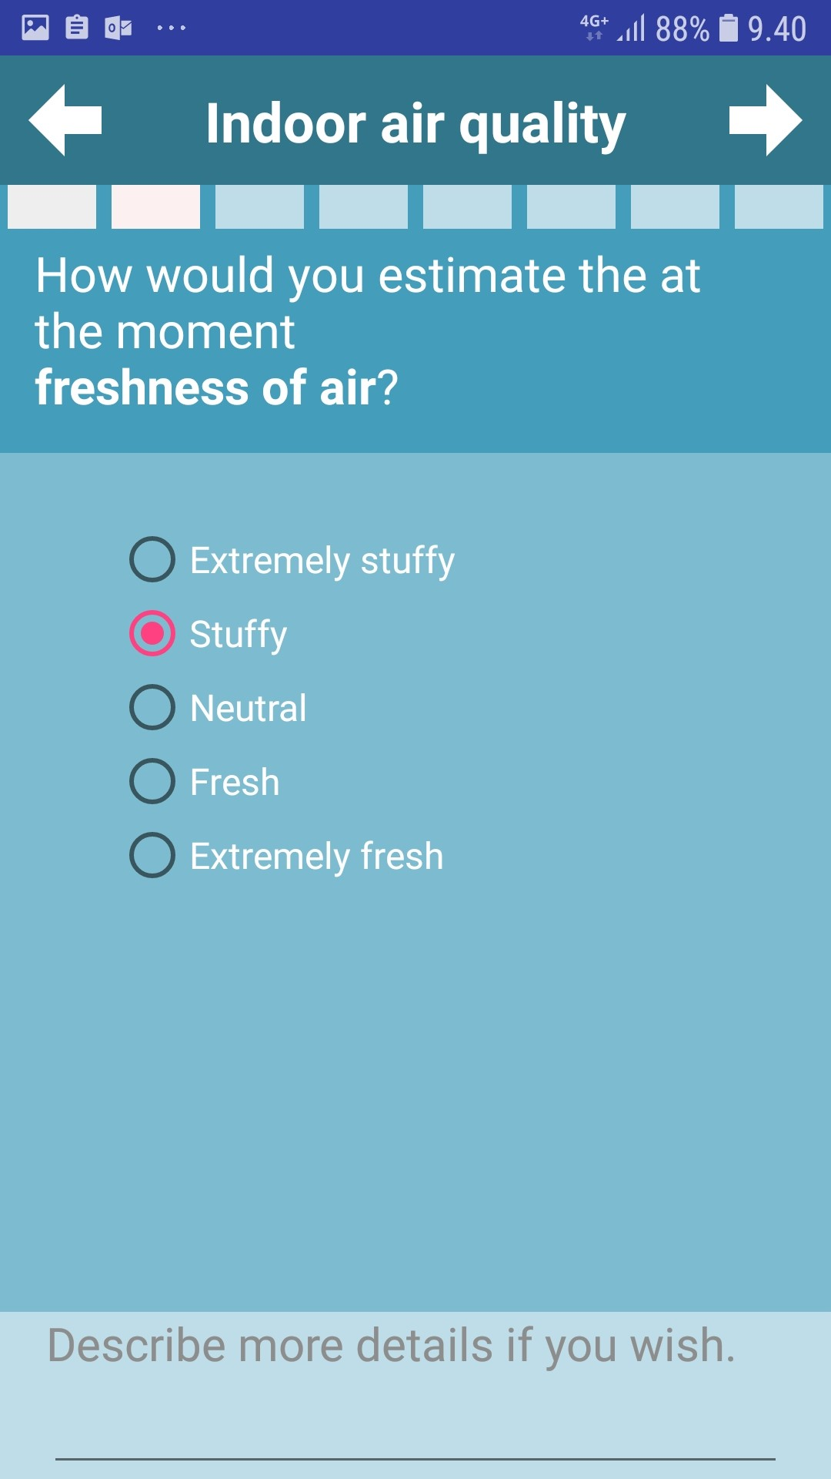
Figure 1. Screenshots of the self-reporting application

2.1.2 Usability study
Usability of the self-reporting application has been studied via questionnaires after each testing phase (4 phases in total in the18 weeks school pilot). After each phase, four items were inquired: 3 selected questions from SUS questionnaire (System Usability Scale; Brooke, 1986, Digital Equipment Corporation: Reading, England) and additional question on reliability. In the end of the study, the entire SUS questionnaire was filled by the participants. The questions for usability are presented in the table below (Table 1).

Table 1. Questionnaires related to usability of self-reporting app.
Question | P1 | P2 | P3 | P4
Self-report app was robust | x | x | x | x | 5-point Likert
I thought the self-report app was easy to use | x | x | x | x | 5-point Likert
I would imagine that most people would learn to use the self-report app very quickly | x | x | x | x | 5-point Likert
I felt very confident using the self-report app | x | x | x | x | 5-point Likert
I think that I would like to use the self-report app frequently |  |  |  | x | 5-point Likert
I found the self-report app unnecessarily complex |  |  |  | x | 5-point Likert
I think that I would need the support of a technical person to be able to use the self-report app |  |  |  | x | 5-point Likert
I found the various functions in the self-report app were well integrated |  |  |  | x | 5-point Likert
I thought there was too much inconsistency in the self-report app |  |  |  | x | 5-point Likert
I found the self-report app very cumbersome to use |  |  |  | x | 5-point Likert
I needed to learn a lot of things before I could get going with the self-report app |  |  |  | x | 5-point Likert
How useful did you perceive the self-report app? |  |  |  | x | 10-point
I would use self-report app in the future. |  |  |  | x | 5-point Likert
Open feedback ("What did you think about the self-report app? What was good/bad about it?", "Tell, what kind of thoughts or comments related to self-report app you have?") | x | x | x | x | Open
What kind of feedback you would like to give about the usability of the self-report app? | x |  |  |  | Open

2.1.3 Results from the usability study
User experience related to the self-reporting application were received from the participant teachers of the school pilot (N=4). Four usability items were tracked at each pilot phase (presented in Table 1) and the averages are illustrated in Figure 2. Usability average of the self-reporting application remains quite good throughout the pilot, above 4.2, even though after the phase 3 there is a slight decrease in all of the items. Already, in the beginning of phase 1, teachers felt that most people would learn to use the self-reporting application very quickly, it was easy to use, they were confident using it and it was robust.

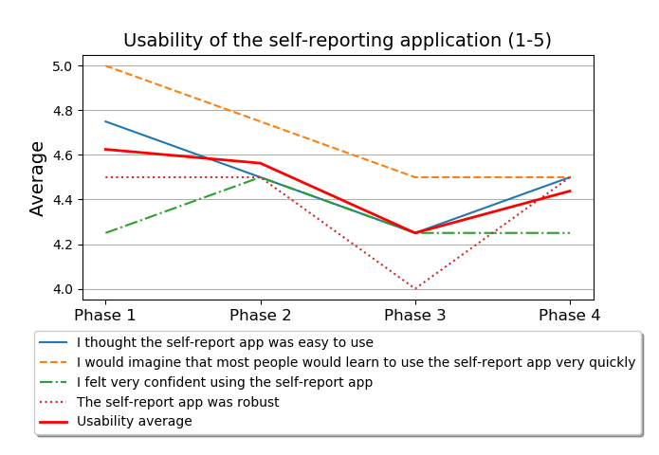
Figure 2. Usability results per phase and per item.
At the end of the pilot, usability was measured with more extensive questionnaire, the System Usability Scale (SUS). The scores are calculated according to Brooke (1986) and range between 0 and 100. The average SUS score was 78.1.
In their open feedback at the end of phase 1, the teachers considered the self-reporting application as clear and easy to use. They appreciated that there were a lot of answer alternatives for the questions and a possibility to elaborate on the answers further. However, one participant would have wanted longer time window for the questionnaire to be available. One of the participants felt the answers were repeating themselves and she was answering all the time similarly. In the phase 2, this issue was brought up by all the respondents. They said that the answers were almost always the same and repeating themselves, which made answering heavy and boring. Frustration continued in phases 3 and 4, since they felt their answers still stayed almost the same. One of participants suggested that there could be a button for reporting “situation has not changed” and previous answers would be copied. The busy afternoons, when there was for instance a meeting after the class, were the most difficult times to remember to answer the questionnaires. The self-reportin application was not modified during the pilot.

2.1.4 Future of the self-reporting application
The solution can be utilized in research projects also in other domains in the future. For the research purposes, a lot of data is needed. The participants felt it to bit hard to fill in the timed questionnaires twice a day during 18 weeks. But, in commercial use, the reminders could be timed differently and the most possible use of the application would be optional; the user could fill in the report whenever necessary.
The potential for the indoor air quality would be the straight feedback from the facility users that would enable faster reaction to the indoor air quality problems. This would enable noticing the problems in the buildings before they will create structural damages and also it would prevent people getting sick from the poor indoor air quality.

2.2 ESTABLISH GUI

2.2.1 Description of the GUI
The GUI developed in the ESTABLISH project is an ecosystem where device producers can plug-in their devices, data captures is stored and processed, and consumers and other stakeholders can subscribe to processed data, analysis, and specific functionalities. The main components of GUI include Coordinator (WEB SOA enabled Application), Kernel services (REST services), Data storage (Big Data, time series), Data analysis services, and Data presentation services.
The GUI enables to combine environmental sensor data with physiological and behavioural sensor data to empower patients in a rehabilitation clinic with decision support tools for behavioural choices and treatment options.
The pilot study about Rehabilitation decision support used the data from ambient sensors (air quality, atmospheric pressure, temperature, humidity) and the biometric, physiological and behavioral sensors, (heart rate and respiratory number of steps) to provide patients in clinical rehabilitation/ keeping fit programs with decision support tools related to behavior and treatment options.

2.2.2 Usability study
The pilot was run in the premises of a Romanian NGO, ASOCIATIA MAME (https://asociatiamame.com/) in Bucharest and developed decision support system and services based on the outdoors environment parameters and indoor location were evaluated. The aim of the pilot was to monitor health parameters to constantly improve the health of through rehabilitation and kinetotherapy care, specifically targeting the patient's functional aspect of integration in everyday life, environment and work.
In the study, the participants were different aged (children 6, middle age 3, old age 1) and different genders (5 male , 10 female) with different affections and different recovery plans. In the pilot study, we have identified also different health affections such as: overweight, obesity, kyphosis, scoliosis, lombosacralgia, rheumatoid arthritis and lymphedema.

2.2.3 Results from the usability study
In the usability studies we resulted that the developed decision support system and services based on the outdoors environment parameters and indoor location reduce operations costs and improve quality of the services provided. Novel product will be available at the end of the project. The GUI offers different advantages for different user groups:
For medical facilities
Better staff and activities management – dinamic reports based on different parameters
For medical staff
Improved patients’ management workflow
Usage of analytics to determine best recovery programme for the patients
Environment alerts based on AQI sensors
Health alerts based on Fitbit/Garmin data

For patients
Environment alerts based on AQI sensors
Health alerts based on Fitbit data
Users can see the effects of their actions in real time and can adjust their behaviour.

2.2.4 Future of the GUI
In the future, the GUI can be utilized in medical facilities from the public and private sectors (local and abroad), and in wellness centers.

2.3 Window opener

The aim of the solution is to prevent the indoor air to become stale and with poor quality. It is necessary to ventilate the indoor environment due to pollutants production, men activity, equipment, technology, animals, and outside pollutant sources. The primary aim is of course to provide the air for breathing. An adult man has a frequency of breathing typically 16 times per minute, which means approximately 8 l/min. The oxygen consumption varies between 250-350 ml/min.The athospheric air contains about 21 % O₂, 78 % N₂, 0,038 % CO₂ and little amount of argon, neon, helium and hydrogen. The typical composition of the exhaled air is 16 % O₂, 79 % N₂ and 4 % CO₂ plus water vapour.
In most countries there is a legal requirement to ventilate the interior with outside air in a certain intensity. The intensity of ventilation differs from country to country and also depends on the activity of people (or purpose of the room). The basic requirement is usually set at 25 m³.h⁻¹ per person to keep the CO2 concentration under 0,1 % (1000 ppm).
The space can be ventilated by following principles:
1. Natural ventilation – uses pressure difference caused by difference between densities of interioir and exterior air given by temperature difference OR by wind velocity.
2. Mechanical ventilation – pressure difference is caused by dynamic pressure of fan.
3. Hybrid ventilation – combination of natural and mechanical ventilation.
The main issue in case of natural ventilation is the impossibility of regulation. The ventilation rate very much depends on the outside temperature and wind velocity. It is not possible to give an advice, how many windows have to be opened for some time to ensure an adequate air quality. In case of natural ventilation, the ESTABLISH solution enables to monitor and manage the ventilation rate according to indoor air quality.

2.3.1 Description of the window opener
The window opener is the active element of the indoor air quality management system. It enables to open the window to start ventilating the space. Several types of window openers were investigated during the study period. Two types were selected for the actual testing (see the Figure 3 and Figure 4). Both types are designated to work with Tilt-Turn windows only (see the Figure 5).

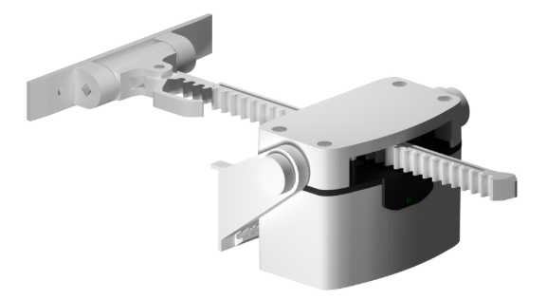
- Type 1 of the window opener.
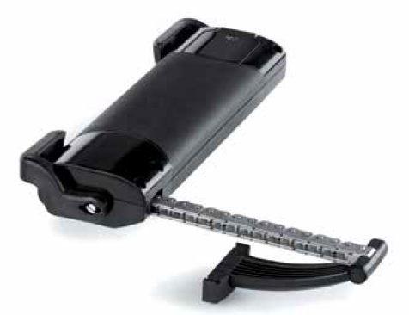
- Type 2 of the window opener.
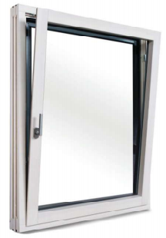
- Example of Tilt-Turn window.

Type 1 window opener has its motor positioned on the inner (movable) part of the window frame – nitche. The Type 2 has its motor positioned directly on the window frame. This is important in the phase of opener selection due to different requirements of space between the nitche and the ceiling (or the head jamb). The technical specifications for the window openers have been defined in Table 2 and 3.
For installation on the location of Use Case test bed, the type 1 window openers were selected. The technical specification is specified in the table below. Location of the test bed is in Prague, Czech Republic, in the open plan office environment.

- Technical specification of Type 1 window opener.
Parameter | Specifications | Additional information
Power adapter | Input: AC 50Hz/230V  Output: DC 12V/1,5-2A | Adapter type C, cable length 1.5m,
Speed of movement | Optional: approx. 3-20 seconds | Approximate time needed to close / open the window
Range of operating temperatures | -5° to + 40° Celsius | Minimal and maximal operating temperatures
Obstacle detection | yes | Motor stops when obstacle occurs

- Technical specification of Type 2 window opener.
Parameter | Specifications | Additional information
Power supply | 24 VDC | Adapter type C, cable length 1.5m,
Speed of movement | 16 mm/s | Approximate time needed to close / open the window
Range of operating temperatures | -5° to + 50° Celsius | Minimal and maximal operating temperatures
Push strength | 200 N | The strength of the opener while pushing
Pull strength | 250 N | The strength of the opener while pulling
Motor voltage | 0,9 A | Voltage of the motor
Obstacle detection | yes | Motor stops when obstacle occurs

2.3.2 Usability study

User-based evaluation
User-based evaluations are usability evaluation methods in which users directly participate. Users are invited to do typical tasks with a product, or simply asked to explore it freely, while their behaviors are observed and recorded in order to identify design flaws that cause user errors or difficulties. During these observations, the time required to complete a task, task-completion rates, and number and types of errors, are recorded. Once design flaws have been identified, design recommendations are proposed to improve the ergonomic quality of the product. The sensor devices used in the solution are defined in Table 4.
The implementation of a user test generally goes through a certain number of steps such as:
the definition of the test objectives,
the qualification and recruitment of tests participants,
the selection of tasks participants,
the creation and description of the task scenarios,
the choice of the measures that will be made as well as the way data will be recorded,
the preparation of the test materials and of the test environment (the usability laboratory),
the choice of the tester, and the design of the test protocol per se (instructions, design protocol, etc.),
the design and/or the selection of satisfaction questionnaires,
the data analyses procedures,
and finally the presentation and communication of the test results.

The topics that will be addressed are:
the number of participants one has to recruit for conducting a user test,
the test procedure,
conducting user test remotely,
the tools available and needed to conduct usability tests,
and the evaluation of the service.

- Sensor devices used within the solution.
Sensor manufacturer | Sensor type | EUI | Measured air quality parameters
Ascoel | CO868LR | 0E7E3464333100B6 | Temperature (°C), Relative Humidity (%), CO₂ (ppm)
Protronix | NLII-CO2+RH+T-SX | 2057D2 | Temperature (°C), Relative Humidity (%), CO₂ (ppm)
Protronix | NLII-CO2+RH+T-SX | 2057DE | Temperature (°C), Relative Humidity (%), CO₂ (ppm)
RisingHF | RHF1S001 | 8CF95740000002E2 | Temperature (°C), Relative Humidity (%)
RisingHF | RHF1S001 | 8CF9574000000231 | Temperature (°C), Relative Humidity (%)
RisingHF | RHF1S001 | 8CF95740000008AF | Temperature (°C), Relative Humidity (%)
COWAY | IAQ-3 | 8472071FC66C | Temperature (°C), Relative Humidity (%), CO₂ (ppm)

2.3.3 Results from the usability study

User-based evaluation results
In the table 5 below you can find the results of user-based evaluation. Users were using a standard questionnaire to gather their feedback. Evaluation parameters were: Manageability, Operability, Installation difficulty, Recommendation likelihood, Reliability. Based on the results, the testers were very positive with the window openers. The avarege for all the tested parameters was 2,05 (in the scale of 1 meaning very good and 5 very bad). The users mosly liked the recommendation likelihood (1,3) and manageability (2) and operability (2).

- User based evaluation results.
Tester no. | Evaluation parameter | Evaluation result
1 | Manageability (1 – Very Good, 5 – Very Bad) | 2
 | Operability (1 – Very Good, 5 – Very Bad) | 2
 | Installation difficulty (1 – Very Good, 5 – Very Bad) | 3
 | Recommendation likelihood (1 – Very Good, 5 – Very Bad) | 1
 | Reliability (1 – Very Good, 5 – Very Bad) | 3
Personal note: the batteries needed to be changed from time to time.
Ascoel sensor needed a battery change every 6 months (nontraditional battery that needed to be soldered).
2 | Manageability (1 – Very Good, 5 – Very Bad) | 1
 | Operability (1 – Very Good, 5 – Very Bad) | 2
 | Installation difficulty (1 – Very Good, 5 – Very Bad) | 2
 | Recommendation likelihood (1 – Very Good, 5 – Very Bad) | 1
 | Reliability (1 – Very Good, 5 – Very Bad) | 2
 | Personal note: sometimes the measured values did not appear in the application. IMA had to restart the service, after restart, it was OK.
3 | Manageability (1 – Very Good, 5 – Very Bad) | 3
 | Operability (1 – Very Good, 5 – Very Bad) | 2
 | Installation difficulty (1 – Very Good, 5 – Very Bad) | 2
 | Recommendation likelihood (1 – Very Good, 5 – Very Bad) | 2
 | Reliability (1 – Very Good, 5 – Very Bad) | 3
 | Personal note: -

2.3.4 Future of the window opener solution
The proposed system is applicable to various buildings across the building stock. Windows in the building need to be Tilt-turn type to be capable of the openers to be installed. It is not beneficial to install the system with window openers into the building with central Air Handling Unit (AHU), because there is mechanical ventilation system that is responsible for air exchange. The AHU usually has a recuperation unit that lowers the heating energy consumption of the building.
The above mentioned information means that the market is very broad. The limitation of the buildings where the system cannot be used (or it is not suitable for that type of building) is mentioned below in table 6.
- Buildings and their limitations for installation of the system.
Limitation issues | Building type | Suitable for installation
Non-openable windows | All | No
No tilt-turn window type | All | No
Security | Buildings with high security demands | No (the window is still opened, the window is held and locked by the motor in the opener)
Ventilation type | Buildings with central ventilation unit or local ventilation units | No (only when the opening of the window is desired because of reasons different from health issues)
Special requirements for comfort | Buildings with higher requirements for thermal comfort | No (in winter the cold outside air can cause draughts, which can be bothering to some people)

It is clear that the solution is suitable to wide range of different building types (single family houses, apartment houses, educational buildings, existing office buildings) apart from the ones that have limitation issues expressed in the table above. The potential of market success is very high.

2.4 Sensor management and configuration

2.4.1 Description of the sensor management and configuration tool
Web application IoTLoRaWAN monitors the status of the environment using the LoRa wireless network. Effectively monitors environmental features (CO2, temperature, humidity, dust) as well as flow of water and air (sewerage, piping, air conditioning, chimneys), see figure .

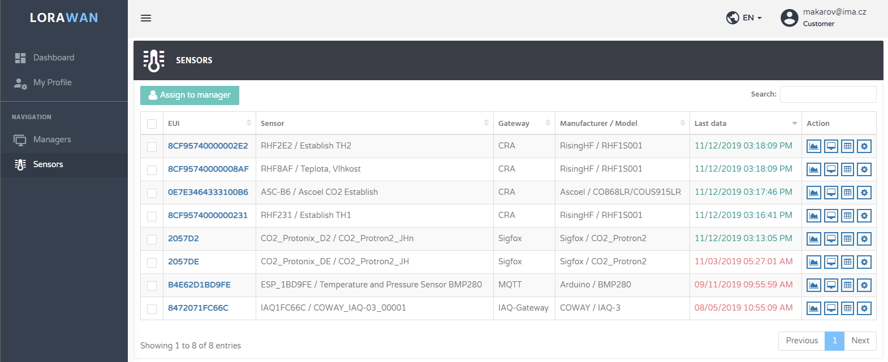
- Sensors monitored in IoTLoRaWAN solution.

The User Interface
Users can access the IoTLoRaWAN from any web enabled device. The Software is optimised for use with the latest version of Google Chrome, but will work on any web browser. Please note that downloading data on a mobile device may incur significant data charges.
There are three levels of access permission, from Manager, where data can be viewed but not changed, through to Administrator which has the capability of changing all variables. All access is password protected and the Users, and their level of access can be easily defined or changed with immediate effect. Data is displayed in real time, and is stored for easy access at a later date. The data can also be downloaded into a .csv format for local storage and manipulation. A detailed data display allows the user to view system status and unit performance at a glance. From the Monitoring and Control System User Interface Users with appropriate access privileges can configure the target settings.
Registration
In order to use the system, all Users must be registered. This maintains the integrity of the system, and ensures that each User is only permitted access to UNITS within their remit. The User privileges are set at the time of registration, but can be changed at any time.
The three levels are: Administrator, Customer, and Manager. The most comprehensive level of access is Administrator. The Administrator is able to register new customers, change Passwords and deactivate existing Customers. After registration, each user will receive a registration email detailing their Username and Password, and a link to activate the account.
Cookies
The Software uses cookies to ensure optimum performance. Please ensure cookies are enabled on the device used to access The Software. A cookie will be placed on the device used each time the User logs into the system and provides the following functions:
Identifies the User
Ensures The Softwareremains logged in for 24 hours following the last action
Retains the User’s preferences. For example, once the location menu or tab has been navigated, its position will be retained for the next time the User logs in.
The cookie used is a persistent cookie with an expiration time of 24 hours. This means that it will be stored on the device after the web browser window is closed or the device switched off. The system will remain logged in, even if the browser is closed, allowing the Userto re open the system program without having to re enter their Password each time.
Data Protection
IMA Ltd will not share any personal information, or use it for any purpose other than that for which the system is designed.
Password Security
Each User has a unique Email and Password combination. They enable The system to recognise the User and display the appropriate information for that User account. It is therefore imperative that Passwords are not shared, or disclosed to anyone. In the event of a Password having been shared, it should be changed immediately.
Data Display
Click on the device eui or sensor name to view its data. A chart will be displayed showing last 24 hours’ data for each sensor, see figure 7. The date and time is displayed along the x axis. The date is shown in the format „mm/dd/yyyy“ and the time is in GMT, 24 hour format is „hh:mm:ss“.

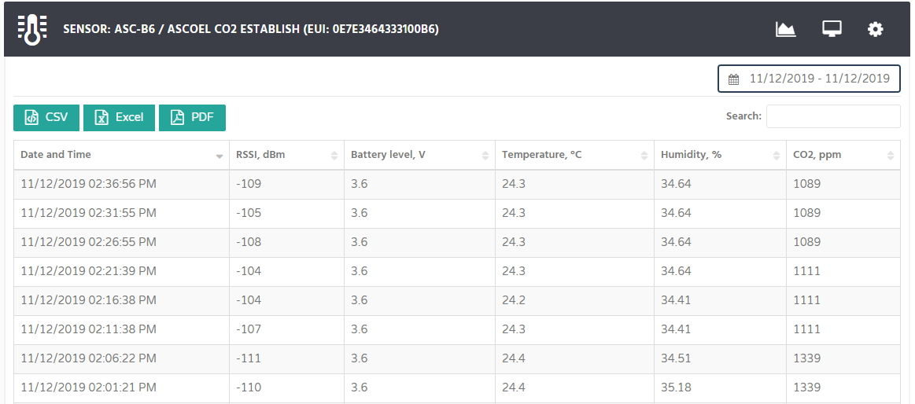
- Sensors data in IoTLoRaWAN solution.
The units measured are shown along the y axis. Red lines show the levels at which an alert will be triggered, see figure 8.
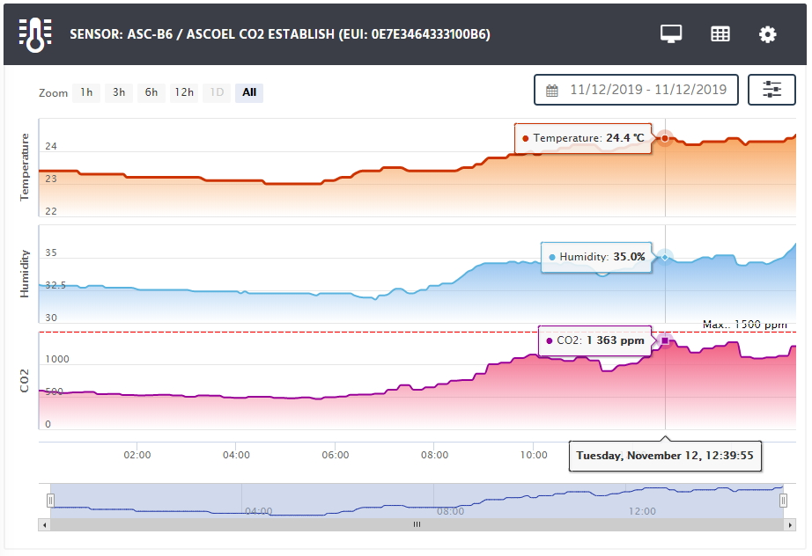
- Sensors data and alerts levels in IoTLoRaWAN solution.

Warnings
An alert is a warning triggered when the monitoring system detects that one or more of the preset sensor parameters have been breached, see figure 9. Alerts can be sent by SMS and email Each UNIT will have a customised contact list which can be different for email and SMS messages. The User Interface allows Users with appropriate access privileges to programme the interval between alert messages.
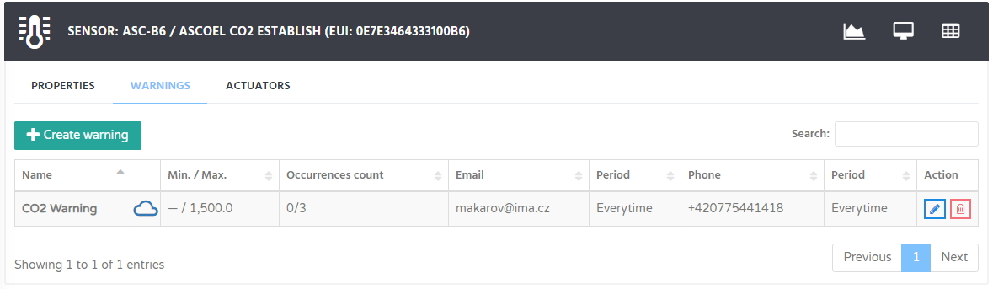
- Warnings in IoTLoRaWAN solution.
Actuators
The actuator is designed for electronically controlled opening of windows in ventilation mode, see figure 10. You can schedule it by time or make it automatically respond to different events. It can be remotely controlled by smartphones or PCs. It means that you can use your existing or future IoT devices to control your windows or connect it to differnet smart home systems. The appliance is powered by an ordinary electrical outlet. Connection to the Internet is provided via your WiFi network.
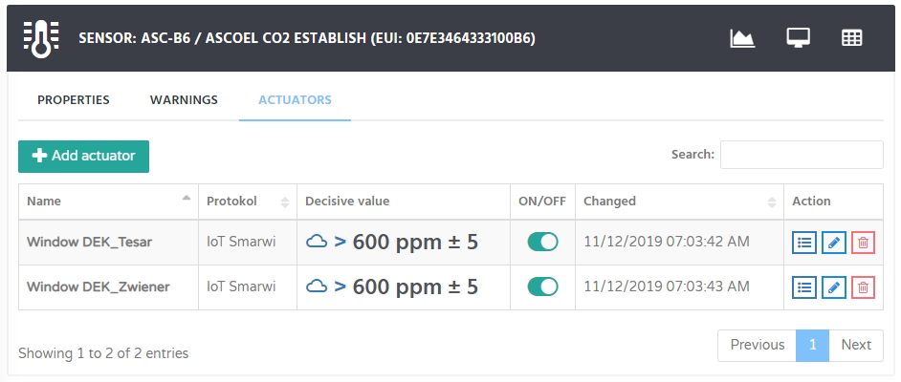
- Managing of window openers in IoTLoRaWAN solution.
The actuator helps not only wherever you want to contribute in the long run to improve the indoor climate or to deal with ventilation. Room air quality affects our ability to concentrate, impacts on fatigue and sleep. Ventilation can be planned in advance, or you can ventilate as on demand, with one click in your phone. And with the use of external services, the window can for example automatically close itself when the storm is close.

2.4.2 Usability study
See the description of the usability study in chapter 2.3.2. Both solutions used the same approach for assessment of the usability.

2.4.3 Results from the usability study
Selected eight parameters linked to LoRaWAN management and configuration were resulted based on tester feedback. These results have been described in table 7. Based on the feedback, the users were very happy with the IoTLoRaWAN solution. Averagely, the result for all these parameters from the two test users was 1,81. Especially, the management platform (1,5), IoT operability (1,5) and usability (1,0) of the solution were appreciated.

- Results from the usability study. Evaluation scale: 1- very good, 5- very bad.
Tester no. | Evaluation parameter | Evaluation result
1  (Institution) | Visualization framework | 2
 | Management platform | 1
 | Management platform of IAQ devices, test beds | 1
 | Big data management | 2
 | Usability | 1
 | Privacy and security | 2
 | Stakeholders’ feedback | 2
 | IoT Interoperability | 1
2  (Industrial) | Visualization framework | 2
 | Management platform | 2
 | Management platform of IAQ devices, test beds | 2
 | Big data management | 3
 | Usability | 1
 | Privacy and security | 2
 | Stakeholders’ feedback | 3
 | IoT Interoperability | 2

2.4.4 Future of the sensor management and configuration tool
Utilization of the solution has been already assessed, see details in D6.5. Big potencial to use the solution has been identified at schools, public and office buildings, and manufacturing environment. Based on the usability research the two business model how to use the solution have been created:
BM1 - Effective mainly for education domain, consulted at elementary schools, high schools and universities, the main issue are the solution costs, the institutions are depends on public financing. Product - application LORAWAN - will be rented for rapid or mid-term measurements.
BM 2 - Public and office Buildings, factory environment, the company or public authorities can cope with the financing of the solution, purchasing of the software for long-term measurements preferred.

Conclusions
This document (deliverable D2.3 Usability of ESTABLISH solutions) presented the results from the usability studies implemented for certain ESTABLISH solutions; Self-reporting application, ESTABLISH GUI, Window opener, and Sensor management and configuration tool. To understand the user feedback makes it possible to develop the products and services that better meet the needs and requirements of the potential users.
In the case of the Self-reporting application, the user experience related to the self-reporting application were received from the participant teachers of the school pilot. Usability average of the self-reporting application remains quite good throughout the pilot, above 4.2, even though during the long-lasting pilot the teachers were asked to report were often. Teachers felt that most people would learn to use the self-reporting application very quickly, it was easy to use, they were confident using it and it was robust. On SUS scale, the result was also very positive, 78.1 (scale 0-100). The self-reporting application can be utilized in research projects also in other domains in the future.
In the usability studies of the developed decision support system and services showed different advantages for different stakeholders, like better staff and activity management for medical facility owners, improved patients’ management determination of best recovery programme for medical staff, and environment and health alerts for the patients. In the future, the GUI can be utilized in medical facilities from the public and private sectors, and in wellness centers.
The usability of the window opener was evaluated with five parameters: Manageability, Operability, Installation difficulty, Recommendation likelihood, Reliability. Based on the results, the testers were very positive with the window openers. The avarege for all the tested parameters was 2,05 (in the scale of 1 meaning very good and 5 very bad). The window opener is applicable to various buildings across the building stock and the market is very broad.
The usability of the sensor management and configuration tool, IoTLoRaWAN solution, was evaluated with eight parameters: Visualization framework, Management platform, Management platform of IAQ devices, Big data management, Usability, Privacy and security, Stakeholders’ feedback, and IoT Interoperability. The users were very happy and averagely the result for all these parameters was 1,81. Especially, the management platform (1,5), IoT operability (1,5) and usability (1,0) of the solution were appreciated. Utilization of the solution has been already assessed, see details in D6.5. Big potencial to use the solution has been identified at schools, public and office buildings, and manufacturing environment.
These results related to the usability of different novel solutions developed in the ESTABLISH project are suggestive for further development. When commercial solutions will be implemented, more studies related to usability and user experience are needed to ensure the success of the solutions. However, that work will be done iteratively during the life cycle of the solution.

Source: https://en.wikipedia.org/wiki/Breathing

