D6.1. Dissemination & Standardisation Activities Report
PARFAIT - Personal dAta pRotection FrAmework for IoT

Editors: Jean-Paul TRUONG Gemalto
Contributors:
Reviewer:

WP2 |  | Dissemination & Standardisation Activities Report
Leader |  | Gemalto
Task |  | T6.1 Dissemination & Standardisation Activities
Deliverable number |  | D6.1. Dissemination & Standardisation Activities Report
Type |  | Doc
Author |  | Gemalto
Other contributors |  | BEIA, SIS, University of Burgundy, University of La Rochelle, Turkgen
Keywords |  | Dissemination, Standardisation
Date of delivery
Draft history (to be removed on publication)
V.0.1 |  |  | Initial Version
V.0.3
V.0.4

Table of Contents
1 Introduction 4
1.1 Deliverable objectives 4
1.2 Acronyms 4
1.3 References 5
2 Project Websites 6
2.1 PARFAIT common Website 6
2.2 News on SIS website 7
3 Dissemination of results 8
3.1 Summary 8
3.2 Dissemination activities by Contributor 8
3.2.1 University of Burgundy 8
3.2.1.1 Strategic objectives 8
3.2.1.2 Achievements 9
3.2.2 University of La Rochelle 10
3.2.2.1 Strategic objectives 10
3.2.2.2 Achievements 10
3.2.3 BEIA 12
3.2.3.1 Strategic objectives 12
3.2.3.2 Technical Events 12
3.2.3.3 Publications 20
3.2.4 Turkgen 22
3.2.4.1 Strategic objectives 22
3.2.4.2 Achievements 22
3.2.5 SIS - Societatea de Inginerie Sisteme 22
3.2.5.1 Strategic objectives 22
3.2.5.2 Achievements 22
3.2.6 Pertimm Developpement 23
3.2.7 NXP Developpement 23
3.2.8 Softeam 24
3.2.8.1 Strategic objectives 24
3.2.8.2 Achievements 24
3.2.9 Gemalto 24
3.2.9.1 Ways to promote PARFAIT project 24
3.2.9.1.1 Events – Speaking Slots 24
3.2.9.1.2 Web Communication 24
3.2.9.2 Achievements 24
4 Standardisation 26
4.1 Strategic objectives 26
4.2 Standards focus 26
4.3 Achievements 26
4.3.1 ISO SC17 26
4.3.2 CEN/CENELEC 27
4.3.3 SEMS 27

Introduction

Deliverable objectives
The main objectives of WP6: Dissemination and Standardisation activities are:
- First, to diffuse scientific and technological knowledge generated within the context of the project through a set of different dissemination activities.
- Second, to provide valuable feedback towards relative standardisation bodies and consortiums about the possible integration of the respective technologies, their applicability, their completeness, their optimization and their future development.
- Finally, to raise awareness and attract potential supporters, end users and customers through a detailed communication strategy comprising of a bouquet of tools and channels, tailored to each target stakeholder.

The main outputs from WP6, detailed in Tasks 6.1, are:
- Project website.
- Dissemination of results to scientific and technical, public and media, and software development industry and end-user (including public sector) communities.
- Promotion of the PARFAIT’ results in the identified standardisation groups.

Acronyms

References

Project Websites

PARFAIT common Website
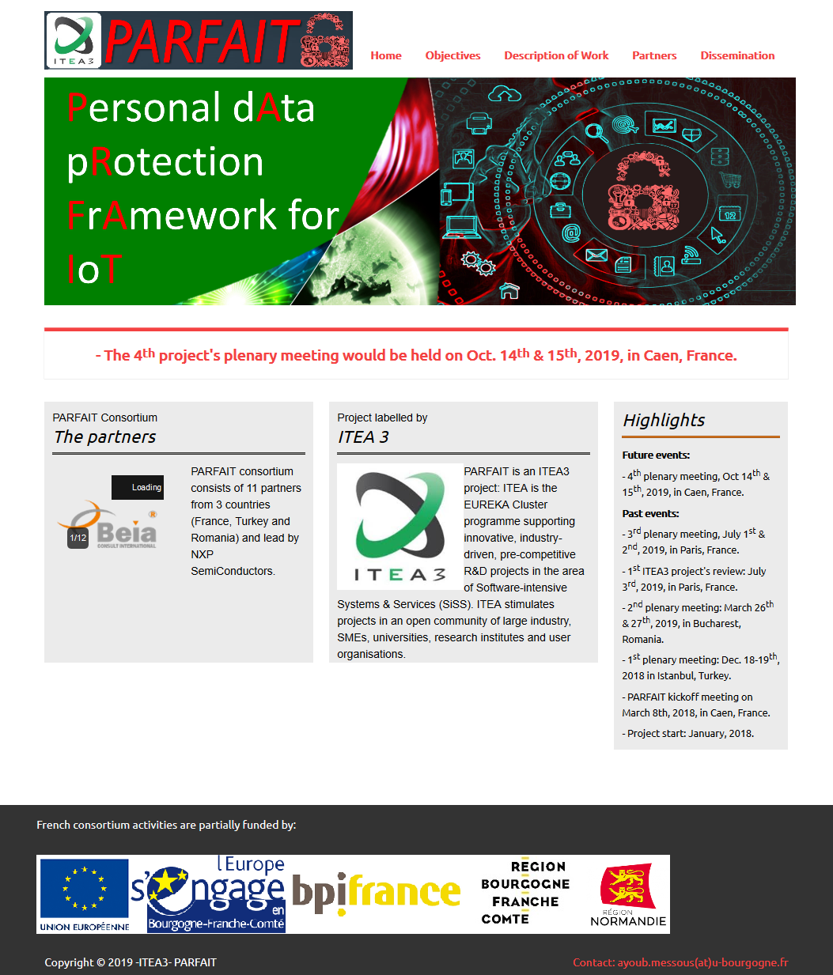
The project website's (http://www.itea3-parfait.com/) is running since March 2018. It is maintained by University of Burgundy. The figure bellow shows the home page of the project website, in which the list of different partners and labialization organization along with the most important mile stones of the project are shown. Besides this first page, the website has also four other sections with specific purpose each. Details are provided in the following:

- Objectives: this page provides the background of the project and the main challenges that the project PARFAIT tackled throughout its duration. It also lists the main project’s objectives and impact.
- Description of Work: this page shows the initial organization of the different work steps. Furthermore, the different work packages and the interaction between them are briefly explained.
- Partners: here, a list of the three different consortia from the three different countries are provided along with an index for the websites of each partners.
- Dissemination: This section provides an up to date list of the project dissemination material used in different events (posters, flyers, leaflets, etc.). It also lists the full list of recent scientific publications in journals and international conferences. Finally, most of the events in which the PARFAIT project was presented by on the partners is also listed.

News on SIS website
SIS has published some news related to PARFAIT on their website:
PARFAIT - Nou proiect international de cercetare
PARFAIT – Sedinta consortiului la Bucuresti
Moreover SIS has also published some news on LinkedIn account
The news details shortly the topics addressed during the meeting, main achievements and future action points set up for the project development. The role of SIS in this project is also empathized. From the start of the project, the access metrics for the different pages related to the project are as follows:
Page | Type | Metric of visits
https://www.sis.ro/produse/20/parfait/ | Research project description | 40
PARFAIT - Nou proiect international de cercetare | News | 5
PARFAIT – Sedinta consortiului la Bucuresti | News | 23

Dissemination of results

Summary
Within this first period, the dissemination activities have been made under different forms:
- PARFAIT presentation in events: We took opportunity in different professional technical and commercial events to present the benefits of PARFAIT project
- Technical presentations on IoT: We attended different professional technical events to make several technical presentations on technologies that have been pioneered during the course of PARFAIT project
- Web communications: publications made on different Web sites, professional networks, technical blogs, etc…
- Technical publications
The number of dissemination results is summarized as below:
 | PARFAIT presentations in events | Technical presentations on IoT | Web communications | Technical Publications
BEIA | 8 |  |  | 4
SIS |  |  | 3 | 2
Turkgen | 1
University of Burgundy | 7 | 2 | 1 | 11
University of La Rochelle | 2 | 1 |  | 3

Dissemination activities by Contributor

University of Burgundy

Strategic objectives
As an academic partner, the main strategic objectives of the UB through its dissemination work is to increase the visibility of its research activities. Furthermore, this would offer an even more exposure of the researchers involved in the different tasks throughout the project. This would be mainly achieved through the following:
- Publishing the research results in highly ranked scientific journals (mainly in journal with a recognized impact factor).
- Participation and presenting the initial finding during the project in international and national conferences (mostly in conferences with a strict peer review process).
- Maintaining the official project website (itea3-parfait.com) with regular updates and entries.
- Finally, preparing and presenting posters and demos in regional and local events.

Achievements
International journal papers (4):
A. Arfaoui, S. Cherkaoui, A. Kribeche, SM. Senouci, M. Hamdi, “Context-Aware Adaptive Remote Access for IoT Applications”, submitted to IEEE IoT Journal.
- Arfaoui, A. Kribeche, O. Merad Boudia, SM. Senouci, M. Hamdi "Context-Aware Access Control and Anonymous Authentication in Wireless Body Area Networks", Computers & Security (Elsevier), 2019.
- Arfaoui, A. Kribeche, SM. Senouci "Lightweight and Adaptive Anonymous Authentication Protocols in the Internet of Things Dedicated to e-Health Applications", Computer Networks (Elsevier), 2019.
- A. Arfaouia, A. Kribecheb, SM. Senouci, M. Hamdi, “Game-Based Adaptive Anomaly Detection in Wireless Body Area Networks”, Journal: Computer Networks, (Elsevier), Volume 163, 9 November 2019, 106870, https://doi.org/10.1016/j.comnet.2019.10687

International conference papers (7):
- A. Arfaoui S. Cherkaoui, A. Kribeche, SM. Senouci, M. Hamdi, “Context-Aware Adaptive Authentication and Authorization in Internet of Things”, IEEE ICC’2019, China, 20-24 May, 2019.
- M. Dammak, O.R. Merad Boudia, M.A. Messous, SM. Senouci, C. Gransart, “Token-Based Lightweight Authentication to Secure IoT Networks”, IEEE CCNC’2019, Las Vegas, 11-14 January 2019.
- Arfaoui, A. Kribeche, SM. Senouci, M. Hamdi, “Game-Based Adaptive Remote Access VPN for IoT: Application to e-Health”, IEE Globecom’2018, Abu Dhabi, UAE, 9-13 December 2018.
- Arfaoui, A. Kribeche, O. Merad Boudia, A. Ben Letaifa, SM. Senouci, M. Hamdi, “Adaptive Anonymous Authentication for Wearable Sensors in Wireless Body Area Networks”, IEEE IWCMC’2018, Limassol, Cyprus, 25-28 2018.
- Arfaoui, A. Kribeche, SM. Senouci M. Hamdi, “Game-Based Adaptive Risk Management in Wireless Body Area Networks”, IEEE IWCMC’2018, Limassol, Cyprus, 25-28 2018.
- Arfaoui, A. Kribeche, O. Merad Boudia, A. Ben Letaifa, SM. Senouci M. Hamdi, “Context-Aware Authorization and Anonymous Authentication in Wireless Body Area Networks", IEEE ICC’2018, Kansas City, Missouri, USA, 20-24 May, 2018.
- Arfaoui, A. Ben Letaifa, A. Kribeche SM. Senouci M. Hamdi, “A Stochastic Game for Adaptive Security in Constrained Wireless Body Area Networks”, IEEE CCNC2018, Las Vegas, USA, 12-15 January, 2018.

Poster presentations (1):
- M. Dammak, S-M. Senouci, A. Messous, A Poster for a "Smart Hotel" Use Case, Sommet International de l'Inovation en Ville médianes (SIIVim 2018) , 8-10 November 2018 in Nevers, France.

University of La Rochelle

Strategic objectives
As an academic partner, we aim at disseminating the project results at Three levels:
- Training: Extend the expertise of ULR researchers and contribute to train students and qualified professionals (Master/Engineer/PhD students, Post-docs),
- Technology transfer to local SME through our partner Technology Transfer Accelerator (SATT Aquitaine / Aquitaine Science Transfert) or through Campus'Innov, our in-campus tool devoted to the promotion and development of innovation in relation with industry, SMEs and start-ups,
- Publication: Dissemination of results in relevant high quality international conferences and journals. Potential targets on the top-tier journals and conferences to disseminate the project results are mentioned below (but not limited to):
Journal:
- IEEE Transactions on Information Forensics and Security
- IEEE Security & Privacy
- IEEE Communication Magazine
- Elsevier Journal of Computer Network
- International Journal of Communication Systems (Wiley)
- IEEE Network Magazine
- Knowledge and Information Systems (KAIS http://link.springer.com/journal/10115)
- Knowledge-Based Systems (http://www.journals.elsevier.com/knowledge-based-systems)
Conferences:
- IEEE Symposium on Security and Privacy
- IEEE International Communication Conference (ICC)
- ACM Mobile Computing (MobiCom)
- IEEE Conference on Computer Communications (InfoCom)
- IEEE GLOBECOM
- Knowledge Representation and Reasoning (KR&R)

Achievements
International journal papers (1):
- Ben Messaoud, N. Sghaier, M. A. Moussa and Y. Ghamri-Doudane, « Privacy Preserving Utility-aware Mechanism for Data Uploading phase in Participatory Sensing », Preprint IEEE Transactions on Mobile Computing (Accepted in August 2018).
International conference papers (2):
- V.H. Hoang, E. Lehtihet, Y. Ghamri-Doudane, « Forward-Secure Data Outsourcing Based on Revocable Attribute-Based Encryption » The International Wireless Communications & Mobile Computing Conference, IWCMC 2019, Tangier, Morocco, Jun. 2019.
- V.H. Hoang, E. Lehtihet, Y. Ghamri-Doudane, « Password-Based Authenticated Key Exchange Based on Signcryption for the Internet of Things » 2019 Wireless Days Conference, WD’19, IEEE Xplore, (Manchester, UK), April 2019.

BEIA

Strategic objectives
The dissemination objectives of the PARFAIT project are to bring the results closer to the stakeholders from relevant fields by participating in specific conferences and fairs of interest for this project. BEIA Consult participated in various events to promote the PARFAIT project, most of them having as main theme Cyber-Security [Romania – Israel Cyber Security Forum (5 June 2019), Cybersecurity Romania – Bucharest Talks (4 June 2019), Bucharest CyberDrill (27-31 May 2019), Security Espresso meetup (22 May 2019)]. Participations in the mentioned events were published on the website www.beiaro.eu in the "News" section, on Twitter and Facebook, our social media accounts being very active. Also, the PARFAIT project was presented by writing several articles (Android Malware Detection and Crypto-Mining Recognition Methodology with Machine Learning, Comparative Analysis of Distributed Ledger Technologies, Mobile Application and Wi-Fi Network Security for e-Learning Platforms).
Following the activities carried out, promotional materials were made and the project was discussed at the Networking sessions within each event."

Technical Events
ROMANIA – ISRAEL CYBER SECURITY FORUM
Our company participates in ROMANIA – ISRAEL CYBER SECURITY FORUM on 5 June 2019 in Bucharest, Romania.
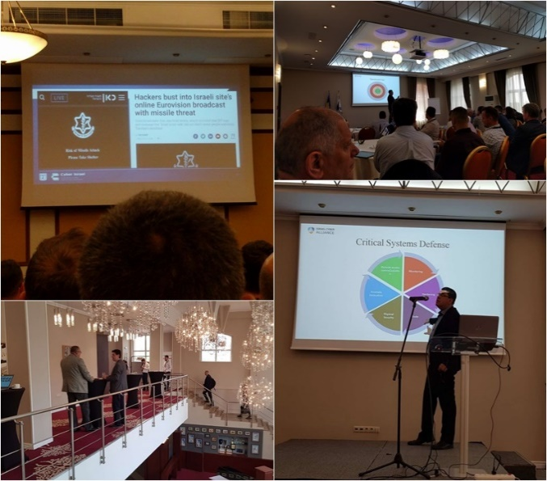
Cybersecurity industry top 500: USA > Israel > UK > Canada > France > Sweden > Germany > China

Bucharest CyberDrill
BEIA Consult participates in Bucharest CyberDrill on 27-31 May 2019 in Romania. The CyberDrill event is hosted by University Politehnica of Bucharest (UPB), the largest and the oldest technical university in Romania, with its traditions connected to the founding of the first Romanian higher technical school, back in 1818.
The main goal of the Bucharest CyberDrill event is to develop and strengthen the cyber security response capability as well as the communication / interaction capacity of the participating teams.
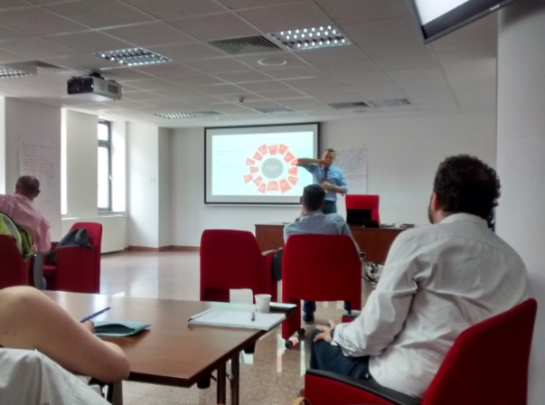
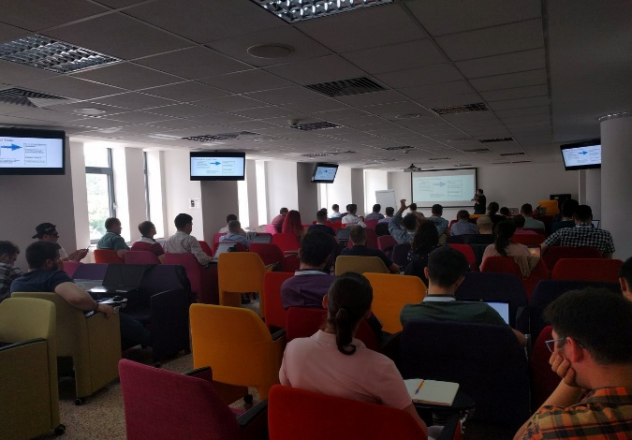

Security Espresso
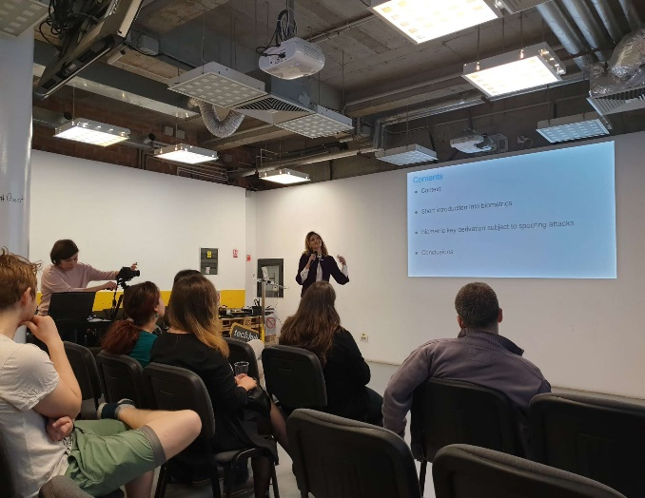
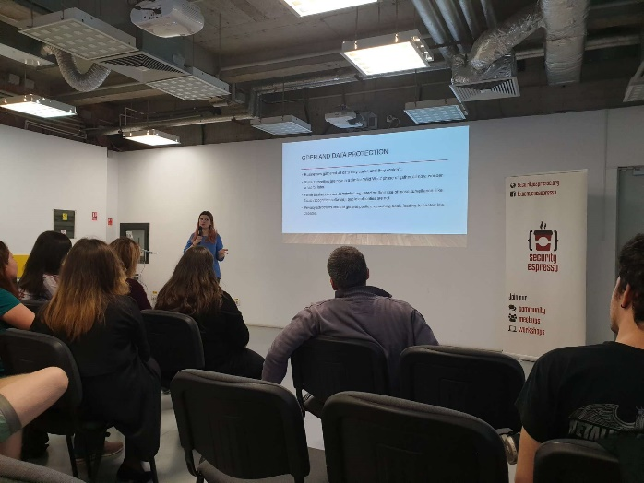
BEIA Consult participated in Security Espresso on 22 May 2019 in Bucharest, Romania.

ZF Cybersecurity Trends 2019
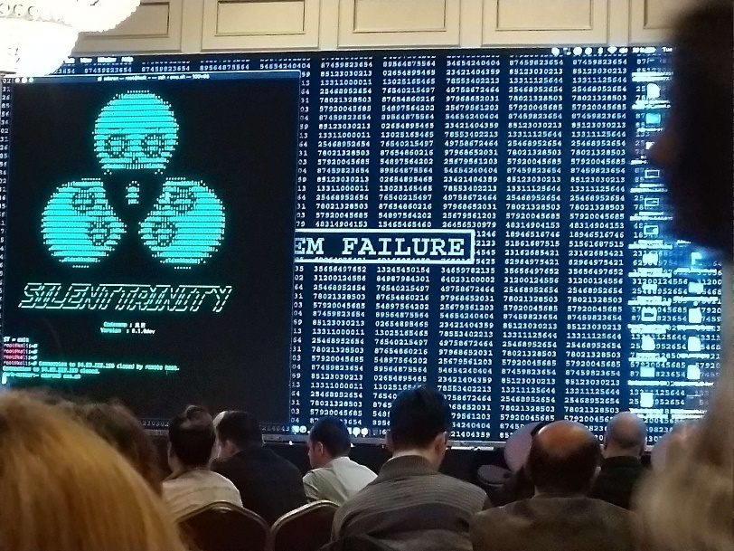
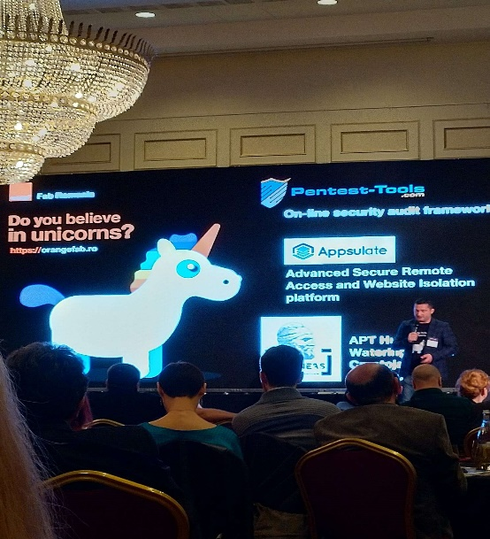
Our company participates in ZF Cybersecurity Trends 2019 on 21 May in Bucharest, Romania(JW Marriott Hotel). This event is about how an IT infrastructure breaks down and how an attack can be intercepted, the future of cyber attacks – the new generation of cybersecurity entrepreneurs expose their vision, the impact of GDPR – Good Practice Guide.

Cybersecurity Forum 2019
BEIA Consult participated in the Cybersecurity Forum 2019. The event was on 12.03.2019 at JW Marriott Bucharest Grand Hotel. The event brought together ambassadors, business people, top management companies in areas such as cyber security, IT, energy, banks, capital markets, telecom, gambling, industry, military, journalists and other.
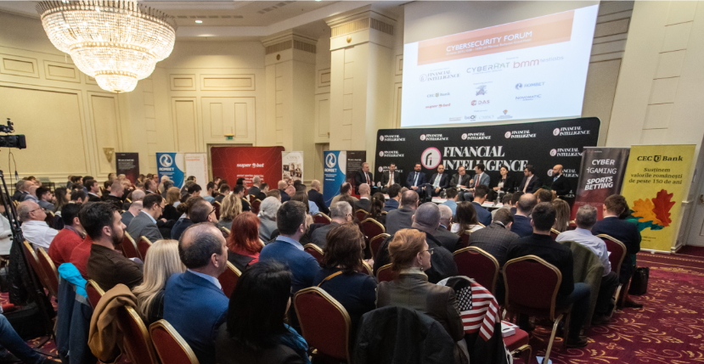

Cybersecurity Romania – Bucharest Talks
BEIA Consult participates in Cybersecurity Romania, Bucharest Talks on 4 June 2019 in Bucharest, Romania.
“BUCHAREST TALKS” is the “newborn” of a series of international events with the main characteristic of being strictly nonprofit, apolitical, neutral, non-marketing and non-technical, allowing for an international dialogue of the highest quality.
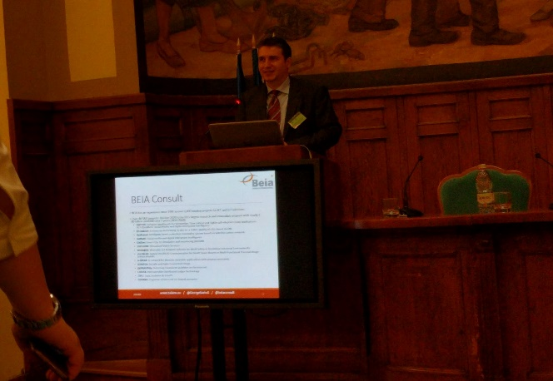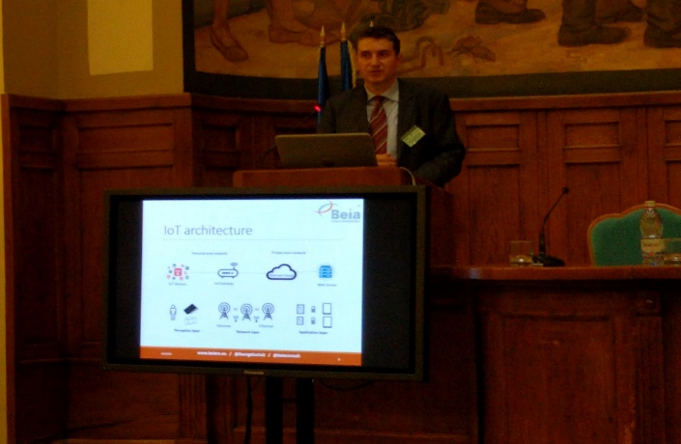

GWS -2018
The 6th Global Wireless Summit (GWS -2018) - Chiang Rai, Thailand - 25-28 November 2018, presented article: Comparative Analysis of Distributed Ledger Technologies

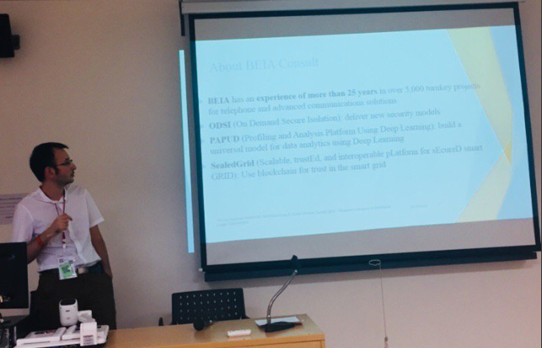

DEFCAMP 9
DefCamp9 - Bucharest, Romania - 8-9 November 2018 - is the most important annual conference on hacking and information security in Central and Eastern Europe. Every year brings together the world’s leading cybersecurity people to share the latest researches and knowledge. Over 1,500 security specialists, entrepreneurs, developers, academic, private and public sectors will meet at this event, year after year. Beia gave the last details on the Parfait project

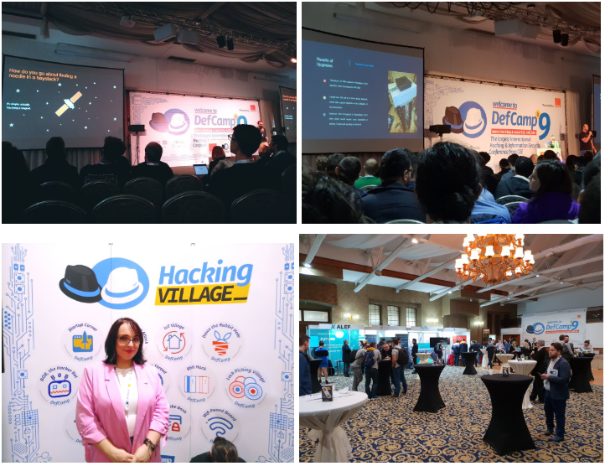

OWASP Bucharest AppSec Conference: (24 - 26 October 2018)
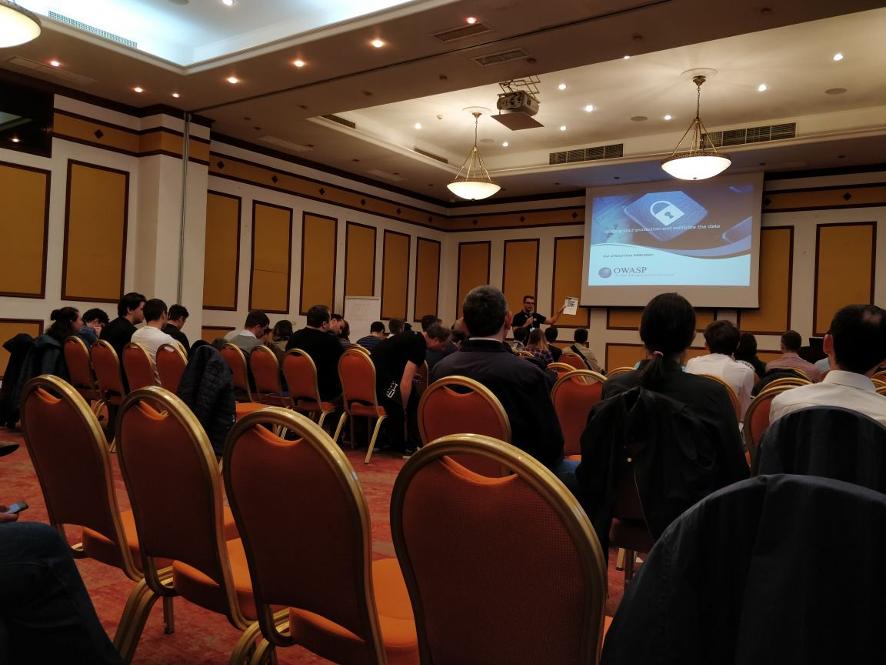

Europol-ENISA
Second Europol-ENISA Conference - The Hague, Netherlands - 24-25 October 2018 - proposing a broad discussion about the Internet of Things (IoT) security by bringing together experts from cybercrime units, CSIRTs, international organizations, private industry, regulatory agencies, and academic environment. Beia has disseminated the Parfait project.

CyberSecurity Day
CyberSecurity Day - Bucharest, Romania - October 24, 2018 - focused on trends and technologies, technical solutions and security services that specialists can use to approach the cyber challenges. The conference provides an opportunity to relate with cybersecurity professionals, to share ideas and discuss the challenges facing the industry. Beia has disseminated the Parfait project.

CERTCON8
The New Global Challenges in Cyber Security CERTCON8: (15-17 October 2018): Bucharest, Romania - October 16-17, 2018 – it focused on the new global challenges in cybersecurity, together with cybersecurity experts from European and International institutions, as well as cybersecurity companies. Beia presented the Parfait project
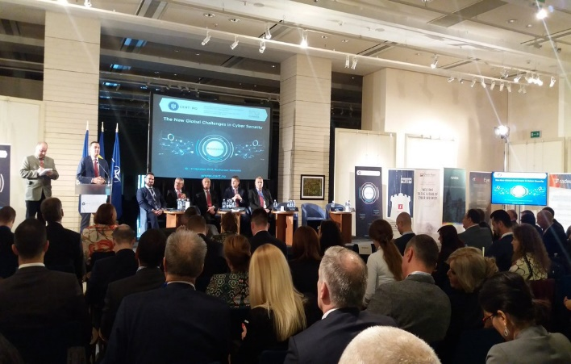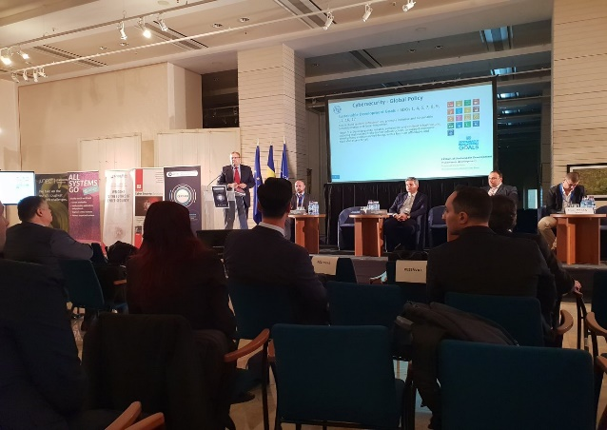

Regional South East European Conference 2018
Participation in the "Fourth edition of the Regional South East European Conference 2018", which took place at the Polytechnic University of Bucharest, 3-5 October 2018. The event presented the article "Energy performance analysis using EnergyPlus for an office building "- G. Suciu, MC Ditu, I. Rogojanu, T. Uşurelu;bbbb
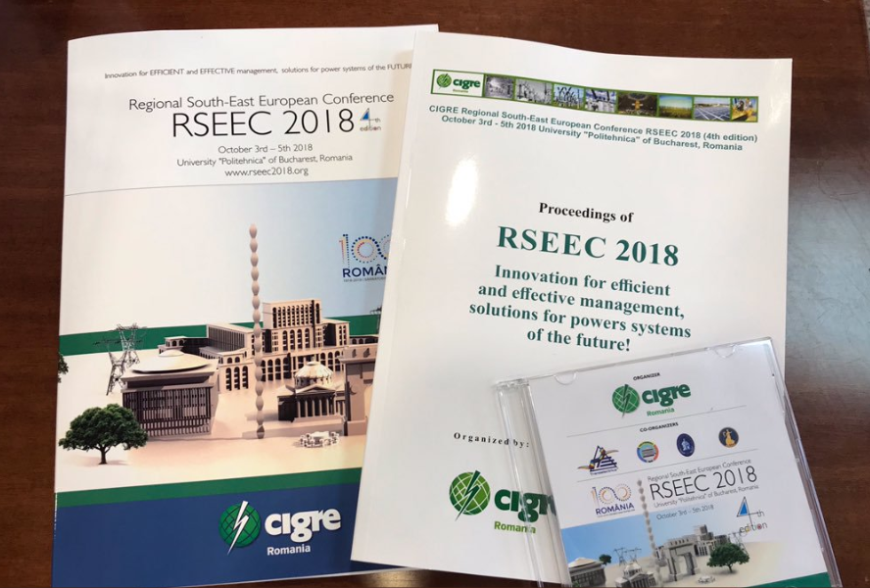

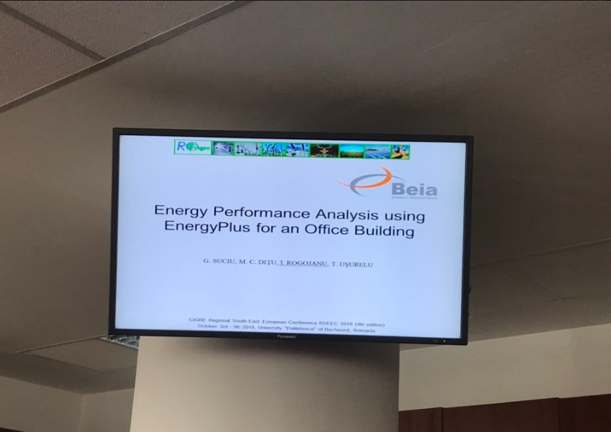

IMWorld
IMWorld - Bucharest, Romania - 2-3 October 2018 - Supports the entrepreneurial environment to adopt digitization in all industries to increase efficiency and productivity. Beia participated with a stand and provided information on the Parfait project

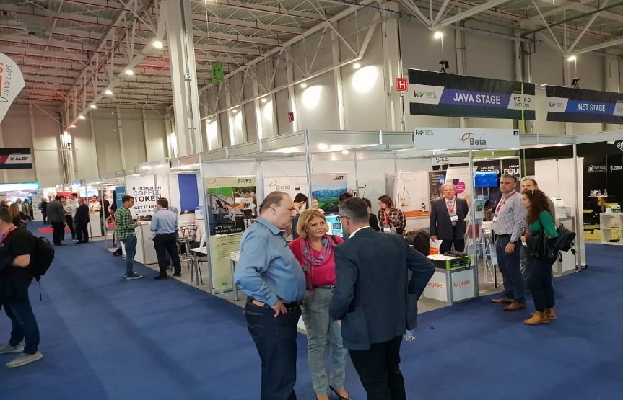

Central European CyberSecurity Congress
6th edition of the Central European CyberSecurity Congress -Sibiu, Romania - 12-14 September 2018 - BEIA has disseminated the concepts of the Parfait project
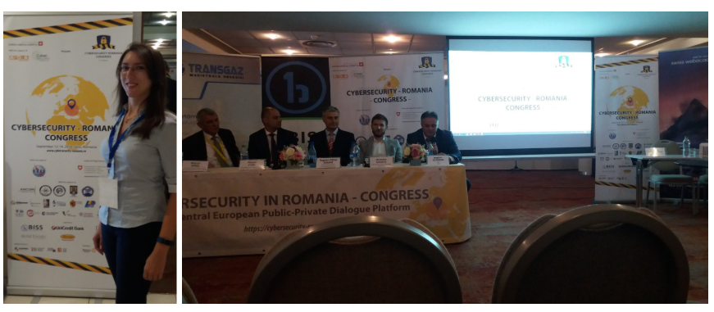

IoT Week 2018
Participation in the IoT Week 2018 event, the most important annual conference organized by IoT Forum since 2011. The latest editions attracted some 500 IT specialists. The conference took place from 4 to 7 June in Bilbao

IT Congress 2018
Annual ICT event organized by ETA2U. It took place between May 17-18, 2018 in Timisoara. This event is the largest in the country, bringing together over 1,000 ICT experts along with the world's most renowned technology vendors.

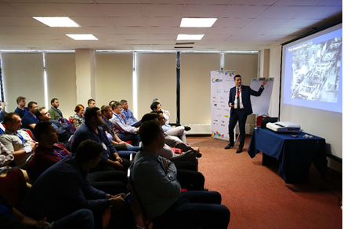

BTECHWEEK 2018
Bucharest Technology Week. The event took place between May 18th and May 20th, and the participants were able to interact with cutting-edge technologies: robots, drones, electric and hybrid cars, virtual reality, smart home solutions and more.

Publications
- Soviany, S., Scheianu, A., Suciu, G., Vulpe, A., Fratu, O., & Istrate, C. (2018, October). Android Malware Detection and Crypto-Mining Recognition Methodology with Machine Learning. In 2018 IEEE 16th International Conference on Embedded and Ubiquitous Computing (EUC) (pp. 14-21). IEEE.
- Suciu, G., Nădrag, C., Istrate, C., Vulpe, A., Ditu, M. C., & Subea, O. (2018, November). Comparative Analysis of Distributed Ledger Technologies. In 2018 Global Wireless Summit (GWS) (pp. 370-373). IEEE.
- Suciu, G., Anwar, M., & Istrate, C. (2019). Mobile Application and Wi-Fi Network Security for e-Learning Platforms. In The International Scientific Conference eLearning and Software for Education (Vol. 1, pp. 393-399). " Carol I" National Defence University.
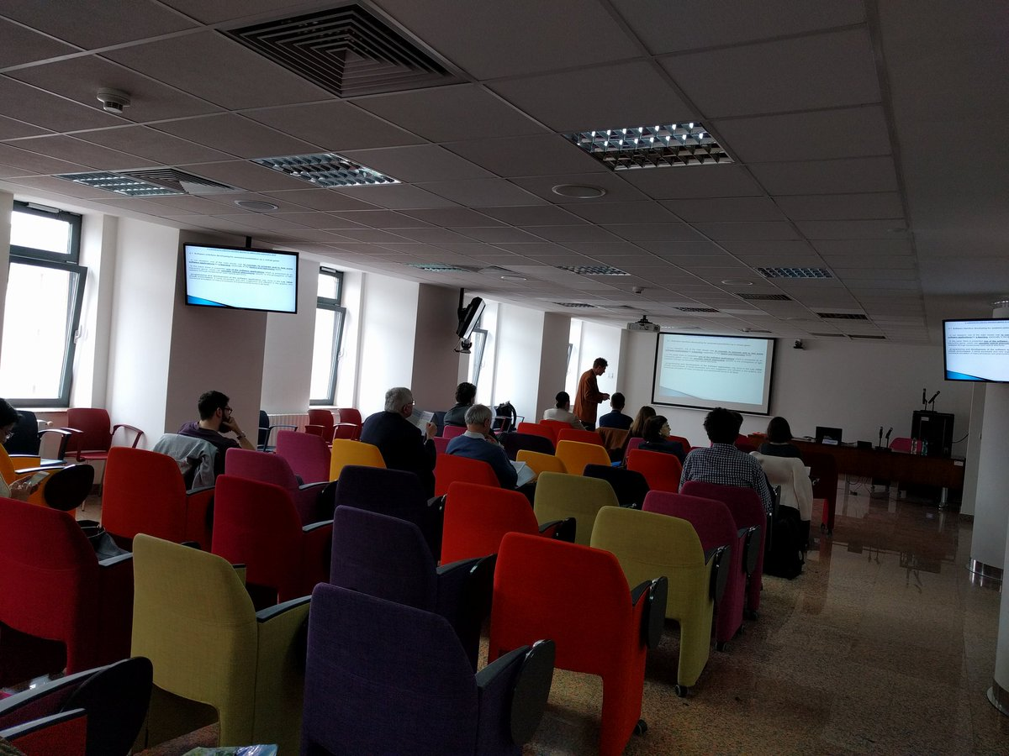
- Suciu, G., Istrate, C., Petre, I., & Scheianu, A. (2019, April). Lego Methodology Approach for Common Criteria Certification of IoT Telemetry. In World Conference on Information Systems and Technologies (pp. 165-174). Springer, Cham.

Turkgen

Strategic objectives
Türkgen plans to have a solif output from the project which will have a marketing value for the company. According to strategic roadmap of Türkgen, their main target to achieve from PARFAIT project is a product that targets the management of the IoT devices by textual commands. We intend to have two languages at the starting point and then include more languages, since all of them needs good NLP techniques. As mobile application usage increase, and IoT devices are spread all around the houses, a smart home management via a mobile app, have high potential to be used in the market.

Achievements
- A meeting has been done in Istanbul University Computer Engineering 3rd and 4th grade students by Dr. Tolga Ensari from Istanbul University, Computer Engineering division. In the meeting the PARFAIT architecture and approach explained to students. More than 40 students participated to the seminar.
- Two meetings have done with different customers of Turkgen. Both have IoT solutions in the market and the feature that PARFAIT can provide to them attracted the customers. Since the development process is ongoing, the customers wanted to be informed periodically about the progress in the product. In the coming period, more meetings will be arranged with different number of existing and potential customers. (Customer names are not provided due to the privacy issues.)

SIS - Societatea de Inginerie Sisteme

Strategic objectives
The strategic objective in our dissemination plan is to increase our market visibility as providers of secure IoT devices and applications. Specific foreseen actions in accomplishing this objective are:
- Participating at at least one international conference of workshop to present the results of the testing and validation activities
- Adding one news on SIS website and LinkedIn account after each main event or milestone achieved in the project
- Organizing face to face presentations and demo to possible beneficiaries

Achievements
- News publication on SIS website (in Romanian)
  - PARFAIT - Nou proiect international de cercetare: an initial announcement of PARFAIT project start
  - PARFAIT – Sedinta consortiului la Bucuresti: short presentation of the achievements during the consortium meeting in Bucharest
- Participation with brochure at CSCS22 conference in Bucharest: 29 May 2019, Bucharest, Romania
- Participation with brochure at Innovative Enterprise Week event in Bucharest: 19-21 June 2019, Bucharest, Romania
SIS designed a brochure that presents main objectives of the project, describes the Smart Home use-case and architecture and emphasis the need of increasing the security of privacy in IoT transmitted data. The brochure was given to different participants at each event, represented by academic and industry professionals.

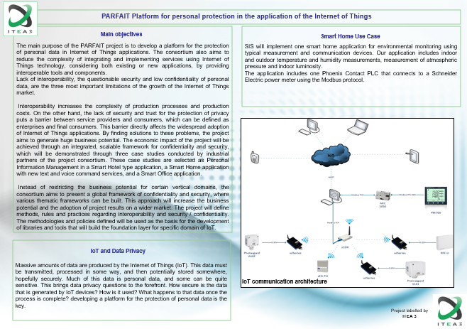

Pertimm Developpement
The strategic objective in our dissemination plan is to push forward our Viky.ai platform and its visibility through the use of the platform within the PARFAIT project. We will describe the use of the solution, in the Smart Home use case with TurkCell, Ericsson and SIS. We have two upcoming actions:
- Presentation at the VoiceTech Paris 2019 (November 26-27 2019)
- Presentation at Paris Open Source Summit (December 10,11 2019)
Those presentation will be relayed on the viky.ai website and also on the social networks.

NXP Developpement
The strategic objective in our dissemination plan is to promote NXP’s NFC controller plus secure element integrated platforms: SN1x0 with the use of Global Platform SEMS (Secure Element Management Service) to distribute securely and widely secure element applications. At date of Nov 2019, SN 1x0 is already the chipset chosen by several Chineese and Korean manufacturers for their 2019-20 cell phones.

Softeam

Strategic objectives
Softeam is dealing with a lot of personal data coming from its customers. IoT data is the next step of this era. Softeam’s objective is to provide to its customers a way to handle private information and manage permissions to thirdparties. This is the strategic objective for Softeam with the PARFAIT project. Since there is not so much material for communication and dissemination around this new tool, dissemination activities for Softeam are, for now, about the project activities.

Achievements

Some twitter activities about the project :
https://twitter.com/lgonKlves/status/1146416515241132032?s=20

https://twitter.com/lgonKlves/status/1146413412605472770?s=20

Gemalto

Ways to promote PARFAIT project
In Gemalto, our intent is to use our traditional communication channels to disseminate PARFAIT project results.

Events – Speaking Slots
Events and Speaking Slots will be the opportunities to promote PARFAIT project:
- IoT & Automotive & Government events
- Speaking Slots can be a good opportunity to raise awareness

Web Communication
- “Gemalto.com” & all its web connections: we can mention the project in a blog, on our website, in an emailing or in our magazine the review
- Press & Media > draft & push a press article via our PR agencies)

Achievements
MWV 2019 Barcelona
Mobile World Congress February 25-28 2019 in Barcelona
Speaking Slots
- A Digital Society Needs Digital Identity, 27 February
- From specification to live products, 28 February
Events
- IoT Solution Optimizer showcase (NB-IoT): with our Partner Deutsche Telekom
- Poster at Ericcsson booth to promote the use case: Out-of-the-box global connectivity for healthcare IoT

8th Mobile IoT Summit
February 24th, Hesperia Barcelona Tower Hotel
- Presentation on LTE-M to the Mobile IoT Mass Market.
- Dedicated Product showcase at the event: Mobile IoT Solutions showcase in GSMA demonstration zone

Standardisation

Strategic objectives
In the IoT domain, our ambition is to leverage the security of the framework with the following focuses:
- Strong Authentication for IoT ecosystems
- Secure Authentication protocols for IoT at both devices and Users levels
- Interoperability
- Ease of use
- Wide adoption
- GDPR / Privacy By Design

Standards focus
The standard bodies we put our focus are:
- International / National levels: ISO, CEN, AFNOR
eIDAS : Regulation on electronic identification and trust services for electronic transactions between businesses, citizens and public authorities
- Alliance level:
FIDO : industry association with a focused mission: authentication standards to help reduce the world’s over-reliance on passwords

Achievements

ISO SC17
WG4: ISO/IEC 19286 (Identification cards - Integrated circuit cards - Privacy-enhancing protocols and services) – Focus: eIDAS and GDPR
WG10, WG4 and WG3: ISO/IEC 23220 - Generic mobile identity application and protocols, “mobile ID management building bricks », a new standard to host and leverage generic mobile ID design – Focus : eIDAS
- New program of work with Gemalto as Contributor
- Strong synergy gained (between WG10, WG4 and WG3) on "mobile ID management building bricks" (ISO/IEC 23220) topic, validated with AAMVA, NIST, HID, IDEMIA, G&D, Gematik and Bundesdruckerei as a new standard to host and leverage generic mobile ID design.
WG4: ISO/IEC 22924 on improved connectivity to secure element on board a device:
- New program of work in WG4 with Gemalto editorship
- Alignment with ETSI and enhancement with additional features/use cases (e.g. plug&play, HCP protocol translator, additional bus topology instead of network topology)
WG4: ISO/IEC 23465 - API to ICC on abstraction layer for legacy-preserving portability, "Programming interface for security devices -- Functions and parameters" – Focus : GDPR
- New program of work in WG4 validated as ISO/IEC 23465 on "Programming interface for security devices -- Functions and parameters".
- Gemalto as co-editor

CEN/CENELEC
JTC8: EN on Privacy by Design → GDPR
Focus Group on Blockchain : White Paper in June 2018 (Recommendations for Successful Adoption in Europe of Emerging Technical Standards on Distributed Ledger/Blockchain Technologies) : with an entire section written by Gemalto on eIDAS (Digital Identity and Signature Management)

SEMS

To promote NXP’s way to distribute secure element application, NXP’s has been at the origin of the standardisation of SEMS as Global Platform standard:
GPC_SPE_121 V1.0 Secure Element Management Service
Global platform is a consortium of companies building common standard for trusted secured services.
Among members, we have: NXP, Apple, VISA, MasterCard, Infineon, ARM, ST Microelectonics, Cisco, Oracle, NTT, Huawei, Beijing Union Pay, Thales-Gemalto …

