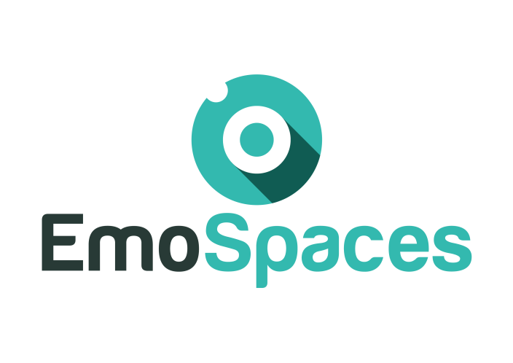

**Enhanced Affective Wellbeing based on Emotion Technologies for adapting IoT spaces**

**D6.3 Exploitation Plan**

Final

|  |  |  |
| --- | --- | --- |
| **Consortium:** | **ITEA** | |
| **Deliverable ID:** | **6.3** | |
| **Work package/Task: WP6** | |
| **Responsible partner:** | **ANSWARE** | |
| **Contributing partner(s):** | **THALES** | |
| **Dissemination level:** | **public** | |

🙔 This page is intentionally left blank. 🙔

Index

INDEX

1. Introduction 7

2. Scope and deliverable objectives 8

2.1. Scope 8

3. Dissemination activities 9

3.1. Target groups 9

3.2. Dissemination channels 15

3.2.1. ES identity 16

3.2.2. ES Website 16

3.3. Pathway to exploitation 16

4. Exploitation Service A1 use case - Wellbeing coaching for elderly people 18

4.1. Business overview 18

4.1.1. Business Model Canvas 19

4.1.2. Exploitable results 22

4.1.3. Market issues 24

4.1.4. Strategy for exploitation 25

4.1.5. Intellectual property rights 26

4.2. Socio-economic impact of the results 26

4.2.1. Societal and ethical impact 26

4.2.2. Economical impact 26

5. Exploitation Service A2 use case - Wellbeing coaching for social integration 27

5.1. Business overview 27

5.1.1. Business Model Canvas 27

5.1.2. Exploitable results 28

5.1.3. Market issues 29

5.1.4. Strategy for exploitation 31

5.1.5. Intellectual property rights 32

5.2. Socio-economic impact of the results 32

5.2.1. Societal and ethical impact 32

5.2.2. Economical impact 32

6. Exploitation Service B use case - Sound optimization 33

6.1. Business overview 33

6.1.1. Business Model Canvas 33

6.1.2. Exploitable results 34

6.1.3. Market issues 36

6.1.4. Strategy for exploitation 36

6.1.1. Intellectual property rights 37

7. Exploitation Service D use case – E Learning market 37

7.1. Business overview 37

7.1.1. Business Model Canvas 37

7.1.2. Exploitable results 38

7.1.3. Market issues 39

7.1.4. Strategy for exploitation 41

7.1.5. Intellectual property rights 41

7.2. Socio-economic impact of the results 42

7.2.1. Societal and ethical impact 42

7.2.2. Economical impact 42

8. Contribution to standards or policy developments of the EmoSpaces platform 43

**Document history**

|  |  |  |  |
| --- | --- | --- | --- |
| **Revision** | **Date** | **Content description/Modification** | **Author(s)** |
| V0.1 | 28/02/18 | Index, main text, content, Business Canvas SERVICE A1 | A.Chietera (Thales) |
| V0.2 | 14/06/18 | Content and Business Canvas for SERVICE B | A.Chietera (Thales) |

**Glossary**

|  |  |
| --- | --- |
| EmoSpaces | Enhanced Affective Wellbeing based on Emotion Technologies for adapting IoT spaces |
| ITEA3 | Information Technology for European Advancement 3 |

# Introduction

In this document, the landscape of adoption barriers and success strategies for implementation of interoperable IoT platform services is reviewed.

An EmoSpaces multi-stakeholder value chain and a reference business use case for each application have been developed by the project consortium. Based on an extensive literature review, stakeholder engagement and a reporting procedure for sharing feedbacks and any relevant information after dedicated workshops, this deliverable takes advance from these items in their organisational context.

Given the current rapid progress of the legal/regulatory field of IoT interoperability, the deliverable currently places less emphasis on these issues than it does on organisational matters. In the ES workflow another deliverable is especially dedicated to policy in WP1.

With these findings in mind, the deliverable concludes with an outlook of the next tasks to be elaborated to provide the baseline for a checklist and roadmap to the adoption of ES interoperable solutions.

# Scope and deliverable objectives

## Scope

The exploitation plan is divided into two sections:

1. A public one related to results that will be disseminated and the corresponding dissemination activities (specifying the target audience and the applied communication strategy);

2. A confidential one describing exploitable results and related planned activities. This section should include:

* a verifiable list of all intellectual property rights that have been applied for or registered (e.g. a European patent has been applied for);
* a list of all the results that may have commercial or industrial applications (e.g. software, inventions, prototypes, compiled information and data, etc.)
* an explanation of how the foreground has been or is going to be used, in either further research or commercial exploitation activities, including elements such as the following:
* purpose, main features and benefits of each technology or product, derived from the research results: intended audience, innovative aspects in comparison with technologies and products already available, needs for further R&D activity and implied risks, collaboration needs for exploitation (technology transfer activities);
* customer detection: identification of the potential customers and the factors that affect their purchasing decisions;
* features of the target market: size, growth rate, share that the technology/product could reach, driving factors likely to change the market, legal, technical and commercial barriers, other technologies likely to emerge in the near future;
* how the participant (or other entity) entitled to the technology exploitation is positioned (or should be positioned) in the market, competing businesses/applications/technologies.

The plan should also describe:

* the socio-economic impact of the results
* any contributions to standards or policy developments

# Dissemination activities

## Target groups

The goal of “dissemination” is to promote and raise awareness about the project achievements, and communicate its benefits to the targeted stakeholder community.

ES partners include main European and Korean Research institutes, industrial actors and service providers from the different ICT sectors, who will accelerate the creation, management and deployment of new products, services and business models for future IoT technologies, in the following categories:

* Domestic aids: to improve personal independence of patients and or elderly people
* Wellbeing coaching: to improve physical and mental conditions.
* Management of critical situation for depressive disorder and patients affect from autism
* Educational training: to improve learning capabilities
* Entertainment: Improve retail experience capturing emotions

The project results will be of great interest not only for health, entertainment professionals or learning centers but also to local, national and European authorities (healthy ageing, educational campaign…) who should bring these new technologies into their planning for investment leading to Europe-wide deployment.

The results will, if properly presented and disseminated, be of great interest for potential end users, but also for industry and business users as catalyzer of new breakthrough technologies in the Internet of things to improve the daily life quality.

The dissemination process aims to spread information among all potentially concerned stakeholders and to all levels of policy-makers, as well as to certification and standardization bodies, engineering organizations and universities.

Dissemination of research results occurs mainly through scientific publications in journals and conference proceedings, as well as by presentations in these conferences and other venues. This approach will be eased by the research and academic organizations participating to the ES consortium. These include venues in specific to the application domain of this project (i.e. emotion in smart environment systems), as well as in venues related to fields applied in the project (i.e. Artificial Intelligence, Machine Learning, IoT, Robotics and so on). The following institution has been or are currently involved in numerous venues:

* Université Paris-Est Créteil
  + Paper published at the main track of Ro-Man 2017 conference, in Lisbon, Portugal
  + Organization and talk at the Autonomous Robot Ontology Workshop, part of Ro-Man 2017 conference
  + Organization of the Assistance and Service Robotics in a Human Environment (AR) Workshop in IROS 2017.
  + Two papers accepted and presented at AAAI Fall Symposium Series 2017
* Universidad Politécnica de Madrid
  + Paper published at Information Processing and Management. Rodrigo Barbado, Oscar Araque & Carlos A. Iglesias. (2019). A framework for fake review detection in online consumer electronics retailers. Information Processing and Management, 56 (4), 1234-1244 (Q1).
  + Paper published at Knowledge Based Systems. Oscar Araque, Ganggao Zhu & Carlos A. Iglesias. (2019). A Semantic Similarity-Based Perspective of Affect Lexicons for Sentiment Analysis. Knowledge Based Systems (Q1).
  + Paper published at MDPI Sensors. Sergio Muñoz López, Oscar Araque, J. Fernando Sánchez-Rada & Carlos A. Iglesias. (2018). An Emotion Aware Task Automation Architecture Based on Semantic Technologies for Smart Offices. Sensors, 18 (5), 1499. JCR 2.677 (Q1).
  + Paper published at Transactions on Knowledge and Data Engineering. Ganggao Zhu & Carlos A. Iglesias. (2017). Computing Semantic Similarity of Concepts in Knowledge Graphs. Transactions on Knowledge and Data Engineering, 29 (1), 72-85. JCR 2,476 (Q1)
  + Paper published at Expert Systems with Applications. Oscar Araque, Ignacio Corcuera-Platas, J. Fernando Sánchez-Rada & Carlos A. Iglesias. (2017). Enhancing Deep Learning Sentiment Analysis with Ensemble Techniques in Social Applications. Expert Systems with Applications. JCR Q1 (2.981)
  + Paper published at Knowledge-Based Systems. Ganggao Zhu & Carlos A. Iglesias. (2017). Sematch: Semantic Similarity Framework for Knowledge Graphs. Knowledge-Based Systems. JCR Q1 (3.325)
  + Paper published at the main track of Taller de Análisis Semántico SEPLN conference in Murcia, Spain. Oscar Araque, Rodrigo Barbado, J. Fernando Sánchez-Rada & Carlos A. Iglesias (2017). Applying Recurrent Neural Networks to Sentiment Analysis of Spanish Tweets. In Ceur WS (editor).
  + Paper published at the main track of Practical Applications of Agents and Multi-Agent Systems conference in Porto, Portugal. Jesús M. Sánchez, Carlos A. Iglesias & J. Fernando Sánchez-Rada (2017). Soil: An Agent-Based Social Simulator in Python for Modelling and Simulation of Social Networks. In Demazeau Y., Davidsson P., Bajo J. & Vale Z. (editors), Advances in Practical Applications of Cyber-Physical Multi-Agent Systems: The PAAMS Collection. Springer Verlag. B2 - CAPES Qualis CC-Events; C – Core
  + Paper published at the main track of Practical Applications of Agents and Multi-Agent Systems conference in Porto, Portugal. Eduardo Merino, Jesús M. Sánchez, David García Martín, J. Fernando Sánchez-Rada & Carlos A. Iglesias (2017). Modeling Social Influence in Social Networks with SOIL, a Python Agent-Based Social Simulator. In Demazeau Y., Davidsson P., Bajo J. & Vale Z. (editors), Advances in Practical Applications of Cyber-Physical Multi-Agent Systems: The PAAMS Collection. Springer-Verlag.
  + Paper published at the main track of Affective Computing and Intelligent Interaction conference in San Antonio, Texas. Oscar Araque, Marco Guerini, Carlo Strapparava & Carlos A. Iglesias (2017). Neural Domain Adaptation of Sentiment Lexicons. In Proceedings of ACII 2017. San Antonio, Texas, USA.
  + Paper published at Sensors titled An Emotion Aware Task Automation Architecture Based on Semantic Technologies for Smart Offices. Sergio Muñoz López, Oscar Araque, J. Fernando Sánchez-Rada & Carlos A. Iglesias. (2018). An Emotion Aware Task Automation Architecture Based on Semantic Technologies for Smart Offices. Sensors, 18 (5), 1499.
  + Master Thesis titled Prototype of a Sentiment Analysis System Based on Ensemble Algorithms for Combining Deep and Surface Machine Learning Techniques. Oscar Araque (2016).
  + Master Thesis titled Development of an Emotion Aware Ambient Intelligent System for Smart Offices. Application in a Living Lab and in a Social Simulated Scenario. Sergio Muñoz López (2017).
  + Master Thesis titled Design and Implementation of a Google Action enabled Smart Agent System for Mobile App Review Monitoring based on Sentiment Analysis Techniques. Antonio Fernández (2017).
  + Master Thesis titled Design of a facial emotion recognition system using Deep Learning techniques. Ignacio Ramos (2019)
  + Final Degree Projects, 2 during 2016, 3 during 2017 6 during 2018 and 3 during 2019.
* Instituto Tecnológico de Informática
  + Organization of a Technological Breakfast at 11th April 2019 for presenting the results obtained in the project.

HUFS:

|  |  |  |  |  |  |  |
| --- | --- | --- | --- | --- | --- | --- |
| **1** | WES Architecture | Exploiting IoT Services by Integrating Emotion Recognition in Web of Objects | HUFS (Muhammad Aslam Jarwar, Ilyoung Chong ) | IEEE ICOIN 2017, Cotakinabalu, Malaysia | 11-13 Jan. 2017 | 1st Year |
| **2** | WES Architecture | WoO Enabled IoT Service Provisioning Based on Learning User Preferences and Situation | HUFS (Sajjad Ali, Muhammad Golam Kibria, Ilyoung Chong ) | IEEE ICOIN 2017, Cotakinabalu, Malaysia | 11-13 Jan. 2017 | 1st Year |
| **3** | WES Architecture Model | Architecture of Web Objects enabled Self-Directed Ubiquitous Learning Environment | HUFS (Ilyoung Chong ) | UKC 2017, Washington, USA | 9-12 August 2017 | 2nd Year |
| **4** | Smart Home Network | Web Objects Based Energy Efficiency for Smart Home IoT Service Provisioning | HUFS (Muhammad Golam Kibria et al. and Ilyoung Chong ) | IEEE ICUFN 2017, Milan, Italy | 4-7 July 2017 | 2nd Year |
| **5** | Use Case of Depression Design | Microservices Model in WoO based IoT Platform for Depressive Disorder Assistance | HUFS (Sajjad Ali, at al. and Ilyoung Chong) | IEEE ICUFN 2017, Jeju, Korea | 18-20 October 2017 | 2nd Year |
| **6** | Social Ontology based Service Model | A Model of Socially Connected Web Objects for IoT Applications | HUFS (Sajjad Ali, et al., and Ilyoung Chong1 | Journal of Wireless Communication and Mobile Computing | January, 2018 | 2nd Year |

Another important venue for dissemination and market insertion are industrial standards. UPEC is currently involved in at least three working groups at IEEE Standards Association (IEEE P1872.1, P1872.2 and P7007). Work in EmoSpaces is expected to percolate to these groups. The working group developing the P7007 standard is particularly relevant to this project, as it is proposing an ontological standard for Ethics in Robotics and Automation systems. The following institution has been or are currently involved in numerous standards:

* Université Paris-Est Créteil
  + Co-chairing of IEEE P7007. The IEEE P7007 (Ontological Standard for Ethically Driven Robotics and Automation Systems) will define a set of guidelines for evaluating, designing and operating ethical robots and automation systems. One member of this project is the current co-chair of the working group.
  + IEEE P1872.1 Robot Task Representation. Involved as a voting member.
  + IEEE 1872.2 Standard for Autonomous Robotics (AuR) Ontology. Involved as a voting member.
* Universidad Politécnica de Madrid
  + Co-chairing of Linked Data Models for Emotion and Sentiment Analysis Community Group, a forum to promote sentiment analysis research.
* CEA
  + Vaquette, G., Orcesi, A., Lucat, L., & Achard, C. (2017, May). The DAily Home LIfe Activity Dataset: A High Semantic Activity Dataset for Online Recognition. In *Automatic Face & Gesture Recognition (FG 2017), 2017 12th IEEE International Conference on* (pp. 497-504). IEEE.
  + Website creation to make the dataset available : <http://www-mobilemii.cea.fr/>
  + Presentation of the activity recognition technology at the CEA DigiHALL Day 2018.
* HUFS



ES benefits also of the interest of prestigious organisations, either public or private which have a strong willingness to contribute or benefit to ES results and future outcomes.

Their contribution will be complementary to the project partners’ work.

In this framework ANSWARE will make use of its **relationship on specific User associations** such as**:**

* **ASTRADE -** <http://www.astrade.es/> - Asociación para la atención de personas con trastornos generalizados del desarrollo de la Región de Murcia
* **ASTRAPACE -** <http://www.astrapace.com/> - Asociación para el tratamiento de personas con parálisis cerebral y patologías afines
* **ASSIDO -** <http://www.assido.org/> - Asociación para personas con síndrome de Down de Murcia

Partner_X will make use of ...

These user associations fully support the ES project and are committed to participate to our open workshop to comment and enhance the scenarios and use cases driving the project:

## Dissemination channels

The various channels used in the project for dissemination & exploitation purposes are selected and adapted according to the intended audience or target groups. The table below presents the landscape of the dissemination solutions exploited in the ES project:

|  |  |  |  |  |  |
| --- | --- | --- | --- | --- | --- |
| **Target Group / Tool** | **ITEA** | **industry** | **Research** | **General public** | **Autorithy** |
| **Website** | x | x | x | x | x |
| **Technical & Scientific** |  | x | x |  |  |
| **Publications** |  | x | x |  |  |
| **Dedicated,workshops, Symposia, etc** |  | x | x |  | x |
| **Trade shows** |  | x |  | x |  |
| **Technical fairs** |  |  |  |  |  |
| **Stakeholder forums** |  | x |  | x | x |
| **Posters, flyers, leaflets, etc.** |  | x | x | x | x |
| **Congresses** | x | x | x |  | x |

### ES identity

Before any communication can be properly executed, a visual identity needs to be developed that reflects the project vision and key concepts and creates an easily recognisable “image” to improve the project visibility.

Such visual identity is defined by the project logo that is used prominently in all dissemination tools and printed materials.

The ES logo has been created; colour as well as black & white versions have been provided, in several resolutions to meet all dissemination purposes.

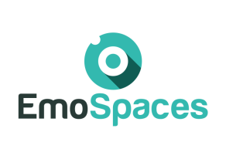

**Figure 1**: ES logo

### ES Website

The ES website is the main promotional tool for publishing research results as well as a dynamic database compiling ES public documents and the scientific, standard, market information relative to the ES context.

The following domain name had been secured from proposal stage and is linked to the same page:

* [www.emospaces.org](http://www.EMOSPACES.org)

## Pathway to exploitation

The aim of this deliverable is to assess the benefit of initiatives that revolutionise the currently used of IT products and services in healthcare, learning, entertainment framework, as a whole, and to distil a strategic approaches to implement a successful common platform.

The focus in this document is on policy, process and organisationally-related aspects of interoperability. A strong underlying assumption is that, to turn initiatives for change into credible, broadly endorsed, and financially sustainable endeavors, approaches need to be considered that win hearts as well as persuade minds.

The methodology used in this deliverable applies desk research and complements with output from dedicated workshops. The desk research comprises policy documents, project documentation, and literature from both academia and practice in relation to change management and incentivisation of organisational interoperability. The workshops represent a powerful tool to reach stakeholders from various disciplines. The stakeholders provide essential input to and validate content on their engagement, business modelling, and incentivisation. The output generated from these workshops has been used to suit the ES perspectives and focus.

While the aim of this deliverable is specific, the resources used to elaborate its work are purposefully broad and multidisciplinary. The intention is to consider perspectives from several different viewpoints so as to remain open to the challenges and solutions from practice in Europe and beyond and to reflect the broad multi-stakeholder perspective in a home scenario.

By mapping these wide-ranging activities onto the Business Model Canvas (see Figure 1), WP6 is mainly concerned with customer segments, customer relationships and channels that could be used from the ES market perspective. An emphasis is, in other words, put on the aspect of value delivery.



**Figure 2. Mapping WP6 onto the Business Model Canvas**

The potential barriers of adoption of the use cases identified were difficulties with liability, confidentiality and ethics. In terms of benefits, it seems that the prime beneficiary in each case is the citizen. However, the actual benefits derived may be societal and also not just financial. Similarly, the incentives used may be linked to professional standards and, again, not be uniquely financial. For example, unifying the patient summary strengthens standards and ease of adoption. It could be important to improve the use of technologies based on user-centered design and characterised by ease-of-use and gamification.

To complete the market scenario a value proposition canvas is used to understand the customers’ needs, and design products and services they want.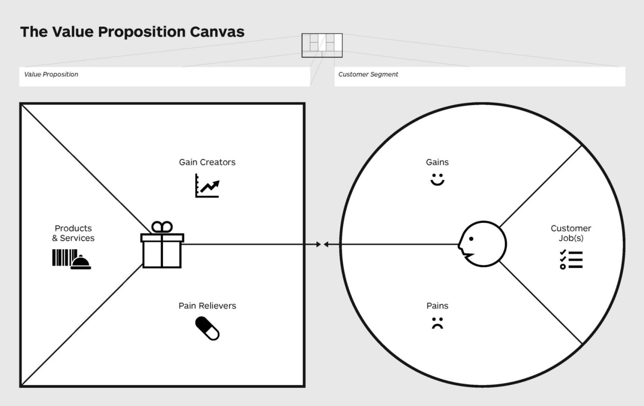

**Figure 3. Value proposition Canvas to use in conjunction with the business model canvas**

# Exploitation Service A1 use case - Wellbeing coaching for elderly people

## Business overview

E-health is a large and constantly evolving business sector composed of heterogeneous activity segments with a wide range of activities from information and wellbeing services to telemedicine services. E-health covers the whole spectrum of activities involved in functional process of healthcare provision such as information, prevention, treatment and patient support.

Below follows a description of the main e-health activity types among all e-health activities.

**EmoSpaces Service for wellbeing coaching diabetes is part of e-health, m-health and quantified-self technologies. However, Service A is not linked to any telemedicine activities covering care treatment.**

mHealth (mobile health) is a general term for the use of mobile phones and other [wireless](http://searchmobilecomputing.techtarget.com/definition/wireless) technology in medical care (e.g. ECG) and coaching services (sport, wellbeing, diet, etc.)

Those are generally characterized by the following functionality:

* Communication between people and care services
* Remote access to information (such as the electronic health record)
* Monitoring and surveillance of patients.

Examples of main actors in France are Withings, B Braun, Medical, Fresenius Care Fusion, Avitum, EMA, Gambro and UmanLife [1].

Quantified self is a movement to incorporate technology into data acquisition on aspects of a person’s daily life in terms of inputs (e.g. food consumed, quality of surrounding air), states (e.g. mood, [arousal](https://en.wikipedia.org/wiki/Skin_conductance), [blood oxygen levels](https://en.wikipedia.org/wiki/Pulse_oximetry)), and performance ([mental](https://en.wikipedia.org/wiki/Cognitive_test) and physical). Such self-monitoring and self-sensing, which combines wearable sensors ([EEG](https://en.wikipedia.org/wiki/Electroencephalogram), [ECG](https://en.wikipedia.org/wiki/Electrocardiogram), video, etc.) and [wearable computing](https://en.wikipedia.org/wiki/Wearable_computing), are also known as [life-logging](https://en.wikipedia.org/wiki/Lifelogging).

The main products and services are:

* Body scales: Ihealth, Withings, Terraillon, Fitbit;
* Physical activity trackers;
* Activity, Heart rate and Breath monitors;
* Blood pressure monitors.

Telemedecine allows health care professionals to evaluate, diagnose and treat patients remotely using telecommunications technology. Telemedicine allows patients in remote locations to access medical expertise quickly, efficiently and without travel.

### Business Model Canvas

As a result of the work of WP1, ES agreed on the use of a reference business use case on the optimal and efficient management of diabetes through interoperable solutions. The reference case consolidates an approach to the two items, Safe Prescribing and Integrated Care, which were found to possess the most immediate relevance and importance to the ES community. The relationship of this reference business use case to its sub-domains is depicted in Figure 4.

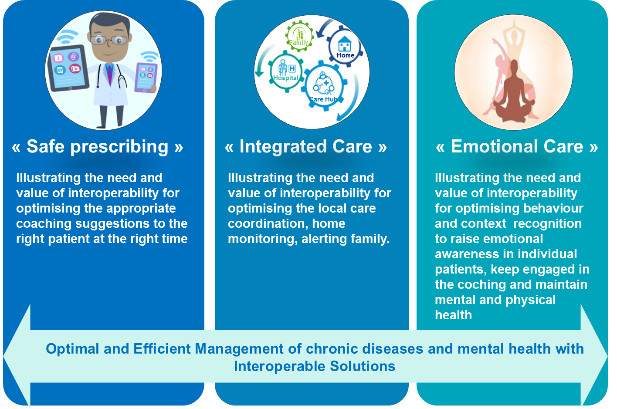

Figure4: EmoService A1: Interconnection of EmoSpaces e-health business use case to its sub-domains

ES has also developed a number of stories and scenarios as a result of having chosen this reference business use case (these are mostly contained in D1.1 and in the upcoming deliverables of WP2 on context and profiling users). The stories related to Jean-Jacques (published in D1.1) comprise and illustrate how the reference case may play out in practice. The case is composed of six scenarios which involve Jean-Jacques, an elderly person that has been diagnosed since a few weeks with type 2 diabetes at an early stage with no dependence on insulin medication. To prevent any future complication and enhance Jean-Jacques lifestile, ES coaching system detects the working and living context of Jean-Jacques, recognizes his behavior and suggest dietary restrictions to keep his weight on control.

While the use case scenarios are each different – in terms of the user’s circumstances – the underlying commonalities are the interoperability assets employed, and products used, by the end-user himself and the service providers supporting him. In the reference business use case, governments, industry, healthcare providers, and patients are all stakeholders who either have considerable influence over and/or interest in the matter at hand. The interoperable services provide recurrent values to these stakeholders.

For example:

* Governments are interested in societal value occurring through patient safety and better treatment outcomes.
* Industry is interested in the economic aspects of the case through the opening up of new markets and the reduction of investment risks resulting from large-scale innovation environments.
* Healthcare providers are spurred on by clinical and ethical values as the quality of life of the patient is likely to improve and the quality of their own work similarly.
* Patients experience added value from the improvements in the quality of their life that results from the enhanced trustworthy and reliable treatment they receive.

Figure 4 represents the Business Model Canvas (BMC) applied to EmoService A1. The BMC describes the rationale of how the main participants to this use case intend to create, deliver, and capture value. Describing the creation of value requires the description of the offering (value offering) and of the customer segment addressed. For this reason Figure 5 shows a value proposition canvas proposing the improvement of the healthcare thanks to a mobile application dedicate to patient affected by a chronic disease.

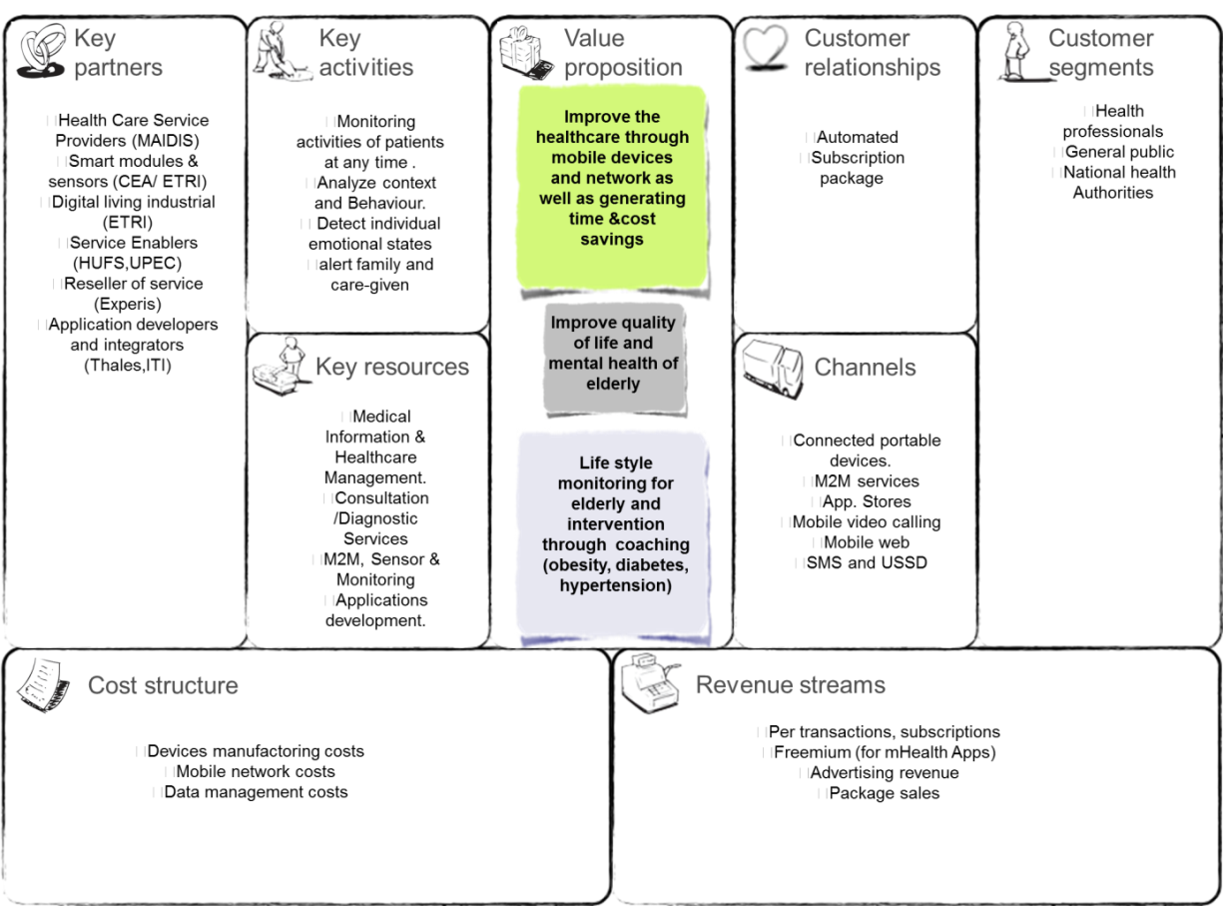

Figure 4. Business Canvas Model applied to EmoService A1

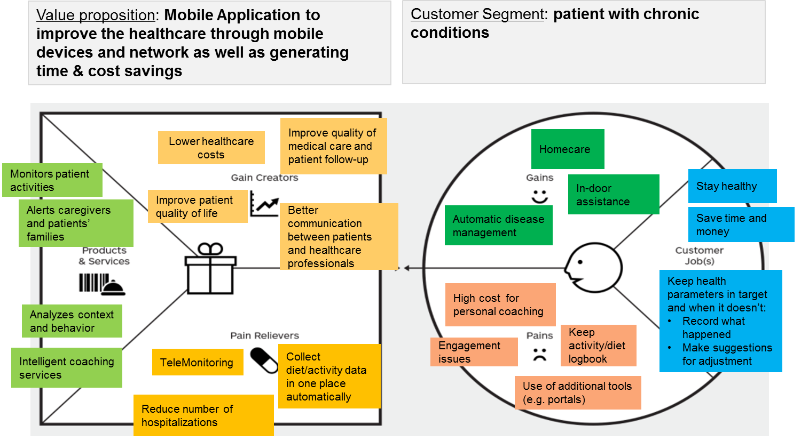

Figure 5. Value Proposition Canvas applied to EmoService A1

### Exploitable results

A list of all the results that may have commercial or industrial applications (e.g. software, inventions, prototypes, compiled information and data, etc.)

Purpose, main features and benefits of each technology or product, derived from the research results: intended audience, innovative aspects in comparison with technologies and products already available, needs for further R&D activity and implied risks, collaboration needs for exploitation (technology transfer activities);

EmoService A1 will create a set of innovative features based on the user behavioral analysis and on the context awareness. During the project a dedicated app (and a patient well-being portal) will be developed with the purpose to provide a customized coaching service for the portal subscribers (or apps buyers).

Currently all the existent applications do not consider sleep, physical activity, emotions and social interaction as part of the disease management.

The following table shows the innovative features that characterize this new application.

#### Innovation positioning of EmoService 1 versus existing technology

|  |  |  |
| --- | --- | --- |
| Service | Features provided by existing technologies | Targeted Innovation of Service A1 |

|  |  |  |
| --- | --- | --- |
| Chronical coaching (as diabete etc.. smartphone applications | All information shall be manually indicated. These applications do not benefit from any automated context awareness. | The targeted innovation is the capability of EmoSpaces to detect the information of context (activities, behaviour, mood) automatically |
| Wellbeing coaching services | The services cover a large range of Wellbeing domains (diet, habits, sleep, sport, social activities, work…) and help **users to track** the daily activities | The targeted innovation is the capability of EmoSpaces to automatically analyse behaviours and **provide coaching services via an AI engine** related to long-term daily monitoring. |
| Quantified-self technology | This technology provides the ability to **monitor vital signs** | The targeted innovation if the capability to **fuse and integrate** this type of data with further information provided by further sensors (cameras, Kinect, fitbit…) and further data analysis to provide an overall context awareness of the user. |

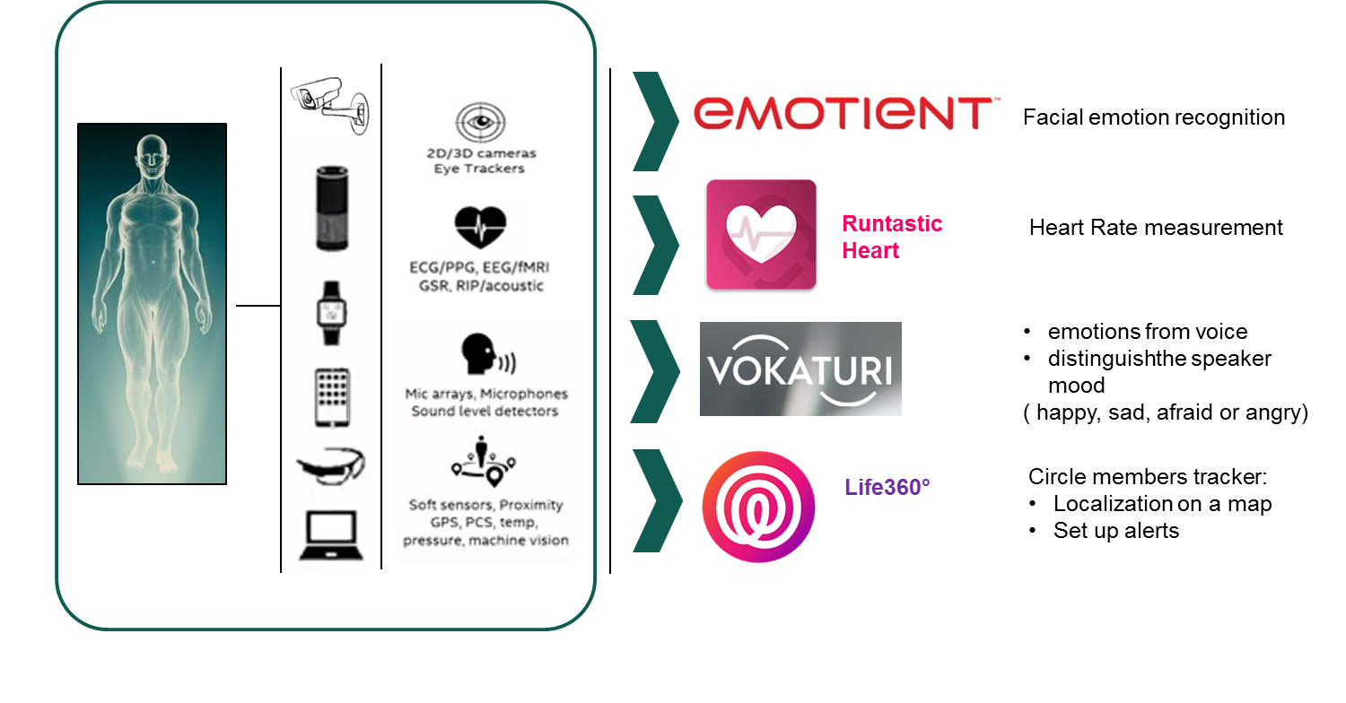

Every day we are surrounding by many devices able to monitor and understanding many personal features as the heart bit, the posture faces gesture locations, the eye tracking etc.. Currently for each of this ability a basic smartphone application is deployed as described in the above figure. Our purpose is to go beyond that, we propose a holistic approach, mixing sensor outputs and developing a new technology building block that knows how you feel, reads human emotion in real time by detecting gesture and posture and understands tour habits and your activities. By combining sensor technology, big data and machine intelligence, Emotion Analytics engines, as describe in the figure below, consumers will be engaged more effectively propelling a new Emotion Economy.

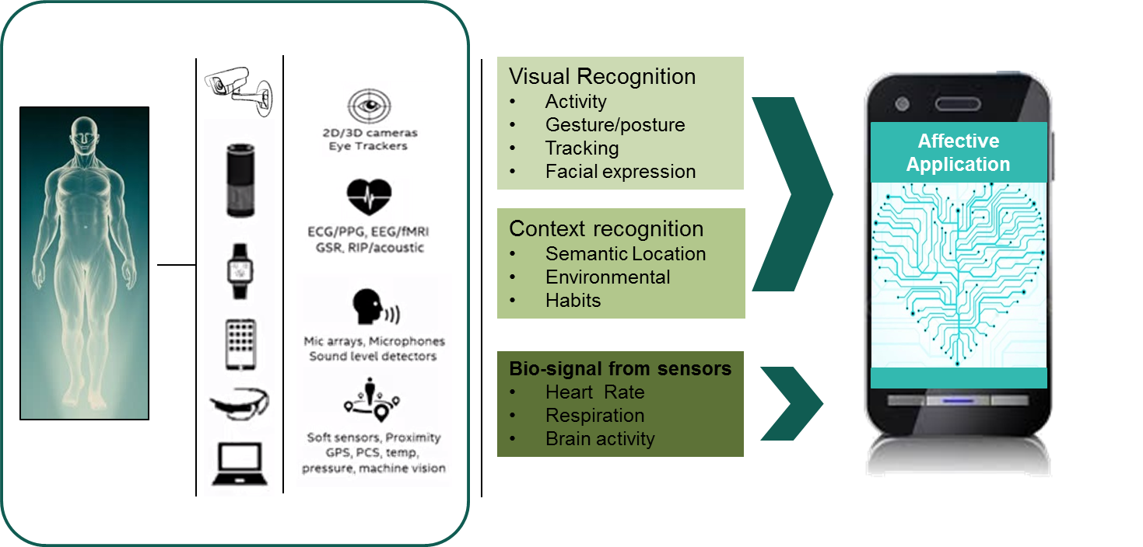

### Market issues

Features of the target market: size, growth rate, share that the technology/product could reach, driving factors likely to change the market, legal, technical and commercial barriers, other technologies likely to emerge in the near future;

The market analysis show that the healthcare and well-being domain faces some larges challenges. Reducing the costs of healthcare and improving the quality of medical care, patient follow-up and more generally the quality of life. One way of doing so is by providing an intelligent coaching support, via an online portal or a mobile device app.

Nowadays, people (and patients) are totally familiar with apps and studies show that 63% of people use 4-10 apps per days1. Consumers (patients) say that apps are convenient and want to use apps with specialized content and saved user information.

Furthermore, Healthcare-related mobile apps are becoming popular at an astonishing speed, as indicated by the fact that 69% of U.S. smartphone owners track at least one health indicator using them 2.

The mHealth apps market was valued at $6.6 Billion in 2013, and is expected to reach 20.7 billion in 2018 at a CAGR of 25.5%3. As consumers are increasingly taking their health into their own hands, we saw the number of health app downloads reached 3.2 billion in 2016, compared to only 1.7 billion in 20134. Additionally, a recent report from New Market Research provided insight from industry exports predicting the global fitness app market to grow at a CAGR of 31.35% during the period 2016-2020.

Among the market’s key drivers: the world’s aging population with its increasing need for medical care. In the United States alone, almost 20 percent of Americans will be older than 65 by 2030, making them more vulnerable to Alzheimer’s, cardiovascular disease, and other age-associated conditions as well as chronic conditions.

1 Source**:** Milward Brown Digital, “The New Mobile Mantra,” 2015

2 Source: [www.pewinternet.org/2013/01/28/tracking-for-health](http://www.pewinternet.org/2013/01/28/tracking-for-health)

3 Source: Research2Guidance

4 Source : <https://www.ama.org/publications/enewsletters/marketing-news-weekly/documents/ama_dom_digitalhealth_052017.pdf>

### Strategy for exploitation

An explanation of how the foreground has been or is going to be used, in either further research or commercial exploitation activities, including elements such as the following:

* how the participant (or other entity) entitled to the technology exploitation is positioned (or should be positioned) in the market, competing businesses/applications/technologies.
* customer detection: identification of the potential customers and the factors that affect their purchasing decisions;
* ...

Maidis vision is to be able to provide an intelligent solution at the heart of the healthcare system supporting the patient wherever he goes during all his life.

Maidis current business model is based on revenues coming from the licenses sold to healthcare facilities, recurrent maintenance fees and implementation services (such as configuration, assistance, and training).

Maidis current revenues all come from healthcare facilities.

We expect our product main benefits to:

Help reduce the costs by managing the patient conditions in a better way, thus preventing patients to go to healthcare facilities too frequently.

Help improve the patient quality of life by delaying the apparition or the aggravation of chronic disease.

Help improve the quality of treatment with access for doctors to more consolidated data gathered outside of the healthcare facilities.

The main beneficiaries are patients (quality of life), healthcare facilities (quality of treatment) and insurance companies (costs).

In our current understanding of the market, patients will rarely pay to use the HapiCare portal and its associated services (monitoring and coaching).

Therefore, Maidis two main customer segments are:

1. Healthcare facilities.

Maidis already has a strong relationship with healthcare facilities that are current clients of the solution. Maidis has presented its solution to a couple of clients and there has been some interests. Maidis has a strong competitive advantage as the only solution able to gather structured data both inside and outside of the healthcare facilities. The business model would be an increase in the annual service fee already paid by the clients.

1. Insurance companies. With current trends in the healthcare domain, insurance companies fear a continuous cost increase in the coming year and are looking for way to reduce those costs. Maidis initiated discussions with some insurance companies and received positive feedback. The business model envisioned in this case would be a monthly subscription fee per patient paid by the insurance companies to Maidis. The insurance company would also provide the necessary connected devices to the patients.

### Intellectual property rights

A verifiable list of all intellectual property rights that have been applied for or registered (e.g. a European patent has been applied for);

All the intellectual property rights belong to MAIDIS.

## Socio-economic impact of the results

### Societal and ethical impact

Concerning the EmoService Well-Being Coaching is an application in the area of digital medicine (E-Health) that allows coaching recommendation considering a remote monitoring of the end-user health parameters, Emotions and daily activities. This application at least partially removes the need for a visit to the doctor’s practice or a local care of the patient by a doctor or care workers. This leads to considerable cost savings and avoids effort and inconvenience. In addition, a complete management of chronic illnesses in enabled, which allows patients to remain independent for longer periods in an environment which is familiar to them.

### Economical impact

# Exploitation Service A2 use case - Wellbeing coaching for social integration

## Business overview

### Business Model Canvas

Due to the characteristics of autistic people, who like routine and get very nervous with unusual activities, there is a need to work the action of waiting and training extraordinary situations. In this way they are prepared to face challenges such as those described in the document example history of D1.1. It explains how an autistic person named Xavier faces a visit to the dentist using the VR simulation and without using it.

Before and after training, the user's emotions are detected. Specialists can adjust the software so that the training is more effective to the person's state. In this way, Emospaces can improve the social integration and daily life of people with autism.

Values ​​provided by the project:

* Bring technology closer to a disadvantaged group.
* Provide a new work tool for specialists.

Provides a solution to a problem for autistic people.

Below is the Business Model Canvas of the A2 service, Social Integration.

|  |  |  |  |  |
| --- | --- | --- | --- | --- |
| **Key Partners** | **Key Activities** | **Value Propositions** | **Customer Relationship** | **Customer Segments** |
| Emotion Research Lab: Emotion recognition with cameras  Astrade: autism association  Iona Lab: marketing activities | Presentation meetings with Astrade: Murcia and Cartagena, September  International Autism Congress in Cartagena: paper presentation   Demonstration with association families | Improving quality of life and social integration of users. Reducing stress of unusual situations like a dentist visit or having a haircut. | Satisfaction polls, scenes feedback and suggestions made by customers for new scenes. | Associations and families with members with Autism, Down Syndrome, Cerebral palsy or Alzheimer |
|
|
|
|
| **Key Resources** | | **Channels** |
| VR software and experienced developers. Development made with mental health specialists help | | Private and public demonstrations in Murcia and Cartagena.  Scientific articles via ASTRADE Cathedra in the University of Murcia.  Social media and institutions |
|
| **Cost Structure** | **Revenue Streams** | | | |
| Developers costs VR devices and computer VR ready Marketing and demonstrations | Software sales, subscription and new scenes development by demand | | | |
|
|
|
|
|

Among the possible interested are:

* Families of people with autism.
* Associations
* Health System
* Regional or national governments.

At this moment we have developed 2 different scenes, a visit to the dentist and another to the hairdresser. These scenes have been tested by autistic children with very good results.

### Exploitable results

The result of the project is a mobile VR application that can be downloaded for both Android and iOS and that will be able to configure and reproduce 3D scenarios. The basic application has 3 scenarios: a visit to the dentist, go to the hairdresser and wait for the bus in a noisy street. This pack will include a module so that another device can connect to the application and can see in real time what the user sees and even modify some parameter in real time.

The objective is to develop more scenarios that cover a broad spectrum of situations. These new scenarios will be downloaded as modules and can be acquired from the basic application

Currently there are Virtual Reality tools, aimed at specialists, so they can offer therapies for phobias. On the other hand, VR is also being used with autistic people with the aim of improving their social relationships and their interaction with other people. In our case, the objective is that they can anticipate situations that need to be carried out and, in addition, they can work the waiting times that occur in them. In this way, when they go to perform the activity, they will know what is going to happen and what they should wait for their turn or when the activity ends.

### Market issues

Some important data:

* Autism Prevalence Now 1 In 59 Rate Increases 15% In 2 Years. Boys are 4.5 times more likely than girls to have autism[1]
* ASD is estimated to affect more than 3 million individuals in the U.S.
* Autism is the fastest-growing serious developmental disability in the U.S.
* Autism costs the nation over $238 billion per year, a figure expected to significantly increase in the next decade
* Autism receives approximately 5% of the government research funding of many less prevalent childhood diseases
* While there is no medical detection or known cure for autism, thousands of children have shown significant improvement resulting from early diagnosis and use of effective interventions[2]
* Countries with the highest rate of Autism[3]:

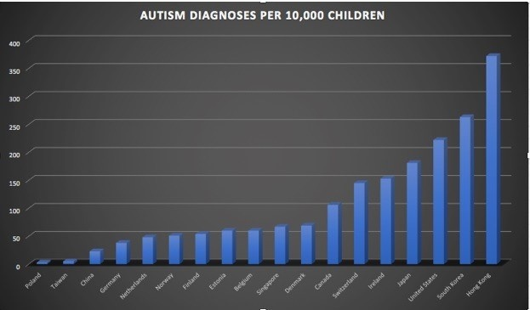

* Target market:

**In our region, Murcia:**

* Autism Federation of Región de Murcia:



1. Astrade[4]: main association formed by more than 550 families spread throughout the region. They have the Astrade Chair at the University of Murcia in Autism and Generalized Development Disorder.
2. Aspermur: 150 families associated. <http://aspermur.org>
3. Asteamur: serves more than 250 people. <http://www.asteamur.org/>
4. Abamur: <http://abamur.org>. Association that works the education of autistic children from the ABA methodology:
   * Analysis: Progress is assessed from the interventions recorded and measures in their progress.
   * Behavior: Based on scientific principles of behavior.
   * Applied: Principles applied in observed behaviors.
5. TEA Yecla: ASD association from Yecla.
6. TEA-Ayuda Caravaca: ASD association from Caravaca.

* More:
* AFAPADE: http://www.afapade.org/

**In Spain :**

* Autismo España: State Confederation with 77 associations, declared Entity of Public Utility by the Ministry of the Interior. http://www.autismo.org.es/
* Spanish Confederation of Autism (FESPAU): 25 associations http://www.fespau.es/
* Autism Professionals Spanish (AETAPI):
* They organize national and international congresses, such as Cartagena in November. http://aetapi.org/
* Fundation Autismo Diario: they do advice and dissemination work with a very active digital media. <https://autismodiario.org/>
* Asperger España Confederation: 26 associations and confederations in the country

The application of VR technology in the cognitive development of people with ASD is a very new field with little research. Our software helps users to face unusual situations in their daily lives and we are getting very good results. ASTRADEspecialists have said that it is a very interesting tool to work with.

Technical barriers:

* It is possible that not all autistic people are predisposed to use VR technology. For now, the current tests have been positive, much more than what the specialists thought.
* We need the communication channels to work so that they reach the target audience.
* User helpers need to see what is going on in the scene, using an external device connected with the application.

Commercial barriers:

* VR technology is not very usual, and users can be afraid about the risks and cost.
* VR glasses are unknown for people that are not familiar with technology. They don’t know where the glasses can be bought or how to use it.
* Not all mobile devices are VR ready. Users need to have a smart phone with gyroscope and enough power to run the application.

Driving factors to change the market:

* The prices of VR equipment are decreasing, and this can lead to greater access by potential users
* VR mobile applications are growing up.

### Strategy for exploitation

VirTEA is aimed at families with members with ASD who wish to work with them waiting and anticipation in situations that often cause anxiety and stress, such as going to the dentist, to the hairdresser, waiting for the bus in the street, visit to the emergency room, etc. VirTEA can also be used in associations of people with ASD, schools and any entity that wants to collaborate or is willing to participate and apply Virtual Reality techniques in their learning and training programs with ASD people.

According to the latest studies, approximately 1% of the population has autism. Therefore, in Spain there are 400,000 people with ASD, of which 67,000 are children of school age (under 16).

VirTEA's competitive strategy combines a strategy of differentiation, focus and price. Today, there are many applications on the market aimed at treating fears and phobias in people suffering from this type of disorder. VirTEA goes one step further by focusing on the group of people with ASD. Our differentiation is not based on a single characteristic, but on a set of them. On the one hand, VirTEA is a tool that helps to work the anticipation and waiting for people with ASD, being a complement to the work that is usually done with pictograms. On the other hand, we have the supervision and support of several associations and groups for the development of the tool, among which are Astrade and EOEP (both from Murcia). In addition, VirTEA is not only designed for specialists to work with, but it is the parents themselves who make use of it with their children. Finally, its competitive price makes it unique. VirTEA can be purchased for € 9.99 (three scenes). Additionally, new scenes can be downloaded at the price of € 4.99.

### Intellectual property rights

All the intellectual property rights of VirTEA belong to Answare-Tech S.L. We have already registered the brand.

## Socio-economic impact of the results

### Societal and ethical impact

Today the Autism Spectrum Disorder affects a large number of people in the world (1 in 68 people), being a group that needs more attention from the Society, Public Administrations and also from companies . The early detection of this disorder at an early age is causing an increasing number of identified cases. A family with a child with ASD can spend more than one thousand euros a month in Catalonia in specialized therapy, pharmacy, physiotherapy, special diet and even diapers, in large part due to the lack of support and resources of the Generalitat administration, according to data from the Catalan Federation of Autism. On the other hand, Virtual Reality is becoming closer, and can be accessible even on your smartphone.

Families of people with ASD lack agile tools that allow them to remedy or reduce the stress they suffer in certain situations. VirTEA is a tool designed so that families can work with their children with ASD in anticipation and waiting. This will require an important degree of involvement of families in the education of their children with special needs. It is also necessary that these families are familiar with the use of new information and communication technologies. Taking into account all these aspects, the benefits that VirTEA provides are:

1 / Prepares and improves the behavior of the child / adult with ASD in the face of new situations that go beyond their usual routine in a simple and enjoyable way for them.

2 / Reduce the fear or stress of the child / adult with ASD when exposed to a situation that may cause fear or discomfort.

3 / Improve the quality of life of people with ASD and their families. People with ASD suffer less from changes in their routine once they have overcome situations that generate stress.

### Economical impact

The sales strategy consists of attacking in the first instance the market of the Region of Murcia (there are 3,800 students with ASD in the Region apart from people with ASD in adulthood). Answare attended the XXXIII International Autism Congress that took place in Cartagena in November 2,018. There we were able to teach VirTEA to assistants who came from all parts of Spain and from outside of Spain.

There are real possibilities to sell VirTEA in other markets outside of Spain such as Latin America, where we have a professional in the field of video games that will help us during the launch and sale of VirTEA in Uruguay and Brazil. Although the use of VirTEA is not associated with a particular language, it is true that the deployment of VirTEA in Spanish-speaking countries will be the most natural. After the launch of VirTEA in Latin America, it will open to the European market.

# Exploitation Service B use case - Sound optimization

## Business overview

The second domain application for the EmoSpaces project is focused on sound. Our goal in EmoService B is to enhance the perception of sounds by the End-user when he/she is at home listening to music on the HiFi or listening to the radio, or watching television, or on the phone, or with a tablet or using any device that generates sounds.

We address 3 types of sound optimizations:

* Optimization of the sound rendering of the sound source (the device that generates sound), such as radio, television, mobile phone, tablet and HiFi loudspeakers.
* Optimization depending on the content: speech/ music, energetic/calm, rich/light…
* Optimization depending on the preferences and the audition capacity of the listener

### Business Model Canvas

The figure below represents the Business Model Canvas (BMC) applied to EmoService B. The BMC describes the rationale of how the main participants to this use case intend to create, deliver, and capture value. Describing the creation of value requires the description of the offering (value offering) and of the customer segment addressed. Instead thevalue proposition canvas Cleary explain the user requirement and the gain that our product produce.

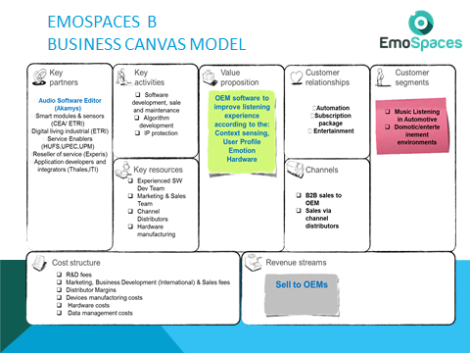

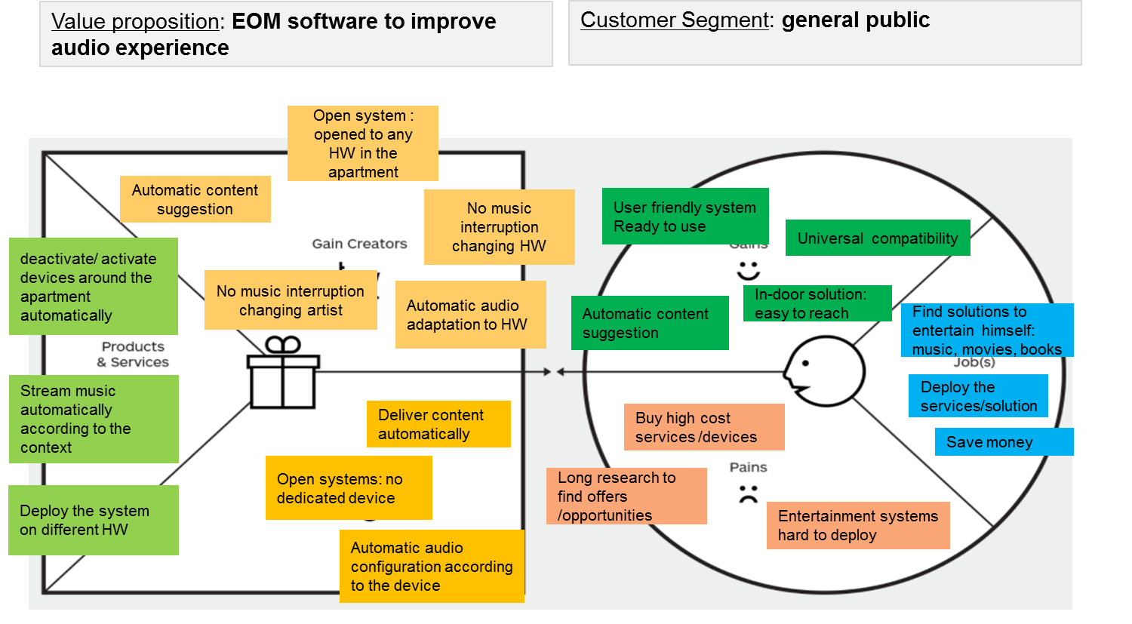

### Exploitable results

A list of all the results that may have commercial or industrial applications (e.g. software, inventions, prototypes, compiled information and data, etc.)

Purpose, main features and benefits of each technology or product, derived from the research results: intended audience, innovative aspects in comparison with technologies and products already available, needs for further R&D activity and implied risks, collaboration needs for exploitation (technology transfer activities);

The idea behind the EmoService B is to mix three different technologies together in to an innovative OEM (cf. table below) taking in the account innovative features based on the user behavioral analysis and on the context awareness. The software will mix:

The Emospaces Service B on music content streaming combines the capabilities of:

* a multi room audio streaming systems that streams music automatically around different rooms according to the End-user localization
* an intelligent music player that learns user-habits and preferences.
* a mood smart phone application abilities to recognize user moods and stream music according to the user feelings.

Described in the figure below.

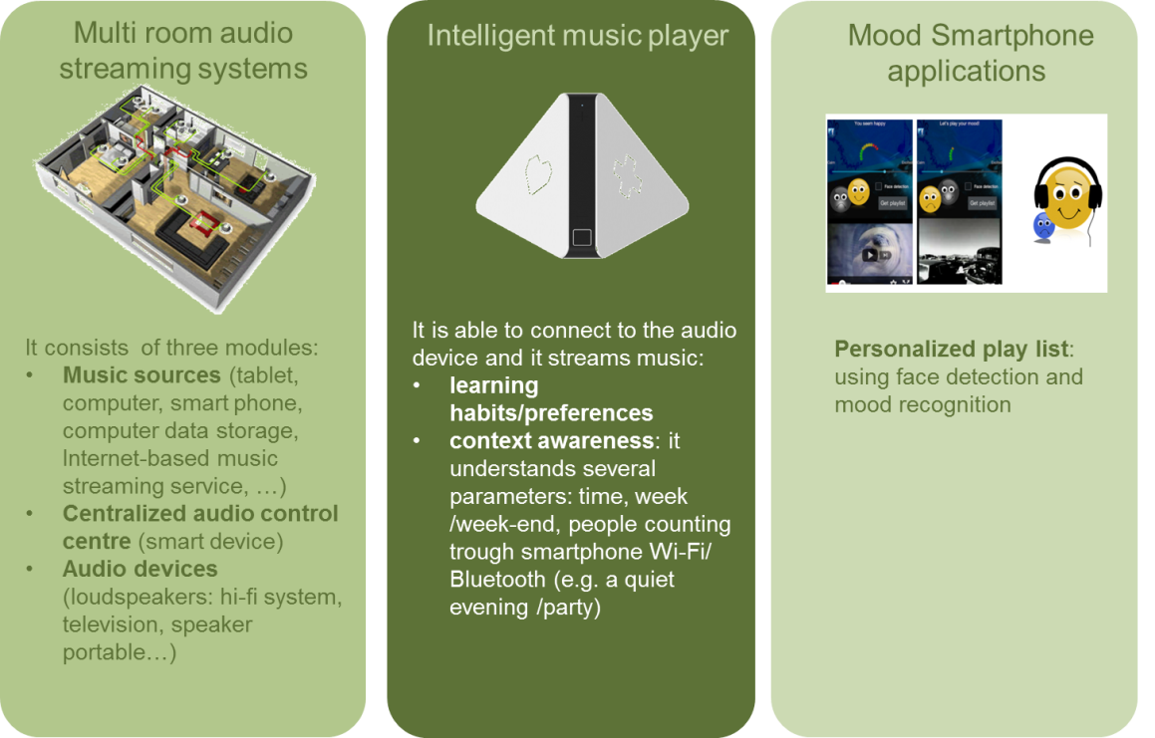

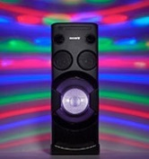

**EmoSpaces Service B**

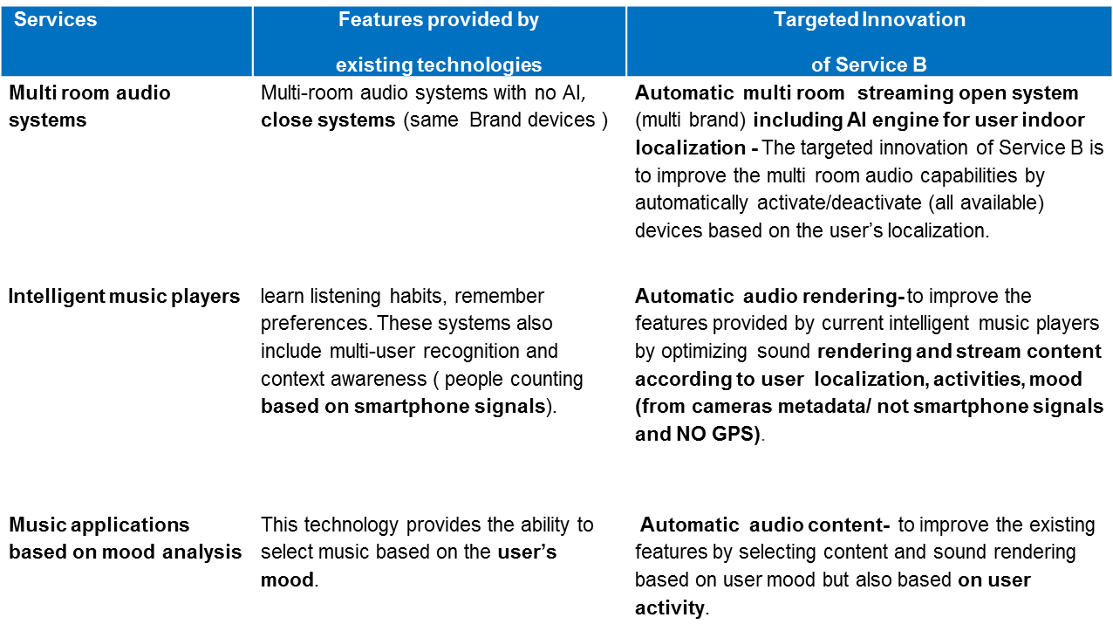

### Market issues

Features of the target market: size, growth rate, share that the technology/product could reach, driving factors likely to change the market, legal, technical and commercial barriers, other technologies likely to emerge in the near future;

The total voice controlled smart speaker unit shipments are expected to increase from around 10 million to approximately 80 million, between 2017 and 2022, globally (TAM). This includes market segments: voice controlled room speakers, portable/battery powered speakers, sound bars and wireless multi-room speakers.

In this context, the targeted product is an audio software program managing the audio content / audio effect (not the speaker hardware), reaching in 2020 750k€ as the addressable market (SOM).

### Strategy for exploitation

An explanation of how the foreground has been or is going to be used, in either further research or commercial exploitation activities, including elements such as the following:

* how the participant (or other entity) entitled to the technology exploitation is positioned (or should be positioned) in the market, competing businesses/applications/technologies.
* customer detection: identification of the potential customers and the factors that affect their purchasing decisions;
* ...

After the rearrangement of the company, Arkamys provides a refined value proposition canvas . New strategies to reach the market are currently under exploration.

We identify as potential customers, interested to embed the EOM developed during the EmoSpaces project:

• Renesas Japanese leader in embedded design of innovative application

• Thales for the application on In Flight Entertainment system

• Hunday in the automotive domain, to deliver audio content automatically.Intellectual property rights

### Intellectual property rights

A verifiable list of all intellectual property rights that have been applied for or registered (e.g. a European patent has been applied for);

All the intellectual property rights belong to Arkamys.

### 

# Exploitation Service D use case – E Learning market

## Business overview

### Business Model Canvas

Business Model Canvas (BMC) was used to design the business model for the E-Learning use case. As a result, the following Figure illustrates how this EmoService aims to capture, create and ultimately add value to the stakeholders involved.

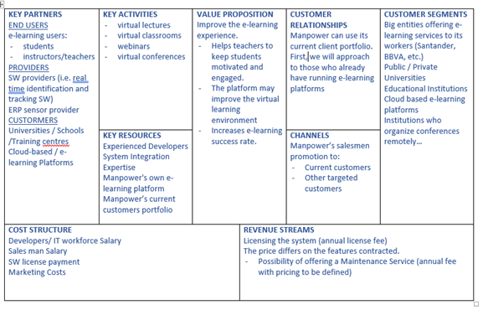

Figure 5. Bussines Canvas applied to EmoService D – E-Learning

### Exploitable results

Companies play a key role in the growth of e-learning. More and more are embracing this type of education. More than 41% of the Fortune 500 corporations (the 500 largest companies in the US with capital open to any investor according to their sales volume) are using some technological tool to offer e-learning training to their employees. On the other hand, a survey conducted by Ambient Insight concluded that e-learning has increased revenues in 42% of companies [1] .. Therefore, those companies that offer training to their employees would be large EmoSpace customers, as they not only offer a flexible and interactive education, but also offer a personalized training based on the emotions of the workers, which can lead to an increase in their performance.

In Spain, the culture of Continuing Education as an integral part of their business policy and strategy is implemented in 80% of companies. Many companies are investing large amounts of resources to improve their methodologies and are actively looking for customized and personalized training systems that will help them to stand out.

For this reason, these companies are large potential EmoSpace clients who can clearly benefit from the added value offered by this EmoService.

Below, in Table 1, are the main companies that could be potential EmoSpaces clients due to their current training programs.

### Market issues

The term e-learning refers to the remote online distance training mediated by information and communication, providing flexibility, personalization, interactivity and cooperation to the process.

E-learning is one of the fastest growing industries worldwide. Since 2000, the e-learning market has grown by 900%. Therefore, it can be established that the e-learning market trend is in full growth and will continue to grow rapidly. If in 2011 the e-learning reached the figure of 35,600 million dollars, by 2020 it is expected to double to 68,800 million dollars, with an annual growth rate of 7.6% until 2020. There are different studies that explain the great growth that this new teaching modality is experiencing:

* While face-to-face learning has a retention rate of 8% to 10%, e-learning increases retention rates by up to 60%.
* Online training requires 40% to 60% less time than face-to-face training.
* The participants of an e-learning course would learn five times more without increasing the time spent in training.

|  |  |
| --- | --- |
|  |  |
| Telefónica | The Telefonica group invests a large part of its capital in the development and implementation of e-learning for its platform |
| Unión FENOSA | Education is carried out through Unión Fenosa Corporate University. |
| Telefónica Móviles | It uses e-learning for the training of its employees and is characterized by offering an education oriented to give quick answers for very specific needs. |
| Banco Santander | The Santander bank is committed to an online education through the virtual channel Form @ via. |
| IBM | In IBM, face-to-face and online courses are alternated, depending on the content of the course. |
| Caixa Galicia | Through the business technology institute (ITE), it manages a large part of educational programs aimed at all its workers. |
| Siemens | Through the e-people portal, it offers customized e-learning training for each worker. |
| Asociación Nacional de Centros de e-Learning y Distancia (ANCED) | The ANCED can be a great client for EMOSPACES because it is the main business organization of national scope that integrates the most important private centers of e-learning and distance education. Its purpose is the representation, management and defense of the common interests of its associates, as well as the promotion and development of teaching in the modalities of tele-training and distance in all areas, both business and private |

Table 1 : EmoSpace potential customers

On the other hand, teaching centers would be another key client for EmoSpaces, since there has been a great increase in the centers that provide courses, masters and university degrees in recent years. The choice of this new form of education can solve many of today's educational problems. Therefore, EmoSpaces is a great opportunity for schools to develop new markets and increase their profitability, as more and more students demand personalized and flexible education. In addition, Spain is also committed to this new form of education, there are already 1300 institutes and universities that use the Moodle tool (virtual learning environment). Below are some of the educational centers that have bet for this modality and that they would be potential clients for EmoSpaces.

|  |  |
| --- | --- |
|  | |
| Universidad de Málaga | Universidad Politécnica de Madrid |
| Universidad de Las Palmas de Gran Canaria | Universidad Politécnica de Cataluña |
| Universidad de Cádiz | Universidad Rey Juan Carlos |
| Universidad de Extremadura | Universidad Carlos III |

EmoSpaces can also provide pedagogical tools for students with learning difficulties or any kind of disability or disorder, meaning that the platform can also be marketed as a complementary therapy. A potential group, for example, would be children with autism, who have demonstrated special facilities, preferences, and abilities to interact through computers or other devices. In this type of patient, learning based on individual’s emotions will be especially appropriate. To reach this type of user, EmoSpaces can be marketed through associations and research centers, or directly to end users and patients. The main autism associations in Spain have been identified with the aim of showing them EmoSpaces as a complementary therapy for their patients.

### Strategy for exploitation

The exploitation strategy involves marketing the product by access, either to the platform with monthly/annual registration or through courses where a student can have access to his or her classes. In addition, companies will be able to contract access to the training space in order to insert courses and offer the benefits of this system.

The added value in terms of exploitation of an emotion-oriented e-learning platform resides in the ability to collect anonymous data and trace a behaviour thanks to BigData analytics, where interesting conclusions can be drawn thereby enabling the platform to grow and anticipate problems or provide solutions based on data.

### Intellectual property rights

The large number of sensors and services offered by EMOSPACE, as well as the data collected, lead to the need for establishing a reliable framework that allows platform users to trust in the information and services provided. Therefore, the most relevant legal aspects have been considered and will be permanently present during the development and design of this project in order to guarantee the maximum care and privacy in the treatment of users’ personal data.

On the other hand, thanks to the development of procedures such as data anonymization and PbD, it will be guaranteed that all users can rely on EmoSpace and maintain a certain power of control over their own data and the associated lifecycle.

The anonymization techniques of EMOSPACES will be based on these six essential strategic axes:

* Use of algorithms that generate a fingerprint that prevents the reconstruction of the original data (known as "hash algorithm")
* Implantation of encryption algorithms with homomorphic properties that optimize the treatment of the data.
* Use of the time stamp that guarantees the date and time when the anonymization has been carried out.
* Use of anonymization layers that reinforce the masking of the data before third parties.
* Disruption of data through its variation and systematic suspension, thus preventing the resulting figures from providing information on specific cases.
* Reduction of the number of original data by minimizing its level of detail without altering them and thus avoiding the presence of unique or atypical data without relevance to the final result.

## Socio-economic impact of the results

### Societal and ethical impact

The social vision of e-learning is part of the common denominator of the company’s commitment to transforming society. The dichotomous vision of training practices (real world/world of ideas) can be reconstructed based on the involvement of companies and universities in transformational processes. To break with this binary ontology, a human approach is necessary, and that is why we believe that it is not possible to develop training models based on e-learning that turn their backs on its social dimension. The integration of citizens in the information society is one of the priority objectives of the New Social Inclusion Strategy of the European Union. This priority follows from the proposal established in the eEurope action plan. There it is stated that "integration in the information society is one of the first objectives of the new strategy for social inclusion, which pivots on the two dimensions".

It is about fully exploiting the potential of the information society and the new technologies of training and communication, ensuring that no one is left out. Digital exclusion often has a cumulative effect: those subjects who suffer a situation of social exclusion they also suffer from digital exclusion, and in this way, they are placed in the Context of the two E (social exclusion and digital exclusion). As several experts suggests: «We found many groups with significant deficiencies in the information society and the use of technologies (informational); In addition, there are low levels of qualification in basic skills for information management (insufficient level of literacy) and in general lack of tools for learning, especially in an autonomous environment (self-training). This social dimension of e-learning must necessarily contemplate the prevention of double exclusion.

### Economical impact

A study conducted by Brandon Hall (http://www.brandonhall.com/), indicates that online training requires 40 to 60% less time than face-to-face training, using the same content. This is thanks to the fact that it can be done asynchronously, at the time and in the time when the user deems it convenient, so that the workday is not interrupted.

E-learning increases knowledge retention rates by up to 60% The Research Institute of America has stated that e-learning increases knowledge retention rates by up to 60%, while face-to-face learning retention rates are low, on average from 8% to 10%.

The same study indicates that participants of an e-learning course learn five times more without increasing the time spent in training. More than 41% of the Fortune 500 corporations (the 500 largest US companies with capital open to any investor according to their sales volume) are using some technological tool to offer e-learning training to their workers. According to data from elearningindustry.com portal, they estimate that e-Learning will grow around 24% in the Spanish-speaking markets of Spain and Latin America during 2017. A large part of the companies surveyed by Ambien Insight, says that knowledge translates into higher revenues: 42% of companies say that online learning has led to increased income.

# Contribution to standards or policy developments of the EmoSpaces platform

|  |  |  |  |  |  |  |  |
| --- | --- | --- | --- | --- | --- | --- | --- |
| **No** | **Standardisation body** | **Document Number** | **Standardization Tite** | **Date** | **Afiliation(s)** | **Remarks on standardization** | **Project Year** |
| 1 | ITU-T SG 20 | COM 20-C 299R1-E | Poposal of revision of Draft Recommendation of Y.sfem-WoO (Service Framework of Web of Obejects for Energy Efficiency Management) | 27 June - 8 July 2017 | HUFS | Web of Objects (WoO) framework application for enerngy effciency management | 1st Year |
| 2 | ITU-T SG 13 | T17- SG13-C 0179 | A proposal of revised text of Draft Recommendation Y.fsul | 2 -17 June 2017 | HUFS | Web of Objects (WoO) frameork application for ubiquitous self-directed learning | 1st Year |
| 3 | ITU-T SG 13 | T17-SG13-C 0188 | New appendix in Y,fsul: Appendix VI: Kowledge creation model in Web objects enabled uSDL. | 16-23 Jan 2017 | HUFS | Web of Objects (WoO) based knowledge creationn for ubiquitous self-directed learning | 1st Year |
| 4 | ITU-T SG 16 | T17- SG16-C 125R1 | A proposal for a new appendix on "A creation of my virtual space for WSAS in WVHN". | 16-23 Jan 2017 | HUFS | WSAS (WoO based Smart Ageing Service) in Virtual Home Network (VHN) | 1st Year |
| 5 | ITU-T SG 16 | T17- SG16-C 125R1 | A proposal for a new appendix on "Smart Recommender system for WSAS in WVHN". | 16-23 Jan 2017 | HUFS | Web of Objects (WoO)based smart recommenfding service for WSAS (WoO based Smart Ageing Service) in Virtual Home Network (VHN) | 1st Year |
| 6 | ITU-T SG 13 | ITU-T Y.4452 | Functional framework of web of objects | September, 2016 | HUFS | The ITU-T Y.4452 has been approved and published by ITU-T with In International Standard. | 1st Year |
| 7 | W3C |  | Recommendation. Linked Data Model for Sentiment and Emotion Analysis (Marl and Onyx) | Dec 2017 | UPM | Initial version in W3C Community group | 2nd Year |
| 9 | IEEE | IEEE P7007 | Ontological Standard for Ethically Driven Robotics and Automation Systems | 2017-2022 | UPEC | Work is still preliminary | 2nd Year |
| 9 | ITU-T SG 13 | ITU-T Y..2241 | **International Standard:** Service framework to support web objects based ubiquitous Self-Directed Learning (uDL) | Sept. 2017 | HUFS | The ITU-T Y.2241 has been approved and published by ITU-T with In International Standard. | 2nd Year |
| 10 | ITU-D FG-DPM | FG-DPM-I-082 | Framework to support data interoperability in IoT environments | 20-25 October 2017 | HUFS | Under development.This new draft TR has been proposed to specify a framework to support data interoperability in IoT environments. | 2nd Year |
| 11 | ITU-D FG-DPM | FG-DPM-I-083 | New text for clause 6 of D3.3 (Framework to support data interoperability in IoT environments) | 20-25 October 2017 | HUFS | Under development. Considering different aspects of data interoperability in IoT environment, this proposes relevant items of data conversion and transformation to support data interoperability. | 2nd Year |
| 12 | ITU-D FG-DPM | FG-DPM-I-084 | New proposal for clause XX of D3.3 (Framework to support data interoperability in IoT environments) | 20-25 October 2017 | HUFS | Under development. This introduces reference model and functional capabilities of Web of Objects (WoO) as an efficient platform that supports data interoperability. | 2nd Year |
| 13 | ITU-T SG 20 | Q4-20-Jan18-C-24 | A revised text of Y.WoO-hnbased on TD 329 drafted at the Q4/20 rapporteur meeting, Geneva, 20-28 July 2017 | 15-24 January 2018 | HUFS | This contribution proposes the revised text of the draft Recommendation Y.WoO-hn "Service architecture and capability in web of objects based virtual home network”. | 2nd Year |
| 14 | ITU-T SG 20 | Q4-20-Jan18-C-24 | Proposal of revised text of Appendix II of Y.WoO-hn: Situation awareness function in WVHN | 15-24 January 2018 | HUFS | Under development. The text of Appendix II (Situation awareness function in WVHN) of the draft Recommendation Y.WoO-hn | 2nd Year |

1. <https://tacanow.org/news/autism-prevalence-now-1-in-59-rate-increases-15-in-2-years/>)
2. <https://tacanow.org/autism-statistics/>
3. <https://www.quora.com/What-are-the-autism-rates-in-Europe>
4. Astrade is one of the main assotiations for ASD people in Murcia. <http://www.astrade.es/>