

|  |
| --- |
| ITEA3 Call 2 Project #15032 |

**eWatch**

Deliverable

D2.3 – State of the Art

|  |  |
| --- | --- |
| Editor | Ernst Hermens and PMT |
| Version | 1.0 |
| Submission Date | 28.02.2019 |
| Visibility |  |
| Special Remark by Project Coordinator | The SotA was already prepared in 22 Feb 2018 as a separate section inside Market & Technology Overview Deliverable, because our decision as PMT and the consortium was having a single deliverable which reflects both the market analysis and the SotA. However the suggestions of the ITEA STG has been taken into account and the SotA content has been moved to a separate deliverable.(Isil Ozkan) |

Table of Contents

1 PURPOSE 2

2 EXECUTIVE SUMMARY 2

2.1 Introduction 2

3 Technology overview 3

3.1 Sensor technologies 3

3.1.1 Pulse Oximetry 3

3.1.2 Photoplethysmography 6

3.1.3 Accelerometer 8

3.1.4 Camera 12

3.1.5 Location & posture tracking 13

3.1.6 Posture Tracking 18

3.2 Platform technologies 20

3.2.1 Gateway technologies 20

3.2.2 Cloud technologies 23

3.2.3 Communication technologies and security 27

3.3 Analytics technologies 31

3.3.1 Intelligent IoT systems 32

3.3.2 Signal processing and feature extraction 32

3.3.3 Machine learning and decision support 33

4 CONCLUSIONS 34

# PURPOSE

The deliverable D2.3 provides the SotA the project. With this overview this deliverable provides the background and baseline for the eWATCH project activities.

# EXECUTIVE SUMMARY

## Introduction

This deliverable provides a SotA for a technology overview of the sensor, platform and analytics technologies.

# Technology overview

## Sensor technologies

In the eWATCH project some different sensor technologies will be used and further developed. An overview of these technologies is provided below.

### Pulse Oximetry

For people with COPD, asthma, Congestive Heart Failure (CHF) and other conditions, pulse oximetry is a technology used to measure the oxygen level in your blood and your heart rate.Pulse oximetry is a non-invasive method for monitoring a person's oxygen saturation (SO2). Though its reading of SpO2 (peripheral oxygen saturation) is not always identical to the more desirable reading of SaO2 (arterial oxygen saturation) from arterial blood gas analysis, the two are correlated well enough that the safe, convenient, non-invasive, inexpensive pulse oximetry method is valuable for measuring oxygen saturation in clinical use.

Working Principle of Pulse Oximetry  
The principle of pulse oximetry is based on the red and infrared light absorption characteristics of oxygenated and deoxygenated hemoglobin. Oxygenated hemoglobin absorbs more infrared light and allows more red light to pass through. Deoxygenated (or reduced) hemoglobin absorbs more red light and allows more infrared light to pass through. Red light is in the 600-750 nm wavelength light band. Infrared light is in the 850-1000 nm wavelength light band.

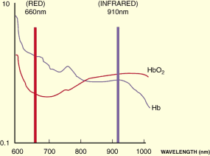

Fig1. Wavelength

How Pulse Oximetry Works  
There are two methods of sending light through the measuring site: transmission and reflectance. In the transmission method, as shown in the figure on the previous page, the emitter and photodetector are opposite of each other with the measuring site in-between. The light can then pass through the site. In the reflectance method, the emitter and photodetector are next to each other on top the measuring site. The light bounces from the emitter to the detector across the site. The transmission method is the most common type used and for this discussion the transmission method will be implied.

After the transmitted red (R) and infrared (IR) signals pass through the measuring site and are received at the photodetector, the R/IR ratio is calculated. The R/IR is compared to a "look-up" table (made up of empirical formulas) that convert the ratio to an SpO2 value. Most manufacturers have their own look-up tables based on calibration curves derived from healthy subjects at various SpO2 levels. Typically a R/IR ratio of 0.5 equates to approximately 100% SpO2, a ratio of 1.0 to approximately 82% SpO2, while a ratio of 2.0 equates to 0% SpO2.

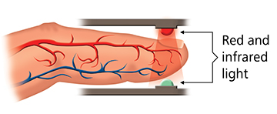

Fig2. Pulse Oximetry Working Principle

Accuracy of Oximeter  
Accuracy of Oximeter has been tested in various scientific Works. Accuracy can be depended on so many factors. Such as measuring device, health situation of patient ant etc.

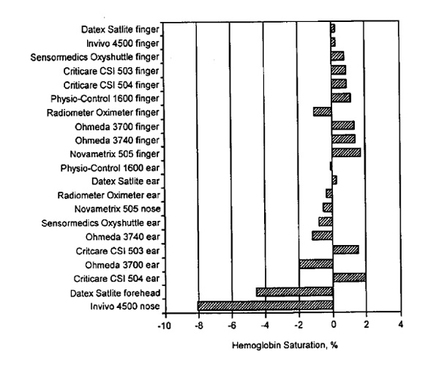

Fig3. Hemoglobin Saturation With Different Devices

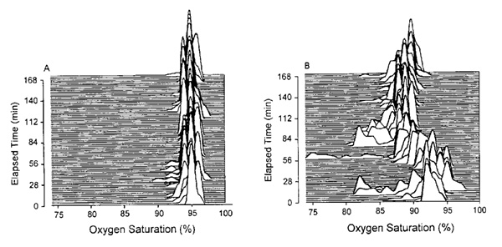

Fig4. Oxygen Saturation For Different Patients

Most Common Using Fields  
The purpose of pulse oximetry is to check how well your heart is pumping oxygen through your body.

It may be used to monitor the health of individuals with any type of condition that can affect blood oxygen levels, especially while they’re in the hospital. These conditions include:

* chronic obstructive pulmonary disease (COPD)
* asthma
* pneumonia
* lung cancer
* anemia
* heart attack or heart failure
* congenital heart defects

There are a number of different common use cases for pulse oximetry, including:

* to assess how well a new lung medication is working
* to evaluate whether someone needs help breathing
* to evaluate how helpful a ventilator is
* to monitor oxygen levels during or after surgical procedures that require sedation
* to determine how effective supplemental oxygen therapy is, especially when treatment is new
* to assess someone’s ability to tolerate increased physical activity
* to evaluate whether someone momentarily stops breathing while sleeping — like in cases of sleep apnea — during a sleep study

### Photoplethysmography

Photoplethysmography (PPG) is a simple optical technique used to detect volumetric changes in blood in peripheral circulation. It is a low cost and non-invasive method that makes measurements at the surface of the skin. The technique provides valuable information related to our cardiovascular system. Recent advances in technology has revived interest in this technique, which is widely used in clinical physiological measurement and monitoring.

Principle of PPG  
PPG makes uses of low-intensity infrared (IR) light. When light travels through biological tissues it is absorbed by bones, skin pigments and both venous and arterial blood. Since light is more strongly absorbed by blood than the surrounding tissues, the changes in blood flow can be detected by PPG sensors as changes in the intensity of light. The voltage signal from PPG is proportional to the quantity of blood flowing through the blood vessels. Even small changes in blood volume can be detected using this method, though it cannot be used to quantify the amount of blood. A PPG signal has several components including volumetric changes in arterial blood which is associated with cardiac activity, variations in venous blood volume which modulates the PPG signal, a DC component showing the tissues’ optical property and subtle energy changes in the body. Some major factors affecting the recordings from the PPG are site of measurement and the contact force between the site and the sensor. Blood flow variations mostly occur in the arteries and not in the veins.

The PPG Waveform  
PPG shows the blood flow changes as a waveform with the help of a bar or a graph. The waveform has an alternating current (AC) component and a direct current (DC) component.

The AC component corresponds to variations in blood volume in synchronization with the heart beat. The DC component arises from the optical signals reflected or transmitted by the tissues and is determined by the tissue structure as well as venous and arterial blood volumes. The DC component shows minor changes with respiration. The basic frequency of the AC component varies with the heart rate and is superimposed on the DC baseline.

As the name suggests, PWV shows the speed with which the pressure pulse travels along a segment of an artery. The PWV can be used as a direct measure of artery stiffness, since it is inversely related to distansibility. In other words, the stiffer the artery walls, the faster the pulse will travel through this artery. PWV is the most frequently used index, it is typically measured between the carotid and femoral arteries. Unlike pressure-diameter indices, which are local by definition, PWV yields regional arterial stiffness.

The pressure pulse has to be recorded at two sites using applanation tonometry or ultrasound techniques. Pulse travel time is then calculated as the time delay between pulse arrival at two locations; simultaneously recorded ECG signal is often used as a timing reference. The arterial segment length is estimated on the subject’s body surface and, hence, it is only an approximation of the actual artery length. The inaccuracy of the length measurement is the main limitation of the PWV method.



*Figure 2. Measurement of carotid-femoral pulse wave velocity (PWV). [1]*

1. Pulse waveform analysis

Arterial pressure pulse is a sum of direct pressure pulse and a pulse reflected from periphery of the vascular tree. The overall waveform of the pulse changes depending on the arrival time of the reflected pulse. Since arterial stiffness has direct impact on the PWV and pulse travel time, the pulse waveform reflects the health of the arteries. Pressure waves are usually recorded by applanation tonometry at the carotid or radial artery sites. The following parameters can be inferred from analysis of the arterial pressure pulse waveform:

* Augmentation index
* Central pressures

Alternatively, volume waves can be detected using photoplethysmography (PPG) technique. PPG measurement also allows to obtain several indices associated with arterial stiffness:

* Amplitude ratio of the second derivative of the pulse waveform
* Time delay between direct and reflected pulses

Indices derived from the PPG signal are not common in clinical practice, since they have weaker correlation with the cardiovascular outcomes compared to PWV. Nonetheless, advantages of the PPG technique are its simplicity, portability and price.

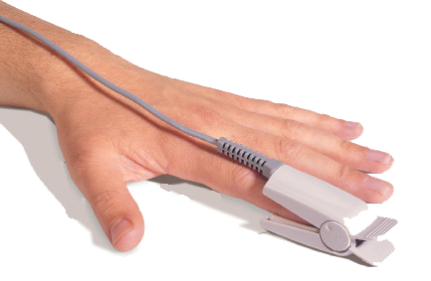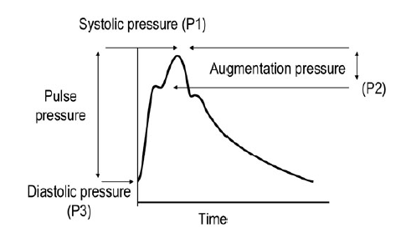

Figure 3. Finger photoplethysmography (left). Pressure waveform example (right).

The overview of the discussed arterial stiffness metrics and measurement techniques is given in Table 1. These techniques are substantially different and should be seen as complimentary to each other. Indices derived from one method cannot be directly compared to the indices derived from a different method.

|  |  |  |  |
| --- | --- | --- | --- |
| **AS** | **METRICS** | **REQUIRED MEASUREMENTS** | **TECHNIQUES** |
| Local | Indices derived from pressure-volume or pressure-diameter relationships (Stiffness index, compliance coefficient, distensibility coefficient, etc) | * Local arterial pressure * Artery diameter * Artery wall thickness | Diameter: Ultrasonic echo-tracking; MRI Imaging; Doppler imaging, Ultrasound  Pressure: Applanation tonometry  Wall thickness: Ultrasound |
| Regional | Pulse wave velocity (PWV) index | * Pulse travel time * Arterial distance covered by the pulse | Applanation tonometry  Ultrasonic echo-tracking  Doppler ultrasound  Electrocardiography (ECG) |
| Systemic | Indexes derived from the pulse waveform (augmentation index, central pressures, a/b ratio, etc) | * Pressure/volume pulse waveform | Photoplethysmography (PPG)  Applanation tonometry |

Table 1. Overview of arterial stiffness assessment methods.

### Accelerometer

An accelerometer is an apparatus, either mechanical or electromechanical, for measuring acceleration or deceleration - that is, the rate of increase or decrease in the velocity of a moving object. Accelerometers are used to measure the efficiency of the braking systems on road and rail vehicles; those used in aircraft and spacecraft can determine accelerations in several directions simultaneously. There are also accelerometers for detecting vibrations in machinery.

Accelerometer Principles

Most accelerometers are Micro-Electro-Mechanical Sensors (MEMS). The basic principle of operation behind the MEMS accelerometer is the displacement of a small proof mass etched into the silicon surface of the integrated circuit and suspended by small beams. Consistent with Newton's second law of motion (F = ma), as an acceleration is applied to the device, a force develops which displaces the mass. The support beams act as a spring, and the fluid (usually air) trapped inside the IC acts as a damper, resulting in a second order lumped physical system. This is the source of the limited operational bandwidth and non-uniform frequency response of accelerometers.

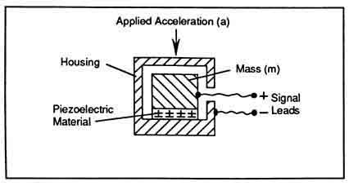

Fig1.Working Principle

Accelerometer Specifications

* Frequency Response – This parameter can be found out by analyzing the properties of the quartz crystal used and also the resonance frequency of the device.
* Accelerometer Grounding – Grounding can be in two modes. One is called the Case Grounded Accelerometer which has the low side of the signal connected to their core. This device is susceptible to ground noise. Ground Isolation Accelerometer refers to the electrical device kept away from the case. Such a device is prone to ground produced noise.
* Resonant Frequency – It should be noted that the resonant frequency should be always higher the the frequency response.
* Temperature of Operation – An accelerometer has a temperature range between -50 degree Celsius to 120 degrees Celsius. This range can be obtained only by accurate instalment of the device.
* Sensitivity – The device must be designed in such a way that it has higher sensitivity. That is, even for a small accelerative force, the electrical output signal should be very high. Thus a high signal can be measured easily and is sure to be accurate.
* Axis – Most of the industrial applications requires only a 2-axis accelerometer. But if you want to go for 3D positioning, a 3-axis accelerometer will be needed.
* Analog/Digital Output – You must take special care in choosing the type of output for the device. Analog output will be in the form of small changing voltages and digital output will be in PWM mode.

Accelerometer Types  
In industrial applications, the most commonly used components to convert the mechanical action into its corresponding electrical output signal are piezoelectric, piezo resistive and capacitive in nature. Piezoelectric devices are more preferred in cases where it is to be used in very high temperatures, easy mounting and also high frequency rang e up to 100 kilohertz. Piezo resistive devices are used in sudden and extreme vibrating applications. Capacitive accelerometers are preferred in applications such as a silicon-micro machined sensor material and can operate in frequencies up to 1 kilohertz. All these devices are known to have very high stability and linearity.

Nowadays, a new type of accelerometer called the Micro Electro-Mechanical System (MEMS) Accelerometer is being used as it is simple, reliable and highly cost effective. It consists of a cantilever beam along with a seismic mass which deflects due to an applied acceleration. This deflection is measured using analogue or digital techniques and will be a measure of the acceleration applied.

What are Accelometers Using For?  
Accelometers can be used in several work fields such as engineering, biology, industry and etc. Except cars, machines, most of people using accelometers without noticed in their electronic devices.

If you have a modern cell phone, MP3 player, or handheld games console, it probably has an accelerometer built into it so it can sense when you tilt it from side to side. That's how an iPhone or an iPod Touch automatically figures out when to switch the screen layout from portrait to landscape. Many games and "apps" designed for gadgets such as iPhones work by sensing how hard or how fast you move or shake the case using tiny accelerometer chips inside.

Use in Biology  
Accelerometers are also increasingly used in the biological sciences. High frequency recordings of bi-axial or tri-axial acceleration allows the discrimination of behavioural patterns while animals are out of sight. Furthermore, recordings of acceleration allow researchers to quantify the rate at which an animal is expending energy in the wild, by either determination of limb-stroke frequency or measures such as overall dynamic body acceleration Such approaches have mostly been adopted by marine scientists due to an inability to study animals in the wild using visual observations, however an increasing number of terrestrial biologists are adopting similar approaches. This device can be connected to an amplifier to amplify the signal.

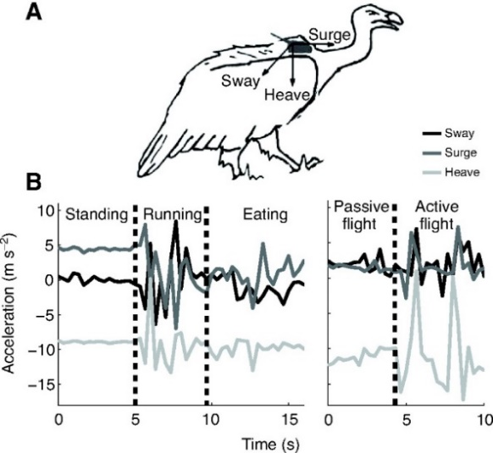

Fig2. Biological Use

Use in Industrial Fields  
Accelerometers are also used for machinery health monitoring to report the vibration and its changes in time of shafts at the bearings of rotating equipment such as turbines, pumps, fans, rollers, compressors, or bearing fault which, if not attended to promptly, can lead to costly repairs. Accelerometer vibration data allows the user to monitor machines and detect these faults before the rotating equipment fails completely.

Building and structural monitoring  
Accelerometers are used to measure the motion and vibration of a structure that is exposed to dynamic loads. Dynamic loads originate from a variety of sources including:

* Human activities – walking, running, dancing or skipping
* Working machines – inside a building or in the surrounding area
* Construction work – driving piles, demolition, drilling and excavating
* Moving loads on bridges
* Vehicle collisions
* Impact loads – falling debris
* Concussion loads – internal and external explosions
* Collapse of structural elements
* Wind loads and wind gusts
* Air blast pressure
* Loss of support because of ground failure
* Earthquakes and aftershocks

Under structural applications, measuring and recording how a structure dynamically responds to these inputs is critical for assessing the safety and viability of a structure. This type of monitoring is called Health Monitoring, which usually involves other types of instruments, such as displacement sensors -Potentiometers, LVDTs, etc.- deformation sensors -Strain Gauges, Extensometers-, load sensors -Load Cells, Piezo-Electric Sensors- among others.

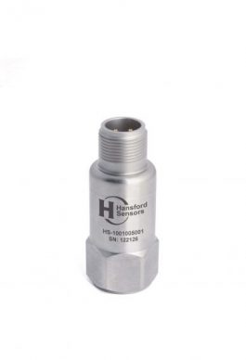

Fig 3. Accelometer for Industrial

### Camera

The follow up of wounds is often executed by nurses at the home of the patients because these patients are sent home as quickly as possible after initial treatment to keep costs under control. Because the nurses are not specialists it is often difficult or even impossible to assess if a patient needs to return to the hospital for further care. Photographs of the wounds are made by the nurses and sent for review to the specialists in the hospitals.

Very often therefore nurses take photographs with consumer equipment (smartphone cameras or consumer cameras) and send these images in a non-secure way to the hospital. These images are often poor in quality and difficult to interpret. There are multiple reasons for this. First of all a lot of smartphones and tablets have low quality camera sensors. Even if the sensor is of high resolution and good sensitivity, they still lack the optics of a professional camera. They do not have a high quality zoom lens for instance. Because of the cost of professional cameras, it is unlikely that a nurse has such a camera at his/her disposal.

Secondly the light conditions have a big influence on the quality of the photograph and especially on the perceived colors. Color is one of the main attributes that is assessed when reviewing the evolution of a wound. The photographs should be taken with controlled lighting conditions to have reproducible pictures in order to be able to evaluate the healing of the wound. It is obvious that a smartphone or tablet is not able to create controlled lighting conditions with the single LED as flash light. With a professional camera it is more possible to have controlled lighting conditions, but this means that the nurse has to travel around with even more expensive equipment and has to setup more or less a professional photo studio at the home of the patient, what is not realistic. Compact consumer cameras are sitting in between the smartphones and professional cameras, but still the same problems appear as with smartphones and tablets.

More advanced solutions do exists for wound imaging. An example is Silhouette from Aranz Medical. This device is a handheld acquisition device with its own light source that can do 3D measurements. The drawback of this device is that it requires a computer with a dedicated SW program to make the images. It is also focused on use by specialists in the hospitals and not on use at the patient’s home by a nurse. Another example of a similar device is the Eykona 3D wound imaging solution. This device has the advantage that it is a handheld device, but it is also oriented towards the specialists and not to the routine follow up visits of the nurses.

### Location & posture tracking

Localization has been one of the main problems in humanity. Advances in the localization technologies enabled the human kind to explore and navigate further places. In the context of this project we will separate indoor and outdoor localization technologies. Very often therefore nurses take photographs with consumer equipment (smartphone cameras or consumer cameras) and send these images in a non-secure way to the hospital for quick review. These images are often poor in quality and difficult to interpret.

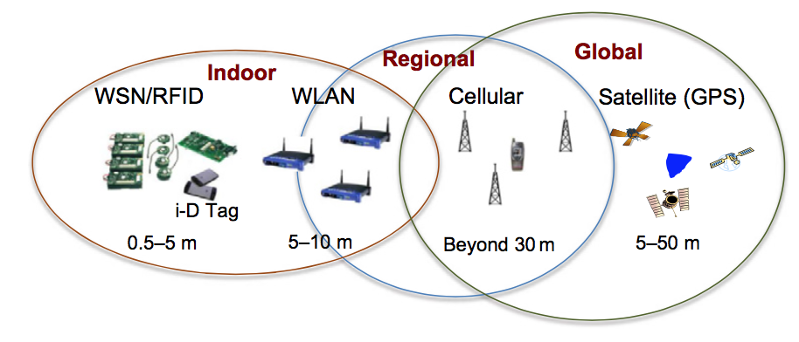

Figure 1: Localization techniques

**Outdoor Localization**

Though there are other alternatives to outdoor navigation sensors GNSS based localization is the most widely used because of its practicality and availability of the same signals throughout the world.

The navigation world has just witnessed an important milestone: the advent and full operability of a number of different satellite navigation systems aiming at competing with and complementing the GPS authority. Europe is urging the deployment of its Galileo global satellite system, Russia is radically modernizing its global orbiting navigation satellite system (GLONASS), and Japan and India have their own regional systems under development, while China is converting its initial regional Beidou system into a global one. The United States itself is investing significant resources for GPS modernization. The advent of this new panorama in the sky has fostered worldwide research in the field of satellite navigation and is going to deeply change the market of navigation receivers as well as the consumers’ perspective, with new applications, new services, and increased availability. However, the undisputed lead among satellite-based systems belongs nowadays to GPS.

In principle, highly accurate position solutions may be obtained by solving the system of equations which are formed by signals coming from different satellites. However, in general, there are several primary error sources to GPS. Two of these include unknown atmospheric errors, or delays, introduced by the ionosphere and troposphere. These effects cause the LOS signal to actually arrive later than predicted by the pseudo range equation. Multipath propagation is another primary pseudo range error source. Multipath signals are (usually undesired) signal reflections from the ground or other nearby obstacles. As opposed to the atmospheric effects, which directly affect the LOS signal TOA, multipath causes the GPS receiver to make erroneous measurements of the TOA of the signal.

GNSS augmentation systems were born to continuously provide robust and safe navigation especially when high precision or enhanced coverage or availability is required. Accuracy, availability, integrity, and continuity are the key performance of any GNSS, so that procedures and external aids to improve them have been developed under the label of the augmentation systems.

Augmentation systems attempt to correct for many of the dominant error sources in GNSS. It is basically accomplished by placing a reference station at a precisely known location in the vicinity of a user, or where high-accuracy navigation is required. The reference station measures the ranges to each of the satellites in view, demodulates the navigation message, and depending on the type of parameter, computes several types of corrections to be applied by the user’s receiver in order to improve its performance. Then the station broadcasts its corrections to local users via a data link, so that position accuracies of a few centimetres are obtained. Augmentation works only against common mode, spatially correlated errors such as the ionosphere and troposphere delays. Multipath-induced errors, as well as interference-induced ones, are not common to the reference station and the user; therefore they cannot be recovered by means of any augmentation systems.

The main augmentation systems currently available are differential GPS (DGPS), satellite-based augmentation systems (SBASs), real-time kinematic (RTK) systems, and assisted GNSS (AGNSS). It is interesting to note that while DGPS, SBAS, and RTK require the deployment of a specific terrestrial network of reference stations and specific communication protocols, the AGNSS approach essentially exploits the network architecture of existing cellular communication systems, with specifically added features. For this reason, AGNSS is a very promising technology, since it inherently implements the concept of NAV/COM integration.

**Indoor Localization**

For indoor applications, usually there are stationary signal reference nodes and mobile users who need to calculate their position. Depending on the node’s hardware capabilities, different kinds of measurements are available based, for example, on RF, inertial devices (e.g., acceleration), infrared, and ultrasound. In particular, when radio signals are considered, useful position-dependent information can be derived by analysing signal characteristics such as received signal strength (RSS), time of arrival (TOA), and angle of arrival (AOA), or just from the knowledge that two or more nodes are in radio visibility (connected).

Let’s group these available techniques and analyse them.

|  |  |  |
| --- | --- | --- |
| Measured Quantity | Positioning Technique | Aspects |
| Angle Of Arrival (AOA) | Angle based | Needs to find the direction of the signal source |
| Received Signal Strength (RSS) | Range based, Fingerprinting, Interferometric | Nodes measure the received power |
| Time of Arrival (ToA) | Range based | Measurement of signal travelling time |
| Time Difference of Arrival (TDOA) | Range difference based | Measurement of signal travelling time differences |
| NearField Ranging | Range based | Relates the distance to the angle between the electric and magnetic fields in near-field conditions |
| Proximity | Proximity range free | No precise location information but guarantee proximity in around 10m |
| Inertial sensors | Depends on acceleration and rotation measurements | Dead reckoning technique needs initialization and accumulates error |

**Angle-of-Arrival (AOA) Measurements**

Angle-based techniques estimate the position of a user by measuring the AOA of signals arriving at the measuring station. The signal source is located on the straight line formed by the measurement station and the estimated AOA (also called *line of bearing* (LOB)). When multiple independent AOA measurements are simultaneously available, the intersection of two LOBs gives the (2D) estimated position. With perfect measurements, the *positioning problem* to be solved in this case is the intersection of a number of straight lines in the 3D space. In practice, noise, finite AOA estimation resolution, and multipath propagation force the use of more than two angles. The measurement station, equipped with an antenna array that allows AOA estimation, can be either the terminal to be located (in this case, it measures the AOAs of signals from different anchor nodes) or the anchor nodes themselves (in this case, they sense the signal transmitted by the agent, estimating its AOA).

**Received Signal Strength (RSS) Measurements**

The simplest measurement, practically always available in every wireless device, is the received signal power or RSS. Based on the consideration that in general the further away the node, the weaker the received signal, it is possible to obtain an estimate of the distance between two nodes (*ranging*) by measuring the RSS. Theoretical and empirical models are used to translate the difference (in dB) between the transmitted signal strength (assumed known) and the received signal strength into a range estimate. RSS ranging does not require time synchronization between nodes. Unfortunately, signal propagation issues such as refraction, reflection, shadowing, and multipath cause the attenuation to correlate poorly with distance, resulting in inaccurate and imprecise distance estimates.

Fingerprinting, also referred to as *mapping* or *scene analysis*, is a method of mapping the measured data (e.g., RSS) to a known grid point in the environment represented by a data fingerprint. The data fingerprint is generated by the environment site-survey process during the off-line system calibration phase. During on-line system location, the measured data are matched to the existing fingerprints. Typical drawbacks of this method include variation of the fingerprint due to changes in geometry, for example simple closing of doors. *Interferometric*technique relies on a pair of nodes transmitting sinusoids at slightly different frequencies. The envelope of the received composite signal, after band-pass filtering, varies slowly over time. The phase offset of this envelope can be estimated through RSS measurements and contains information about the difference in distance of the nodes involved. By making multiple measurements in a network with at least eight nodes, it is possible to reconstruct the relative location of the nodes in a 3D frame.

**Time-of-Arrival (TOA) Measurements**

*Time-Based Ranging:* Considering that the electromagnetic waves travel at the speed of light, that is, *c* ≃ 3 · 108 m/s, the distance *d* between a pair of nodes can be obtained from the measurement of the propagation delay or time of flight (TOF) τ = *d*/*c*, through the estimation of the signal (TOA). When wide bandwidth signals are employed and accurate time measurements are available, time-based ranging can provide high accuracy positioning capabilities. However, time synchronization and measurement errors represent the main issues when designing time-based ranging techniques. *Time-Sum-of-Arrival* systems measure the relative sum of ranges between the agent and the anchor nodes and define a position location problem as the intersection of three or more ellipsoids with foci at two anchors. *Time-Difference-of-Arrival* (TDOA) systems measure the difference in range between transmitter–receiver pairs. A TDOA measure defines a hyperboloid of constant range-difference, with the anchors at the foci.

**Connectivity**

The simplest way to obtain useful measurements for positioning is *proximity*, where the mere connectivity information (yes/no) is used to estimate node position. The location information is provided as a proximity to the closest known anchor (*landmark*). The key advantage of this technique is that it does not require any dedicated hardware and time synchronization among nodes since the connection information is available in every wireless device. However, the kind of position dependent information obtainable using such a kind of approach may be unsatisfactory.

**Near-Field Ranging (NFR)**

NFR adopts low frequencies (typically around 1 MHz) and consequently long wavelengths (around 300 m). The key idea of this method is to exploit the deterministic relationship that exists between the angle formed by electric and magnetic fields of the received signal and the distance between the transmitter and the receiver. This low-frequency approach to location provides greater obstacle penetration, better multipath resistance, and sometimes more accurate location solutions because of the extra information present in near-field as opposed to classical far-field higher frequency approaches. The main drawbacks of this technology are the large antennas required and the scarce energy efficiency.

**Inertial Sensors**

Besides the exploitation of measurements of radio signal characteristics exchanged between nodes (*internode measurements*), a single node could also take advantage in determining its own position of local measurements (*self-measurements*) using on-board sensors such as inertial measurement units (IMUs). The recent progress of the low-cost electromechanical systems (MEMS) market has made IMUs very popular. An IMU may typically contain an accelerometer and a gyroscope. The accelerometer measures the acceleration of the device on which it is attached (rotational speed), in addition to the earth’s gravity, whereas the gyroscope measures the angular rate of the device. These measurements do not provide the device position directly as they enable only the tracking of device displacements. Several strategies, usually based on the integration of measured data, can be adopted to derive the device’s position. However, the ranging estimates can be obtained, but this integration process induces position and orientation drifts due to measurement errors. This is the main limitation of inertial sensors to solve the positioning problem over long intervals of time. To mitigate these drifts, inertial devices can be coupled with a magnetometer to use the earth’s magnetic field as a reference. The greatest advantage of adopting IMUs comes from their combination with some wireless positioning technique by means of data fusion signal processing algorithms.

|  |  |  |  |  |
| --- | --- | --- | --- | --- |
| Technology | Measurement Technique | Accuracy | Advantages | Disadvantages |
| GNSS | TDOA | 10-20m | Earth scale | only outdoor |
| A-GNSS | TDOA | 1-5m | Regional | only outdoor |
| Cellular | Crowdsourcing, TDOA | 50-500m | Regional | Mainly outdoor |
| WLAN, Zigbee | RSS, fingerprinting | 1-5m | Indoor coverage, lowcost | Low accuracy |
| UWB | TOA/TDOA/AOA | 0.1-1m | Indoor coverage, high accuracy | Short range, problems in NLOS |
| RFID | Proximity | Connectivity range | Indoor coverage, low power consumption, low cost | Low accuracy |
| NFR | EM near field characteristics | 1-5m | Indoor coverage | Low frequency , large antennas |
| INS | Acceleration and rotation | Depends on duration and time of travel | Works everywhere | Accumulating errors |

**Ultra wideband technology**

UWB is promising for high-definition indoor positioning, as it can achieve very accurate short distance estimation. UWB is also a viable technology for short-range wireless indoor communication with a number of attractive potential features: high-rate transmission, low complexity, low cost, and low power consumption. This technology has generated considerable and increasing interest by many manufacturers in the United States since February 2002, when the Federal Communications Commission (FCC) opened up 7.5 GHz of spectrum (from 3.1 to 10.6 GHz) for use by UWB devices.   
The traditional design approach for a UWB communication system uses baseband narrow time-domain pulses of very short duration, typically of the order of a nanosecond, thereby spreading the energy of the radio signal quite uniformly over a wide frequency band ranging from extremely low frequencies to a few gigahertzes. This method is usually called *impulse radio UWB* (IR-UWB). A great advantage of the short pulse modulation is the possibility to estimate the TOA with a fine resolution, which translates in ranging estimation with an accuracy of less than one meter.   
In March 2004 a technical group called Task Group TG4a was established under the IEEE 802.15 standardization framework. Its mission was to define an alternative physical layer (IEEE 802.15.4a), based on the UWB characteristics, for the IEEE 802.15.4 standard, the most used by WSNs. The two design goals of low cost and low power are achieved by a new PHY layer based on UWB through simple demodulation schemes, low bit rates, and low transmitted power. Low power consumption is also achieved through low duty cycle operations. The first commercial IEEE 802.15.4a compliant chip-set has been announced to be delivered in late 2011. In parallel, several companies proposing proprietary UWB products for RTLS are deeply involved in the development of the new IEEE 802.15.4f standard, which is devoted to specify a solution to precise indoor positioning with extremely low cost and low consumption tags.

**Positioning in Radio Frequency Identification (RFID)**

RFID technology has attracted an enormous interest worldwide, since the earliest pioneering ideas dating back to 1948. A number of applications can now be found in several fields such as logistics, automotive, surveillance, automation systems, and in general real-time object identification [9]. An RFID system consists of tags applied to objects and their readers. The reader interrogates the tags via a wireless link to obtain the data stored on them. When tag cost, size, and power consumption requirements become particularly stringent, passive or semi passive tag solutions are taken into consideration. Communication with passive tags usually relies on backscatter modulation, and the tag’s control logic and memory circuits obtain the necessary power to operate from the RF signal sent by the reader.

Recent developments indicate a trend to hybridize active RFID and RTLS technologies [19]. Some RFID vendors are adopting or adapting RTLS concepts to provide additional functionalities for their products. Several systems rely on proximity-based positioning algorithms, which, in general, are not very accurate for many applications. The standard ISO/IEC 24730-2 has been introduced in 2006 to fill the gap between the RFID and RTLS technologies. Some research efforts are also going on to merge RFID and UWB technologies toward extremely low-cost RTLS [5]. Positioning algorithms adopted in RFID-based RTLS are usually the same as those adopted in WLANs and WSNs.

**Zigbee like WSN**

First technique for indoor localization is to measure the received signal strength (RSS) coming from different transmitters. To calculate the user position, distance information from several reference sensors is required. Using these several distance measurements from known reference sensor positions and applying the triangulation technique one can calculate the user position.

As an example let’s explore Zigbee sensors. Zigbee is a communication protocol developed for indoors. According to IEEE 802.15.4 standard, its communication range for in line-of-sight (LOS) conditions is between 10m-100m. It is a widely used WLAN technology with low data throughput. It is a more low-cost, simple and low energy solution with respect to Wi-Fi. Localization algorithms, which use these Zigbee protocol sensors, gather their distance measurement from the user using RSS. According to Frii’s free space path loss formula, the received power at the user location is inversely proportional with the square of the distance from transmitter to the user. Aforementioned fingerprinting methodology can also be employed to find the user position from Zigbee signals.

### Posture Tracking

The inertial measurement units attached to different body parts can capture motion through different types of measurements (acceleration, angular velocity and with their integration: position, velocity, orientation, etc.) and this data will allow precise motion capture of required body parts. Through these measurements different types of behaviour can be analysed fall detection, posture tracking, body motion analysis.



Figure 2: One possible placement of body attitude sensors.

Treatment analysis of patients is also possible through minimum and maximum joint angles, angular speeds at joints and other body movement statistics. One possible arrangement of 10 attitude sensors are given in above figure. Certainly the number of sensors can be decreased according to application. Hardware set for a generic body posture sensor is as below:

* This sensor should deliver raw data of all 9 axes - 3 axes of gyro, 3 axes of accelerometer, 3 axes of magnetometer, i.e. a single data vector will consist of 9 raw data.
* Bluetooth Low Energy Data Transfer
* As sensors and microprocessors will be powered by batteries, a low energy data transfer solution - Bluetooth Low Energy is essential to reduce power consumption.
* 2 degree angular accuracy for magnetometer
* 50 mg acceleration accuracy
* For acceleration measurements, maximum error of 50 mg is tolerable.
* 1 degree/second angular velocity accuracy, for gyro we may tolerate 1 degree/second highest error in measurements.
* 25 Hz data transfer rate

There are two commercially available products in the market for body motion capture. First is made by the leading inertial measurement company Xsense called MVN Biomech. The system includes high end sensor modules (17 for the whole body) that are wirelessly connected to the main computer. The second is called Biosyn Systems and they produce Functional Assessment Of Biomechanics System (F.A.B.). It also supports up to 17 sensors at a time and data transferred wirelessly.

**References**

[1] A. Savvides, M. Srivastava, L. Girod, and D. Estrin. Wireless Sensor Networks-Chapter 15 Localization in Sensor Networks. Springer, New York, USA, 2004.

[2] N. Patwari, J. N. Ash, S. Kyperountas, A. O. Hero III, R. L. Moses, and N. S. Correal. Locating the nodes. IEEE Signal Processing Magazine, 22(4):54{69, July 2005.

[3] K.Pahlavan and P. Krishnamurty. Principles of Wireless Communications. Prentice Hall, 2002.

[4] S. Gezici and H. V. Poor. Position estimation via ultra-wide-band signals. In Proceedings of IEEE, volume 97, pages 386-403, 2009.

[5] G. Mao, B. Fidan, and B. D. O. Anderson. Wireless sensor network localization techniques. Computer Networks, 51(10):2529{2553, January 2007.

[6] H. Wymeersch, J. Lien, and M. Z. Win. Cooperative localization in wireless networks. Proceedings of the IEEE, 97(2):427{450, February 2009.

[7] J. Blumenthal, R. Grossmann, F. Golatowski, and D. Timmermann “Weighted Centroid Localization in Zigbee-based Sensor Networks”, Proceedings of IEEE International Symposium on Intelligent Signal Processing, October 2007, p1-6.

[8] ZigBee specification v1.0, http://www.chipcon.com/zigbee/members_only.cfm, Dezember 2004.

[9] <http://www.timedomain.com/p400-mrm.php>.

[10] P. Oguz-Ekim. PhD Thesis, Robust Localization Algorithms in Sensor Networks with Applications on Target Tracking, Lisbon, 2013

[11] T. S. Rappaport. Wireless Communications: Principles and Practice. Prentice-Hall Inc., New

Jersey, 1996.

[12] <http://www.freescale.com>

[13] <http://www.decawave.com/>

[14] <http://www.xsens.com/tags/ahrs/>

[15] S. Gezici. A survey on wireless position estimation. Wireless Personal Communications, 44(3):263{282, February 2008.

[16] P. Oguz-Ekim, J. Gomes, J. Xavier, and P. Oliveira. Robust localization of nodes and time-recursive tracking in sensor networks using noisy range measurements. IEEE Transactions on Signal Processing, 59(8):3930{3942, August 2011.

## Platform technologies

Platform technologies are systems build upon a platform architecture that distributes the system out into different levels of abstraction. This is done in order to differentiate between core – platform – functions, and the application layer that sits on top of, and draws upon, these underlying common services. Below a number of platform technologies where eWATCH will advance in the project.

### Gateway technologies

|  |  |  |  |  |  |  |  |  |  |  |  |  |  |  |  |  |  |  |  |  |  |  |  |  |
| --- | --- | --- | --- | --- | --- | --- | --- | --- | --- | --- | --- | --- | --- | --- | --- | --- | --- | --- | --- | --- | --- | --- | --- | --- |
| **Solution** | **GatewaY** | | | |  |  |  |  |  |  |  |  |  |  |  |  |  |  |  |  |  |  |  |  |
| **Official GatewaY** | | | | | | | | **Client** | | | | | | | | | **Client Data & Communication** | | | | | | **Development** |
| **Official Hardware** | **Official Agent** | **Remote Management** | **Node Self DiscoverY** | **Built-In Data Transfer** | **Built-In Data Filtering** | **Built-In Edge Processing** | **3rd PartY** | **Linux** | **OS X** | **Android** | **iOS** | **Windows** | **Arduino** | **RaspberrY** | **JavaScript** | **Node Support** | **JSON** | **XML** | **MQTT** | **WebSockets** | **HTTP** | **Other Protocols** | **Programming Support** |
| [**Aggregate Tibbo**](http://aggregate.tibbo.com/) |  |  |  |  | Y |  |  |  | Y | Y | S |  | Y | Y | Y |  |  |  |  |  |  |  | Modbus, Meter-Bus, DLMS/COSEM, OPC, SNMP, BACnet | Java, C/C++, .NET |
| [**Airvantage M2M Cloud**](https://airvantage.net/) | Y | Y | Y |  | Y | N | N | Y |  |  | Y | Y |  | Y | Y |  | Y | Y |  | Y |  | Y |  | Y |
| [**Amazon AWS IOT**](https://aws.amazon.com/iot/) | N | N |  |  |  |  |  |  | S |  | S | S |  | S | S | Y |  |  |  | Y | Y | Y |  | Embedded C, JavaScript, ArduiN Y |
| [**ArraY**](https://www.arrayent.com/platform/) | Y | Y | Y |  | Y | Y | Y | Y | S |  |  |  |  |  | S | S | Y | Y | Y | Y | Y | Y |  |  |
| [**AY**](https://www.aylanetworks.com/products/iot-platform) | Certified | Y |  |  |  |  |  |  |  |  |  |  |  |  |  |  |  |  |  |  |  |  |  |  |
| [**C3 IoT**](http://c3iot.com/products/c3-iot-platform/) | N | N |  |  |  |  |  |  |  |  |  |  |  |  |  |  |  | Y |  | Y |  |  |  |  |
| [**Carriots**](http://carriots.com/) | N | N |  |  |  |  |  |  | Y |  |  |  | S | Y | Y |  | Y | Y | Y | Y |  | Y | gRPC | PY |
| [**Davra**](http://www.davranetworks.com/) | ? | ? | ? | ? | ? | ? | ? |  |  |  |  |  |  |  |  |  |  |  |  | Y |  | Y | CoAP, XMPP, JMS, AMPQ, KAFKA, UDP |  |
| [**Google IoT Cloud**](https://cloud.google.com/solutions/iot-overview) | N | N |  | ? |  |  |  |  |  |  |  |  |  |  |  |  |  |  |  |  |  | Y |  |  |
| [**IBM Watson IoT**](http://www.ibm.com/internet-of-things/iot-solutions/watson-iot-platform/) | N | N |  |  |  |  |  |  | CLI | CLI |  |  | CLI |  | Y | Y | Y | Y |  | Y |  | Y |  | PY |
| [**Jasper - Cisco**](https://www.jasper.com/iot-service-platform/control-center) | ? | ? | ? | ? | ? | ? | ? | ? |  |  |  |  |  |  |  |  |  |  |  |  |  |  |  |  |
| [**Kaa**](http://www.kaaproject.org/) | N | N |  |  |  |  |  |  | S |  | S | S | S |  | S |  |  |  |  |  |  | Y |  | Java, C++, C, Objective-C |
| [**macchina.io**](http://macchina.io/) | N | Y |  |  |  |  |  |  | Y | Y |  |  |  |  | Y | Y |  |  |  | Y |  | Y | CoAP, IEEE 802.15.4, Modbus, USB, Bluetooth, RS-232 | C++, JavaScript |
| [**MuraN - Exosite**](https://exosite.com/) | ? | Y |  |  |  |  |  |  |  |  |  |  |  | S |  |  |  |  |  |  | Y | Y | COAP | C, C++, PY |
| [**Onion Cloud**](https://onion.io/cloud/) | Y |  |  |  |  |  |  |  |  |  |  |  |  |  |  |  |  |  |  |  |  |  |  | Omega Specific, C++, Nde.js, PY |
| [**Particle**](http://particle.io/) | Y | Y | Y |  | Y |  |  | Y |  |  | CA S | CA S | CA S |  |  |  | Y |  |  |  |  |  |  | IDE support for Windows, MAC, and Linux |
| [**Predix**](https://www.predix.io/) | N | Y | ? |  | Y |  |  | Y | Y | Y |  |  | Y |  | PM* |  |  |  |  | Y | Y | Y | OPC-UA, Modbus | Java |
| [**Resin**](https://resin.io/) | N | Y | Future Release |  | Y |  |  |  | Y |  | N | N | N |  |  | Y |  | Y |  |  |  |  |  | Nde.js, PY |
| [**RoboMQ**](https://www.robomq.io/) | N | N |  |  |  |  |  |  |  |  |  |  |  | Y | Y |  |  | Y | Y | Y |  | Y | REST, AMQP, STOMP, WebSTOMP | AnY |
| [**Sitewhere**](http://sitewhere.org/) | N |  |  |  |  |  |  | Y |  |  | S |  |  | S | S | N | N |  |  | Y |  |  | AMQP Stomp | N |
| [**Telit**](http://www.telit.com/) | Y | Y | Y |  | Y |  |  |  |  |  |  |  |  |  |  |  |  |  |  | Y |  |  |  |  |
| [**Temboo**](https://temboo.com/) | N |  |  |  | Y | Y | Y |  |  |  | S | S | S | Y |  | Y |  |  |  | Y |  | Y | CoAP | Android iOS Windows - C# Java JavaScript Nde.JS PHP RubY |
| [**ThingSpeak**](http://thingspeak.com/) | N | N |  |  |  |  |  |  | Y |  |  |  |  | S | S | Sample |  |  |  |  |  | Y |  |  |
| [**ThingStudi**](http://www.thingstud.io/) | N | N |  |  |  |  |  |  |  |  |  |  |  |  |  |  |  | Y |  | Y |  |  |  | Web IDE for HTML programs |
| [**ThingWorx**](https://www.thingworx.com/) | Certified | N |  |  |  |  |  | Y | Y |  | Y | Y | Y | Y | Y |  | Y |  | Y |  | Y | Y |  | ThingWorx Edge C, .NET S, Java, iOS , Android |
| [**Ubidots**](https://ubidots.com/) | N |  |  |  |  |  |  |  | S | S | S |  | S | S | S | S |  | Y |  | Y |  | Y | CoAP | PY |
| [**XivelY**](http://xively.com/) | N |  |  |  |  |  |  |  |  |  |  |  |  |  |  |  |  |  |  | Y |  |  |  |  |
| [**Zatar**](http://www.zatar.com/) | Y | Y | ? |  |  |  |  |  |  |  | Y | Y |  |  | Y |  |  |  |  |  |  |  | LWM2M, CoAP, Zatar Edgebox | C++ Java |

Table 1. IoT Solutions – Gateway Features

### Cloud technologies

Each technology is evaluated according to various layer in cloud computing as “cloud” is a generic term. We evaluate each layer according to common features specific to that layer.

**Infrastructure**Server hardware support: Does infrastructure depend on specific hardware brand? Is it in need of a specific CPU architecture?

* Virtualization: Is it an open system or is it to be licensed?
* Deployment: Are there ready-to-use server deployment tools?
* Virtual machine & Container management: What is the management level for virtual machines? Does virtualization environment support container technologies?

**Software As A Service**Cloud technologies used in IoT solutions can be categorized as follows:

* Gateway/Client Support:
  + Supported connectivity protocols
  + Device management including over-the-air updates, inventory
* Data Storage:
  + Structured data
  + Unstructured or Big Data
  + Streaming data
* Data Analysis Utilities:
  + Ad-hoc analysis support
  + SQL-like utilities
  + Big Data analytics tools
  + Complex Event Processing
* Data Visualization And Export
  + Dynamic dashboards for data graphics
  + Data export in industry-wide known formats
* Artificial Intelligence, Machine Learning Support
  + AI support
  + Training Facilities
* Business integration with third parties
  + Data Source Integration
  + Process flow integration
* Programming Support
  + API Support
  + Dynamic programming via configuration
  + Adding solution specific servers to
* Software Technologies Used
  + Licensing: Are underlying software components including operating system open-source?

**Solutions in Market**Evaluation of well-known and widely used IoT solutions are listed in Table 1.

|  |  |  |  |  |  |  |  |  |  |  |
| --- | --- | --- | --- | --- | --- | --- | --- | --- | --- | --- |
| **Solution** | **Cloud Main Features** | | | | | | | **Device Man.** | | |
| **Cloud Server** | **Programming Support** | **Bussiness  Integration** | **Cloud Rules** | **Data Analytics** | **Data Visualization** | **Data Storage** | **Over-The-Air Update** | **Configuration** | **Inventory** |
| [**Aggregate Tibbo**](http://aggregate.tibbo.com/) | Windows, Linux, MAC OS | Java, .NET, Android, .NET Compact | SCADA /HMI HVAC | Yes | Yes | Yes | Yes |  | Yes |  |
| [**Airvantage M2M Cloud**](https://airvantage.net/) | Airvantage | Node.js, Ruby, Clojure, PHP, Go, Java | REST API | Yes | Yes | Yes | Yes | Yes | Yes | Yes |
| [**Amazon AWS IOT**](https://aws.amazon.com/iot/) | AWS IoT | AWS Specific: S3, AWS Lambda  General: Android, Browser, iOS, Java, .NET, Node.JS, PHP, Python, Ruby, Go, C++ | REST API | Yes | Yes | Yes | Yes | No |  | No |
| [**Arrayent**](https://www.arrayent.com/platform/) | * | Java | SOAP, REST, WS |  | Yes |  |  | Yes |  |  |
| [**Ayla IoT Platform**](https://www.aylanetworks.com/products/iot-platform) | Ayla PaaS Cloud |  |  | Yes | Yes | Yes |  | Yes |  | Yes |
| [**C3 IoT**](http://c3iot.com/products/c3-iot-platform/) |  | JavaScript | REST | Yes | Yes | Yes | Yes |  |  |  |
| [**Carriots**](http://carriots.com/) | Carriots PaaS | Groovy Javascript |  | Yes |  |  | Yes | Yes | Yes | Yes |
| [**Davra**](http://www.davranetworks.com/) | Amazon AWS Cisco Dcloud |  | REST WebSockets | Yes |  |  |  | Yes | Yes | Yes |
| [**Google IoT Cloud**](https://cloud.google.com/solutions/iot-overview) | Google | Go, Java, .NET, Node.js, PHP, Python, Ruby, SQL | Yes | Yes | Yes |  | Yes |  |  |  |
| [**IBM Watson IoT**](http://www.ibm.com/internet-of-things/iot-solutions/watson-iot-platform/) | IBM BlueMix | Node-RED, Python, Node.js, Javax | REST Real Time | Yes | Yes | Yes | Yes | Yes | Yes | Yes |
| [**Jasper - Cisco**](https://www.jasper.com/iot-service-platform/control-center) |  |  | IBM Bluemix, ThingWorx, Microsoft Azur, Salesforce, SAP |  | Yes | Yes | Yes | Yes | Yes |  |
| [**Kaa**](http://www.kaaproject.org/) | On-premise |  | REST |  | Yes | Yes |  | Yes |  |  |
| [**macchina.io**](http://macchina.io/) |  |  |  |  |  |  |  |  | Yes |  |
| [**Murano - Exosite**](https://exosite.com/) |  |  |  |  | Yes | Yes |  | Yes | Yes | Yes |
| [**Onion Cloud**](https://onion.io/cloud/) |  |  | REST |  |  |  |  | Yes | Yes |  |
| [**Particle**](http://particle.io/) | Particle Cloud | iOS, Android, Windows, JavaScript |  |  |  |  |  | Yes |  |  |
| [**Predix**](https://www.predix.io/) | Predix Cloud based on open source Cloud Foundry | Microservices | REST |  | Yes | Yes | Yes |  | Yes | Yes |
| [**Resin**](https://resin.io/) | Resin.io |  |  |  |  |  |  |  |  |  |
| [**RoboMQ**](https://www.robomq.io/) | Cloud On-Premise Appliance |  | REST,  AMQP, ESB | Yes | Yes | Yes | Yes |  |  |  |
| [**Sitewhere**](http://sitewhere.org/) | Sitewhere Linux/Windows Server |  | REST | Yes | Yes | Yes | Yes |  | Yes | Yes |
| [**Telit**](http://www.telit.com/) |  |  | Yes |  | Yes |  | Yes | Yes | Yes | Yes |
| [**Temboo**](https://temboo.com/) | Temboo | C# Java JavaScript Node.JS PHP Ruby Python | REST | Yes | Yes | Yes |  | Yes | Yes | Yes |
| [**ThingSpeak**](http://thingspeak.com/) | MathWorks |  | Yes | No | Yes | Yes | Yes | No | No | No |
| [**ThingStudi**](http://www.thingstud.io/) |  |  |  |  |  |  |  |  |  |  |
| [**ThingWorx**](https://www.thingworx.com/) | On-Premise ThingWorx Server | Java |  | Yes | Yes | Yes | Yes | Yes | Yes | Yes |
| [**Ubidots**](https://ubidots.com/) | Ubidots |  | REST | Yes | Yes | Yes | Yes |  |  |  |
| [**Xively**](http://xively.com/) |  |  |  | Yes |  |  |  | Yes | Yes | Yes |
| [**Zatar**](http://www.zatar.com/) | ZatarCloud - Amazon | Java, iOS | REST |  |  | Yes | Yes |  |  |  |

Table 2. IoT Cloud Solutions

**IoT-Ignite Technologies**ARDIC’s IoT Cloud solution IoT-Ignite supports the following technologies:

|  |  |
| --- | --- |
| **Technologies used in IoT-Ignite Cloud** | |
| *Cloud Infrastructure* | |
| Server Hardware | Hardware agnostic |
| Virtualization | Citrix XenServer, KVM |
| Deployment | Jenkins, Puppet, Docker, Sonatype Nexus |
| VM & Container Management | OpenStack, Kubernetes, Docker, Cloud Manager (ARDIC Proprietary) |
| Network Utilities | Nginx, HAPoxy, Traefik |
| Monitoring | Nagios, Prometheus |
| Service Discovery | Etcd, Consul, ZooKeeper |
| *Software As A Service* | |
| Supported Gateway/Client Connection Protocols | MQTT, WebSocket, XMPP |
| Distributed File System | Openstack Swift |
| SQL Databases | PostgreSQL, MySQL |
| NoSQL Databases | MongoDB, Apache Cassandra, Hadoop |
| Queues/Streaming Data Engines | Apach Kafka, ActiveMQ, |
| Complex Event Processing | CEP (ARDIC Proprietary) |
| Front End | HTML5, Javascript, JQuery, AngularJS |
| Data Analytics | Apache Spark, Apache Flink ML Libraries, Splunk |
| AI, Machine Learning | Google TensorFlow |
| API | REST |
| Licensing | Components are licensed by one of these: Apache, BSD, MIT, and GPL |

Table 3. Technologies used in IoT-Ignite

### Communication technologies and security

Many different communication technologies and protocols in this project as any IoT Network can be used to connect the smart devices such as GSM/GPRS/EDGE, WCDMA/HSPA, and CDMA, RFID, Wi-Fi, ZigBee, WiMAX, Xdsl, fiber to the x (FTTx), Internet Protocol Version 6 (IPv6), over Low power Wireless Personal Area Networks (6LoWPAN), Bluetooth Low Energy (BLE), Z-Wave and Near Field Communication (NFC).[1,2] Many such protocols have been developed by IETF, IEEE, ITU, and other organizations and many more in development.

The IoT ecosystem can be defined in the following figure. Also, the communication protocols for IoT can be categorized into: (1) Data Link Protocols which can be divided into Low Power Wide Area Network (LPWAN) such as SigFox and cellular, and short range network such as ZigBee, Bluetooth, RFID, NFC and ZWave, (2) Network Layer Routing and Encapsulation Protocols, (3) Session Layer Protocols, (4) management and security standards in below figure. [3]

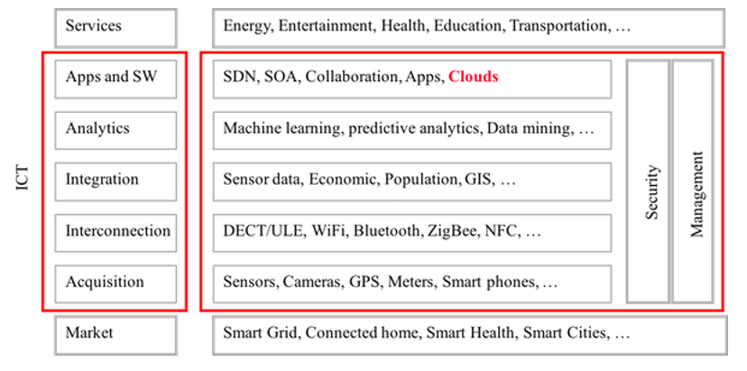

Figure 6 IoT Ecosystem

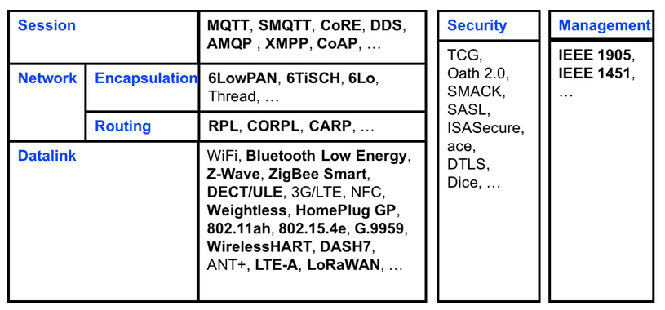

Figure 7 IoT Protocols

In this project, a brief description of the protocols that can be used is given below.

***SigFox*** is a low power technology for wireless communication of a diverse range of low energy objects such as sensors and M2M applications. It allows the transportation of small amounts of data ranging up to 50 kilometers. SigFox uses Ultra Narrow Band (UNB) technology. This technology is only designed to handle low data transfer speeds of 10 to 1, 000 bits per second, and can run on a small battery. NFC technology is used in smart meters, ***patient monitors***, agriculture, security devices, street lighting and environmental sensors.

***Cellular technology*** is a great fit for applications that need high throughput data and have a power source of IoT application that requires operation over longer distances. It can take the advantage of GSM/3G/4G cellular communication capabilities it can provide reliable high speed connectivity to the Internet. However, it needs high power consumption. Therefore, it’s not suitable for M2M (Machine-to-Machine) or local network communication.

***Bluetooth Low Energy (BLE)*** is a significant protocol for IoT application. It’s designed and enhanced for short-range, low bandwidth, and low latency for IoT applications. The advantages of BLE include lower power consumption, lower setup time, and supporting star network topology with unlimited number of nodes.

***ZigBee*** is designed for a large range of IoT applications including smart homes, remote controls and healthcare systems. ZigBee is created to be a standard to suite high level low cost communication protocols creating personal area networks from small size, low power digital radios that transmit data over longer distances. at the same time, it will be used in applications that require a low data rate, longer battery life, and secure networking devices.

**MQTT** is not a great option for local network communications between devices, because it requires the end-user to deploy an additional broker in her system. It requires a message broker(server) for its functioning. This makes it a good option for remote/cloud communication, since the cloud server acts as the message broker between the IoT device and other app/services. Apart from being light weight, MQTT offers publish/subscribe semantics (on the same socket) which makes it easier to program on the IoT device side.

**CoAP** runs on UDP and thus can be run on extremely resource constrained environments. It offers semantics parallel to HTTP for the most part. It is a good mechanism for local network communication, particularly when there is an ecosystem of other CoAP devices.

**REST API over HTTP/HTTPS/WebSockets** is already known, this is a great option for apps <-> cloud communication. Abundant support and frameworks are available for handling all the common use cases. This is also a good option for IoT device (server) <-> app (client) communication in the local network. Again the reason is that this model is abundantly supported in the app ecosystem. And most Wi-Fi enabled IoT devices already support a web server. This can (and is) also be used for device <-> cloud communication. So essentially the IoT device acts as a Web Client. The one problem that you have to work around is that HTTP is a challenge-response protocol. So the device will either have to keep polling the server for new updates, or use long polling, or usewebsocket

There is no best protocol in IoT, it all depends on the use case. As IoT is a very vast field covering everything, the kind of protocols to be used is also very diversified. There are basically three kind of connections

1. D2D(Device to Device)
2. D2S(Device to Service)
3. S2S(Service to Service)

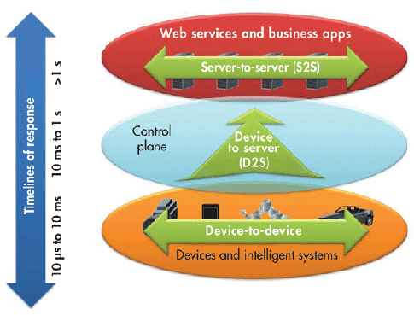

Figure 8 IoT Connection Types

During our research , we found issues of IoT and cloud security such as following:

* Poor Authentication and Authorization
* Poor Encryption strength
* Poor key Management
* Poor Random Number Generator
* Insecure Web Interface
* Insecure Firmware
* Insecure Communication Protocol (wireless)
* No Adaptive  Redundant Design for system level
* No Adaptive Isolation Design for system
* No Adaptive Defence Design for system

SECURE ROOT OF TRUST (TRUSTED ENVIRONMENT)

Security is extremely important to protect the data of the end-user and would be a key feature as we move deeper into contextual awareness. We offer an enhanced trusted environment both at the H/W and S/W level that is shown by the diagram below. [4]

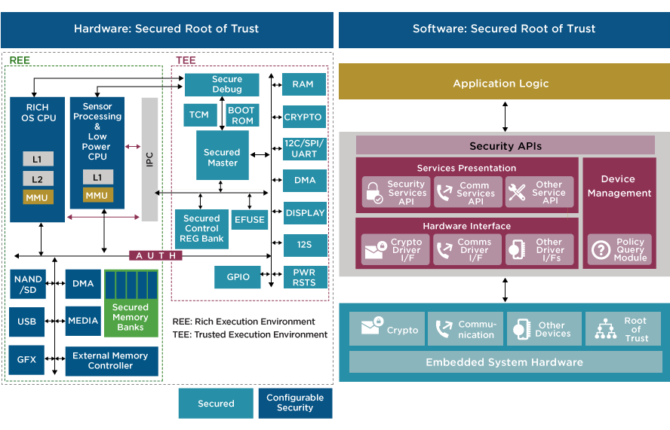

Figure 9 Secured IoT Platform Architecture

**Security capabilities for the Internet of Things**

There are a number of security features to be considered when developing an IoT device. Capabilities that should be evaluated during the requirements specification phase include the items in the table below.

|  |  |
| --- | --- |
| Feature | Implementation in embedded devices |
| Secure boot | Achieved using cryptographically-signed code from the manufacturer along with hardware support to verify code is authentic. |
| Secure firmware updates | The ability to update the firmware on a device in a secure fashion so that only authentic firmware from the OEM can be installed. |
| Data security | Data at rest (DAR) protection using encrypted data storage and data in transit protection using secure communication protocols. |
| Encryption | Data encryption is required for data at rest security, secure communication, secure boot, and secure firmware updates. |
| Key storage, key generation, and certificate management | Security keys and certificates must be securely stored, generated, and managed to enable encryption protocols, authentication, and secure boot. Strong encryption solutions can be easily compromised as the result of improperly implemented key storage. |
| Authentication | All communication with the device should be authenticated using strong passwords (at a minimum) or certificates. |
| Secure communication | Communication to/from the device needs to be secured using encrypted communication. 40-bit encryption keys that were once state-of-the-art are no longer considered secure. |
| Embedded firewalls | Embedded firewalls provide a critical layer of protection against attacks. A firewall can limit communication to only known, trusted hosts, blocking hackers before they can even launch an attack. |
| Intrusion detection & security monitoring | A hacker could execute thousands or millions of invalid login attempts without the attack being reported. Embedded devices must detect and report invalid login attempts and port scans. |
| Embedded security management | Integration with a security management system allows security policies to be updated to mitigate known threats. |

References

[1] ETSI, “Machine to Machine Communications,” TS 102 689.

[2] Al-Sarawi S., Anbar M., Alieyan K., Alzubaidi M., Internet of Things (IoT) Communication Protocols : Review, 2017 8th International Conference on Information Technology (ICIT), July, 2017

[3] Salman, T., Internet of Things Protocols and Standards, 2015.

(Access Date: <https://www.cse.wustl.edu/~jain/cse570-15/ftp/iot_prot/> )

[4] Ineda’s IOT Solutions. <http://inedasystems.com/iot-technology/>

## Analytics technologies

### Intelligent IoT systems

IoT sensors are getting smaller, more advanced and cheaper. Connectivity is ubiquitous, and private networks are more secure than ever. It's highly functional to use these developments in healthcare, like every parts of life. Technology and health science collaboration can create wonders to treat patients. The WHO (World Health Organization) says adherence for long-term treatments of chronical illness such as cancer, HIV in developed countries is around %50 and it's even lower in developing countries.  
There’s growing interest for the IoT healthcare industry, how smart devices and other technology can help improve adherence.   
UK based Telit have projects over IoT healthcare solutions, they have two use case studies. One of them is to monitor patient’s data through web interfaces the other case study is a wearable that is used by patient. Wearable is two-way channel; patients can use it as emergency buzzer.   
xCube from Texas USA also have IoT healthcare solutions, and also have future projects for smart hospitals. They offer these solutions adopted for a customer, customer here is no single user as we planned in eWatch. They offer this solution to a healthcare corporate organization.  
ITCube BPO offers data management solutions captured by IoT devices. ITCube has also ability to analyse and process health data.  
Beside wearables IoT solutions has wide usage in healthcare solutions. Weka, The Vaccine Smart Fridge uses an IoT platform that collects real-time data from numerous sensors on every unit to enable real-time monitoring and analysis. IoT -enable device keeps vaccines fresh, secured and accounted for.  
GOJO offers a hand care hygiene compliance control system through a hospital, it has sensors on the doors that can detect the traffic flowing. The other sensors located on hand care dispensers, so they can analyse the data and monitor hygiene level of specific areas in a hospital.

### Signal processing and feature extraction

Photoplethysmogram (PPG) is a measuring modality that is widely used in wearable solutions. It is low cost and easy to use in watch type applications. However, PPG is prone to artefacts during movement or when the sensor contact is poor. Therefore, detecting the reliability of the measured signal and/or cleaning the signal from artefacts is essential. Various signal processing techniques for resolving this challenging problem have been proposed including adaptive filtering, wavelet analysis, template matching, dynamic time warping, pulse segmentation, and contour analysis. For signal reconstruction of PPG affected by movement artefacts, blind source separation techniques such as independent component analysis both in time and frequency domain and singular spectrum analysis have been popular. Often measurement of body acceleration to detect movement is combined with the PPG measurement and the accelerometer signal can be processed in combination with PPG. An additional critical aspect to consider in the pre-processing of the PPG signal is not to distort the physiological information that it contains.

PPG measures the changes of blood volume in the vascular bed of the tissue and is rich of physiological information. In cardiac monitoring, the most common feature is heart rate, which can be extracted by either using spectral methods or detecting individual pulses which represent the heart beats. For accurate heart rate estimation even during activity, different signal processing methods have been developed. These methods for example combine signal decomposition and spectral estimation. In addition, information from the accelerometer spectrum can be used to further clean the spectral estimate of PPG during activity for heart rate detection.

From detected PPG pulses, inter-pulse intervals have been used for extracting additional features beyond heart rate. Heart rate variability is related to many physiological functions and pulse rate variability features have been shown to be a good surrogate measure for heart rate variability features. In addition, irregularity features such as entropy from inter-pulse intervals have been used for atrial fibrillation detection from PPG.

The shape of the PPG pulse has been also studied for the physiological information that it contains. Extraction of the systolic and diastolic phase is done by dividing the area of the pulse or by fitting several Gaussians. The relationships between the diastolic and systolic phases as well relationships of different fiducial points of the pulse contour have been studied, e.g. for arterial stiffness and aging. In addition, variation in pulse amplitude or width has been used to extract respiratory rate information.

### Machine learning and decision support

**Predictive model selection**The class of (generalized) linear mixed models provides a flexible framework for modeling different data types, including longitudinal and spatial data. These models are widely used in applied statistics in various field such as economics and medicine. In practice, a key aspect of the analysis is model selection or sometimes referred to as variable selection, the choice of a particular model within a possibly very large class of candidate models. The purpose is to choose a parsimonious model with desired properties such as predictive power/accuracy such that the model can be used to predict event/outcome of interests for future data and to play a significant role in terms of decision making.

There is a substantial literature on model selection for linear mixed models which has grown extremely rapidly in the last 5-10 years. In general, model selection methods can be categorized into four broad approaches: (1) stepwise selection; (2) information criteria based methods; (3) shrinkage methods like the LASSO; and (4) Bayesian methods. These techniques are interesting and important both in its own right and as a starting point for the development of more complicated classes of models such as generalized linear mixed models, non-linear mixed models, and various semi-parametric and nonparametric models. On the other hand, primitive applications of various shrinkage methods in generalized linear mixed models have recently been proposed and the academical literature still remains sparse with regards to model selection for prediction in generalized linear mixed models.

In the eWATCH project, a critical component of the decision support system is the automated algorithms that can predict events of interests (such as heart failure) for patients based on the physiological and behavioral information to facilitate timely interventions. Therefore, to ensure the prediction accuracy of the algorithms/model, it is essential to select the most relevant information/model. Not only the techniques of model selection for prediction in the generalized linear mixed model developed in the eWATCH project will significantly improve the accuracy of the decision making support system, it will also have substantial contributions to the research field with wide ranges of applications.

# CONCLUSIONS

The SotA provided in this deliverable explains a good context and starting point for the eWATCH activities, handling the present situation in the technology that the project focuses.

1. C.A. Chirinos, “Arterial Stiffness: Basic Concepts and Measurement Techniques”, J. of Cardiovasc. Trans. Res. (2012)