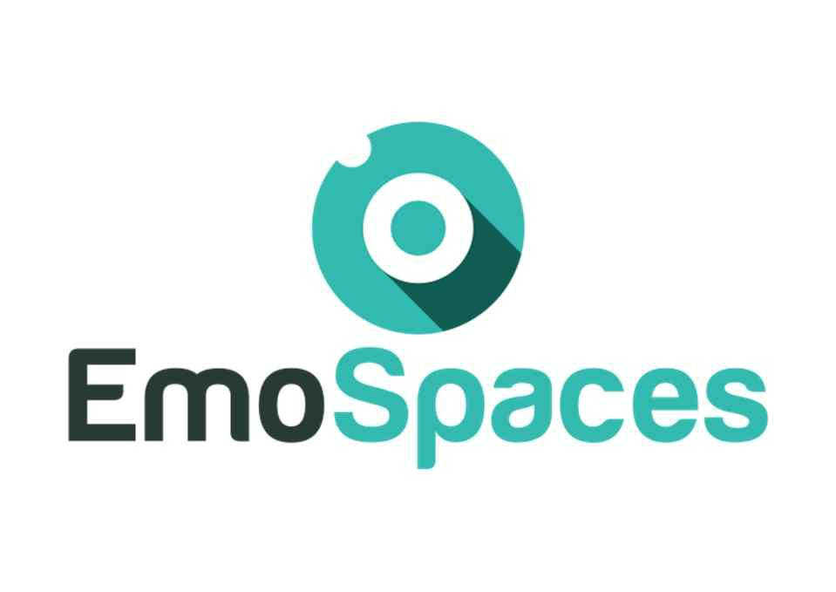

T2.1 – Review on IoT/SmartHome sensor technologies

D2.1 – IoT technologies used in

EmoSpaces Services

Date: | 2018/05/31
Title: | D2.1 – IoT technologies used in EmoSpaces Services
WP/Task: | WP2 – Sensing Emotions in Space
Editor: | ETRI/ Thales

 This page is intentionally left blank. 

Content
1. Introduction 5
2. The EmoSpaces Testbed 5
2.1 Smart home overview and beyond 6
2.2 Smart home services 6
2.2.1 Measuring home conditions and managing home appliances 7
2.2.2 The main components 7
3. Sensor Technologies for EmoSpaces Demonstrator 9
3.1. EmoSpaces Service A 9
3.1.1 – Wellbeing coaching 9
3.1.2. Autism Assistance 10
3.2. EmoSpaces Service B – Sound Streaming 11
3.3. EmoSpaces Service C e-Learning 11

Document history

Revision | Date | Content description/Modification | Author(s)
V0.1 | 2018-01-15 | Creation | Hyungkeuk Lee  (ETRI)
V0.2 | 2018-01-15 | First draft
V0.3 | 2018-01-31 | Minor changes. This version is an  intermediate release. The final release is  planned at M19
V0.4 | 2018-06-256 | Minor changes. This version is an  intermediate release. | Hyungkeuk Lee  (ETRI)
V1.0 | 2019-03-28 | Major changes | A.Chietera  (Thales)
V1.1 | 2019-04-15 | Minor Changes | MG  (Thales)
V1.2 | 2019-04-30 | Description of sensors and services | A.Chietera  (Thales)

Introduction

Intelligent environments refer to a physical environments in which information and communication technologies, sensor systems as well as pervasive computing, go unnoticed by users, since they are discreetly integrated into physical objects, infrastructures, and everyday environment in which we live, travel, and work. The objective is to allow computers and sensors to participate in activities in which they had never been involved, enabling people (users) to interact with different devices via gestures, voice, movements, or simple context information. The progress of the so-called Internet of Things together with the availability of Big Data technologies provides a great opportunity for the smart ambient development. In particular, IoT is composed of two terms: “internet” and ”things”. It allows things, or non-computer devices, to hear, see, think, compute, and act by allowing them to communicate and coordinate with each other in decision making. In other words, it allows things to act smartly and make a consensus decision that benefits many applications.

The applications of this technology range from the automation in home environments measuring and managing its status and they evolve till to provide services to ensure wellbeing. It could be also extended to improve customers experiences in intelligent stores. In fact knowing customer emotion it could be possible to influence the purchase decision, or in educational environments to improve the learning phase.

Today’s physical security infrastructure includes key passes, RFID badge scanners and IP-based cameras—all of which are designed to prevent emergencies. IoT can add another level of security to ensure that all touched points are networked and controlled through the web. And a more integrated physical system can lead to a smarter use of security resources, breathing new life into their roles.
For example, a unified system can help IP cameras recognize badged users to monitor where people should/shouldn't be, identify and predict traffic patterns, and increase fire or flood detection—all of which can alert security staff via smartphone for further investigation.

This represents only few examples of the application of this technology in various domains. For the development of the EmoSpaces testbed we will explore the concept of smart home with the integration of IoT sensors, networking them using the available technologies and facilitating their interaction, and finally deploying services by embedding intelligence in a domestic environment.

The EmoSpaces Testbed

Classic smart home, internet of things and the event processing systems, are the building blocks of our proposed advanced smart home integrated compound. Each component contributes its core attributes and technologies to the proposed composition. IoT may be also attached to home related appliances, such as lights, refrigerators/freezers and other environmental devices transforming objects or sensors from being passive observers to actively computing, communicating, collaborating and making critical decisions. In this perspective, our test environment is also equipped with “smart” camera in which an embedded intelligence is able to detect human activities, emotions and person localization. By embedding computer intelligence into home devices we are able to provide ways to measure human behavior and correlate this latter to the home conditions and finally deploy innovative home appliances. The processing system provides the control and orchestration of the entire advanced smart home composition adding smart algorithm providing ambient adaptation (use case B) and/or recommendation to improve well-being coaching (use case A) (or e-learning –use case C) activities.

2.1 Smart home overview and beyond
Smart home is the residential extension of building automation and involves the control and automation of all its embedded technology. It defines a residence that has appliances, lighting, heating, air conditioning, TVs, computers, entertainment systems, home appliances such as refrigerators/freezers, security and camera systems capable of communicating with each other and being controlled remotely. These systems consist of switches and sensors connected to a central hub controlled by the home resident using wall-mounted terminal or mobile unit connected to internet.
Installation of smart products could be problematic. In fact smart hardware coming from different brands such as Hue, Ikea or Xiaomi, has his own separate bridge or gateway that made difficult to networking them and to maintain a centralized event log. In most cases their infrastructure isn’t flexible enough to integrate w a wide range of devices from different providers and standards. This could be an issue to save money without buying expensive and dedicate gateways and for facilitate de deployment of a smart home platform.

2.2 Smart home services
EmoSpaces technology will deploy services for individuals to recognize their emotions and behaviors, and for which their situations and conditions work together to suit their personal circumstances. The following points have been pushed forward:

- It effectively captures and recognizes key signals, backgrounds, or situations related to a person's emotional life. These personal characteristics of users are deployed through a learning mechanisms (e.g., machines and deep learning) to make IoT services more knowledgeable, and the service policy and situation information are also personalized.
- Through this process, we propose content and ambient adaptation in an artificially constructed smart space.
- The research and development of these analytical models is a system in which the smart space environment and associated ICT devices and functional agents used by people are actively adapted and responsive to the situation.

To ensure that IoT service and major service processing technologies can be installed freely and easily made by using the existing web environment to implement the functions provided by the web.

This research team will simplify the intellection of WES services by using IoT related web object WoO technology which has been developed through European ITEA 2 over the past three years. In other words, we use WoO's VO and CVO processing skills to enable individuals to design and enhance their own personal experience for the intelligent and knowledge of the services they need.

2.2.1 Measuring home conditions and managing home appliances
A typical smart home is equipped with a set of sensors for measuring home conditions, such as: temperature, humidity, presence detectors and switches to manage the home appliances. Each sensor is dedicated to capture one or more measurement. The managing service allows the user, controlling the outputs of smart actuators associated with home appliances, such as such as lamps and fans. Smart actuators are devices, such as valves and switches, which perform actions such as turning things on or off or adjusting an operational system. All sensors allow storing the data and visualizing it so that the user can view it anywhere and anytime. To do so, it includes a signal processer and a communication interface.

2.2.2 The main components

To enable all of the above described activities and data management, the system is composed of the following components, as described in the figure below.
In order to avoid dedicate gateways for each brand of sensors and data publication towards the Cloud (ie mainly chinese or USA servers) we use a Zigbee USB sniffer that listens and decodes the data frames sent by the Xiaomi sensors. The sniffer is able to decode the states (ON / OFF, temperature, power ...) and then publish the data via MQTT messages. The MQTT server, used as a broker, serves as a computer gateway between the home automation software and every other solution to exchange data. For home automation we used Domoticz and to ensure communication with the sensors showed in the figure we installed on the board SDK2 By ST microelectronics / Raspberry Pi. This architecture is particularly advantageous because it allows to keep control of the personal data collected by the sensors: the data are sent via the local network, to the smart home server (without transferring them to a any kind of cloud).
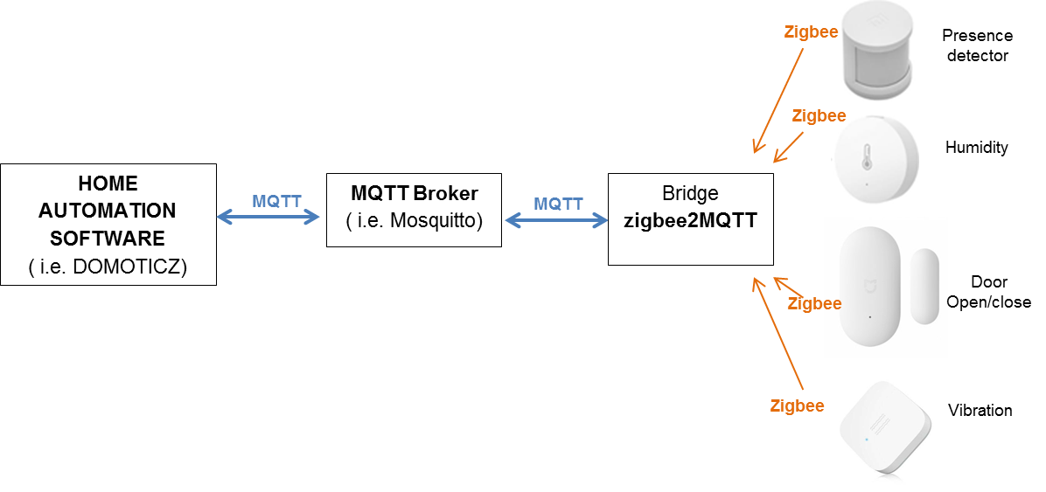

Concerning the broker we chose Mosquitto as an ideal tool for integrating objects connected to a home automation server such as Domoticz. Other smart home automation software compatible with MQTT are Jeedom, openHAB or Home Assistant. Moquitto can easily be installed on a board ST/ Raspberry Pi to facilitate communication between connected objects and the other processing systems implemented by the other partners.
MQTT (Message Queuing Telemetry Transport) is a messaging protocol that works on the principle of underwriting / publishing that was developed at the base to simplify communication between the machines.
Since November 2014, version 3.1.1 of MQTT has become an international standard for communication between machines (M2M) and objects (IoT)
In addition to simplifying communication, MQTT was designed to save as much as possible the battery of the mobile devices on which it is used. It is 11 times less energy consuming to send messages and 170 times less to receive than HTTP. MQTT is also 93 times faster than HTTP.
Other useful functions are:
• The Persistence of messages on a Topic. The messages are stored on the Broker.
• It is possible to manage the subscription / publication rights for each Topic.
• It is possible to secure the transport of the messages in SSL / TLS as well as by identification of the user (identifier and password)
• Topics and the tree are created on the fly. There is nothing to configure on the Broker. It is the “publisher” who created the Topics tree (at the time of publication)
• MQTT also has various QoS settings that are set up at the time of data publication and allowing various scenarii depending on the nature and criticity of the data.

Sensor Technologies for EmoSpaces Demonstrator

EmoSpaces involve a series of service domains. Each service has several use cases, and in this section we review sensor technologies used in each use case scenario.
The following tables summarize the characteristics of the sensors that are intended to be used within each service in the EmoSpaces project.

EmoSpaces Service A

3.1.1 – Wellbeing coaching

Hapicare is the application we develop during the EmoSpaces project that enables to collect heterogeneous information about patients with Chronic diseases and using a smart reasoning-engine in order to provide an e-coaching to them. Although, the majority of collected information are medical, i.e. electrical health records, symptoms and vital sign records, but the non-medical information that EmoSpaces provides is vital to have a more comprehensive understanding of the patients’ situation and hence a better coaching. These information are collected using the sensors listed in the tables below.

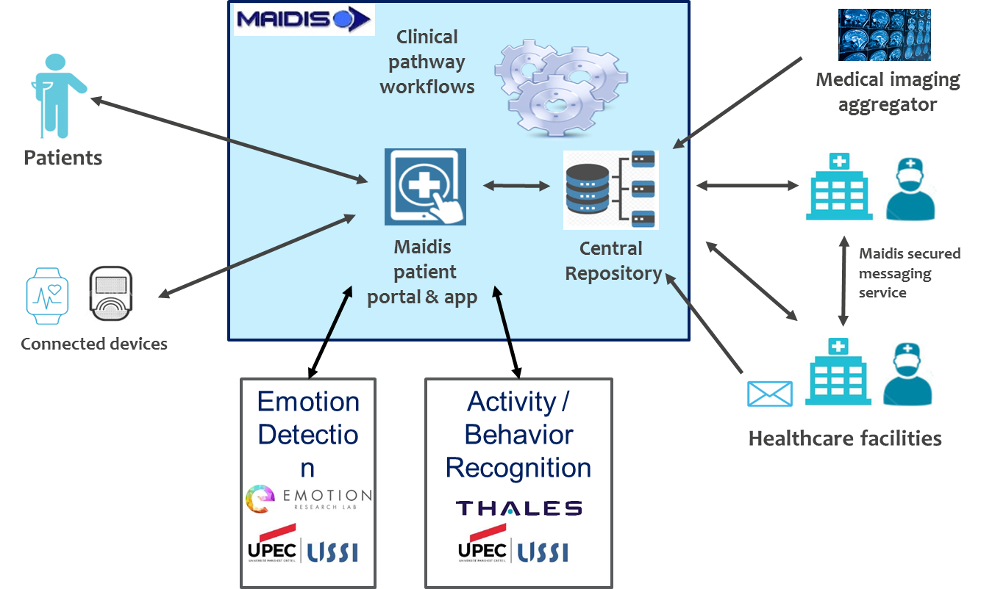

Sensor | RGB cameras; depth cameras; microphones
Place of use | Cameras placed in the user’s home. The corridors, living room, and kitchen are to
 | be fully covered. This amounts to roughly 5 cameras for an average apartment.
Time of use | Always on.
Extracted info | • User ID.
• User location inside the home.
• User activity.
• User emotion.

Sensor | Smartphone
Place of use | Follows the user.
Time of use | Always on.
Extracted info | • GPS Tracking
 | • Nutritional quality of meals.
 | • Type of restaurant the user eats at.
 | • Nutritional quality of purchased foods.

Sensor | Connected band
Place of use | Follows the user.
Time of use | Always on
Extracted info | Physical cues to determine health and wellbeing:  - Heart beat  - Body temperature  - Blood pressure  - Step count  - Weight (connected to scale)  - Calorie intake  - Glucose levels  - Sleep monitoring

Sensor | Smart meter ; Security sensor ; Multi sensors (humidity, luminance, temperature) ;  Smart light switch; Doorlock ; Open/closed sensor ; vibration detector; presence detector
Place of use | Room, living room and kitchen with sensors.
Time of use | Always on.
Extracted info | • User’s usage pattern

3.1.2. Autism Assistance

This service provides a VR to train children affected by ASD to face unusual situation. Going to the dentist is one of the most stressful experiences that we have. Considering that, think about how this activity can be for an autistic kid when they don’t know what is going on.
How the system works:
  - Before users start the training a camera that, including intelligence is able to recognize their emotional state.
  - Helper specialists configure the scene lights and sounds according the user emotional state.
  - After finishing the VR simulation, a camera recognizes their emotional state again.
  - It is possible to check if VR simulation is effective comparing user’s emotional states before and after the training.
  - During the simulation a red light indicates that users have to be seated. When the red light changes to green, users can stand up

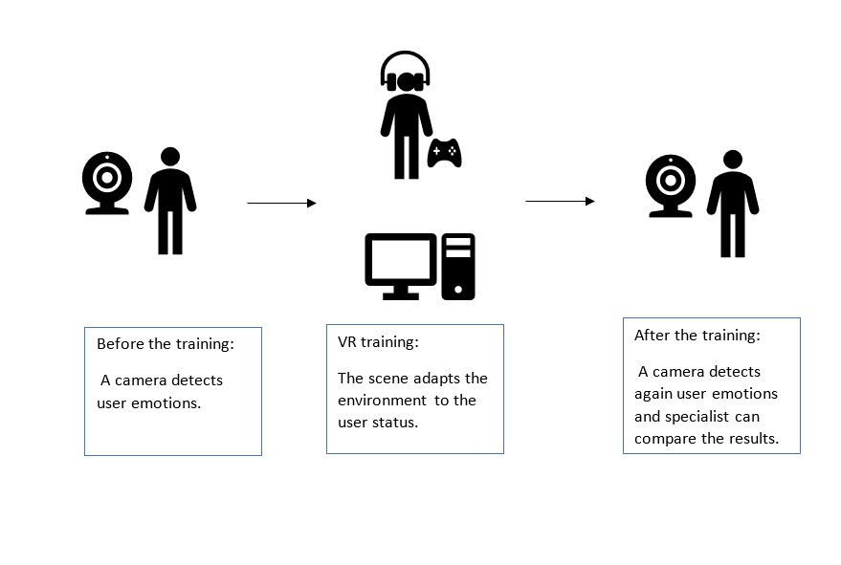

Sensor | RGB cameras
Place of use | Cameras placed in the user’s home.
Time of use | Only during the training phase
Extracted info  with AI Engine | • User ID.
 | • User emotion.

3.2. EmoSpaces Service B – Sound Streaming

The figure below show the architecture and the building block used in a music streaming system able to stream music sur any kind of brand devices according to the preferences of the user, his position in an apartment, his current activity and his emotion.

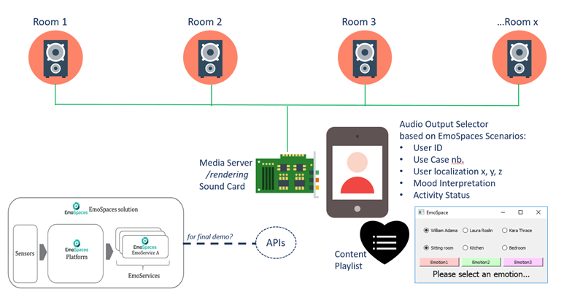
Sensor | RGB cameras; depth cameras; presence detector
Place of use | Cameras placed in the user’s home.
Time of use | Always on.
Extracted info | • User ID.
• User location inside the home.
• User emotion.

EmoSpaces Service C e-Learning
The aim of this service is to integrate a tool within an e-learning platform, capable of
analyzing users’ emotion while Interacting with the virtual classroom, in order to adapt
the intelligent spaces and enhance the user’s experience.
- User Modelling: provide experiences adapted to user’s emotions or preferences.
- Modelling of Virtual and Physical Spaces.
- Interactive Platform that evolves according to users emotional responses.
- Provide Recommendations adapted to users needs focused on their motivation
and offering a more fluid and attractive experience.
- Gather first-hand feedback from users useful to improve contents or
methodologies

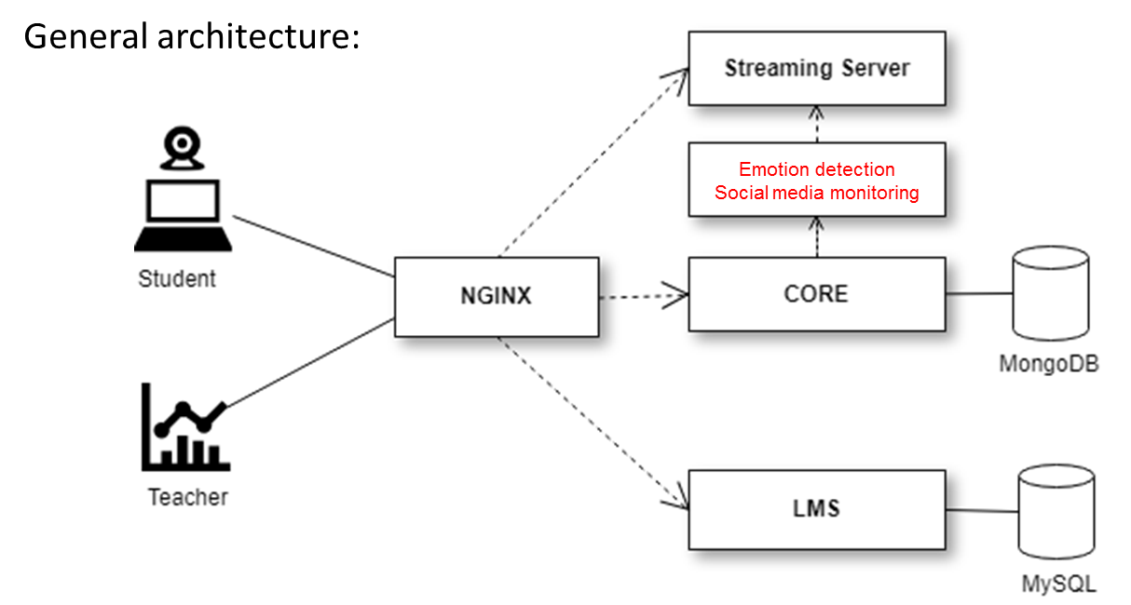
Sensor | User’s laptop camera
Place of use | Placed on the user’s personal computer.
Time of use | During entire tasks (homework).
Extracted info | • Emotion detection.
 | • Engagement with the task
Sensor | Social Networks Monitoring
Place of use | Twitter
Time of use | Always on.
Extracted info | • Online textual cues to determine engagement.
 | • Location (through latitude and longitude).
Sensor | Connected Band
Place of use | On the user.
Time of use | On during task.
Extracted info | • Pulse and skin temperature.

