Standardization and dissemination
•••••••••••••••••••••••••••••••••••••••••••••

Edited by: Antoine Garnier
Date: August 30th, 2017
Table of Contents
1.Introduction 3
2.List of standards in MOOCTAB 4
2.1.Content standards 4
2.1.1.Standards for publication 4
2.1.2.Standards for data management 6
2.2.Standards related to hardware 9
2.3.Security standards 9
3.Cartography of main standards 10
3.1.Security standards 10
3.1.1.Involvement of partners 10
3.1.2.Relationships between standards organizations 10
3.2.Table of standards at stake in the MOOCTAB project 11

Introduction
This task focuses on standardization issues in the project. The deliverable identifies relevant standardization bodies (IDPF, W3C, afnor, ISO, etc.) regarding different aspects of MOOCTAB project (security, digital publication, hardware). This first part also describes the standards associated to these bodies and gives short descriptions of them. It includes their operation and special features when they are in direct competition (xAPI and Caliper). Then it focuses on relationships between standards bodies. Eventually the document provides a table containing all the relevant standards of the project.

List of standards in MOOCTAB

Content standards
Various standards already exist in the education ecosystem. They are used for publication and data management notably.

Standards for publication

SCORM
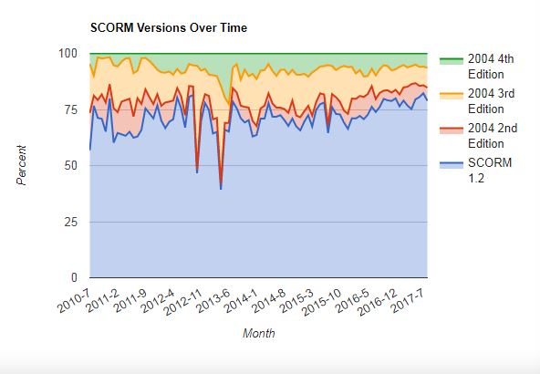
Probably the most well-known standard for education, SCORM first release dated back to the year 2000, then it was widely adopted from 2001 with the second release. We are now using the 4th edition with the most recent release in 2009. Nevertheless the first version is still the most used version:

SCORM versions used over time

SCORM for Sharable Content Object Reference Model is featured by 4 dimensions interoperability, portability, reusability and sequencing. Interoperability defines ways to communicate between client side content and the LMS (learning management system). Portability for SCORM is made up of the CAM (Content Aggregation Model). It provides models for the packaging of content basically in a Zip file (such as it is for ePub file). Reusability is provided by the CAM defines a way to search and discover the learning object. It gives the requirements to build and organize content (e.g., course, lessons, modules, etc.). It includes rules about metadata as well. A later release of the standard introduced sequencing of activities that enables to organise the learning objects in paths. They permit the learner to better watch his progress, bookmark it and then know when to break between competencies.
SCORM is a specification of the Advanced Distributed Learning (ADL) Initiative – a government program from the Office of the United States Secretary of Defense.
The standard uses XML and is based on previous works from AICC, IMS Global and Ariadne (LOM).
Broader than SCORM, TinCan is viewed as the successor of the ADL norm. It resolves many problems inherent to SCORM. It also goes beyond SCORM with the possibility to collect data with statements of learning objects (see infra). ADL stays the owner of the standard and continues to maintain it through Tin Can (Experience API) that replaced SCORM.

ePub
ePub is a standard for digital publication. Like SCORM it enables to package content file in a zip package that could be read in specific e-readers.
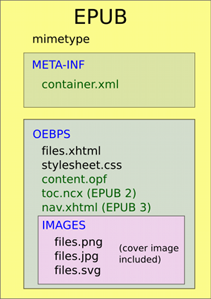
Composition of an EPub file
Content files (HTML files) are encapsulated in a package with CSS files and images. They are displayed following the navigation file (nav.html). The standard vocation is to package and encode structured and enhanced web content to distribute it in a single file format. EPUB allows publishers to produce and distribute a single digital publication file. It provides consumers large interoperability between soft and hardware for digital books and various kinds of publications.
The standard is maintained by the IDPF (International Digital Publishing Forum). The association is responsible for establishing a standard for ebook publishing. On January 2017 IDPF was combined into the W3C. IDPF is now a dedicated branch of the W3C with a Publishing Steering Committee and various sub-groups to support the development of the standard (Business, Digital Publishing Interest and Working Group). This merge was decided to “fully align the publishing industry and core Web technology” as the technologies involved were largely the same. The “education profile” of ePub 3 has been also committed to W3C and still discussed within the community group. The EPUB for Education profile represents the effort to adapt the EPUB 3 format to the unique structural, semantic and behavioural requirements of educational publishing. It includes a strong focus on accessibility with the integration of DAISY consortium requirements directly in the ePub standard. ePub is also compatible with data management standard such as QTI and others IMS Global standards. The last draft of the format has been published on May, 31st, 2017.
As said earlier, technologies used by ePub are very similar to those used for displaying the Web, especially HTML that is completely central.

HTML5
HTML is the main standard to create web pages and web applications. With CSS (Cascading Style Sheets), they constitute two emblematic technologies that organize the World Wide Web. W3C is the maintainer of both the HTML and the CSS standards.
Also used for education, HTML serves more general purposes as it is widely used for displaying every kind of content on the Web. No specificity of the standard is related to education.

Standards for data management

QTI
QTI for Question and Test Interoperability is a standard that ensures interoperability authoring and delivery systems and various kinds of learning managing systems. It defines a standard for the representation of assessment content, the results and the communication between each other.
The specification consists of a data model that defines the structure of the assessment (questions, results, questions and results). The core of the model is a method to interchange questions and other assessment material. This XML data biding is used to exchange questions between different authoring tools and by publishers.
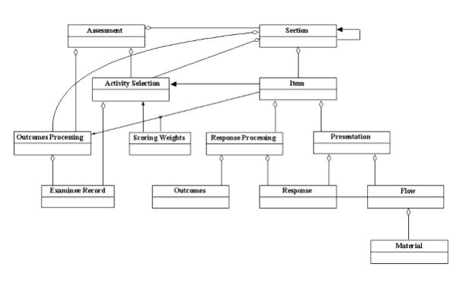
Relationships between the different objects constituting a Q&A interaction
The relationships between the three main elements (item, assessment and section) define the data structure model used for QTI so that tracks could be monitored and assessed.
IMS Global is the maintainer of the standard as for LTI and Caliper (see infra).

Caliper
Caliper helps to capture learning interactions within the learning environment (LMS, learning objects, assessment, etc.). This captured data to promises give new information about how interactions are related to learning outcomes. This data can help educators with more accountability, more insights regarding effectiveness of their work or real time perception of the classroom.
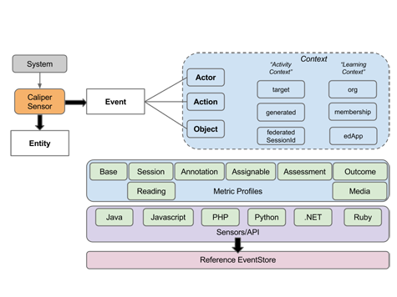
Operation of Caliper and description of main tags related to Sensors API
Caliper maintainer is the IMS Global Learning Consortium also responsible for the QTI and LTI standards.

TinCan

Also named xAPI, TinCan enables communications and tracking between learning objects. “Learning experiences” are gathered in a Learning Record Store (LRS). LRS can be integrated in LMS or stand on their own. xAPI is viewed as the true successor of SCORM even if the technology resolve larger issues than its predecessor especially in security, mobile or analytics area.
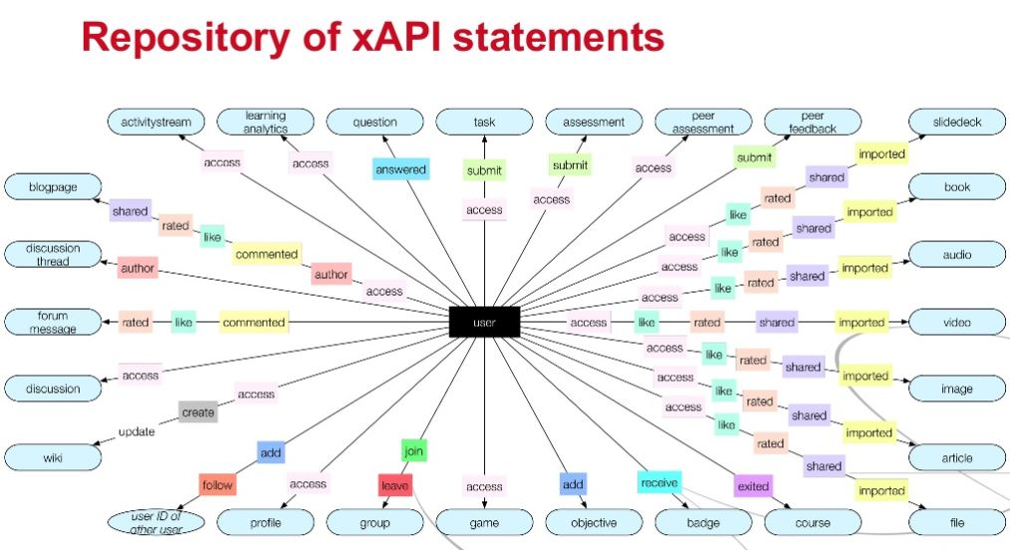
xAPI statements types

xAPI is an open source API. It is maintained by ADL like SCORM. The last version of the draft dated back to October 2016.

Standards related to hardware
Communication (NFC Forum)

Security standards
Two standards related to the secure element are already used by the project regarding electronic identification and secure execution environment.

Electronic identification
eIDAS (electronic IDentification, Authentication and trust Services) is an EU regulation. This is a a set of standards concerning electronic identification and trust services for electronic transactions dedidcated to the European Single Market. It was established in EU Regulation 910/2014 of 23 July 2014 on electronic identification and reestablished in directive 1999/93/EC from 13 December 1999.
eIDAS oversees electronic identification and trust services for electronic transactions. It regulates electronic signatures, electronic transactions, involved bodies, and their embedding processes to provide a safe way for users to conduct business online like electronic funds transfer or transactions with public services. eIDAS has created standards for which electronic signatures, qualified digital certificates, electronic seals, timestamps, and other proof for authentication mechanisms enable electronic transactions, with the same legal standing as transactions that are performed on paper. It has been lately adapted to educational purposes by companies such as Gemalto.

Secure execution environment

GlobalPlatform announced in July 2010 their own standardisation of the Trusted Execution Environment (TEE), focusing first on the client API (the interface to the TEE within the mobile OS) which was expanded to include the TEE internal API, a Remote Administration framework.

Cartography of main standards

Security standards

Involvement of partners

Gemalto
- eIDAS & Privacy Management: TR-03110 v2.20- Part 2 (eID & eSign), ISO/IEC 19286 (ERA), ISO/IEC 7816 – 4, 5, 6, 8, 9, 15
- Global Platform 2.3
- Javacard 3.0
- European Standard EN 419212 on digital signature, EN 419211 part 2 to part 6
- Biometry: ISO/IEC 19794-2 Finger Minutiae Compact-Size Card formats, ISO/IEC 7816-4 and 7816-11
- Communication interfaces: ISO/IEC 7816-3, ISO/IEC 14443 - 3, 4
- Physical Characteristics and Test Methods: ISO/IEC 7810 (Identification cards – Physical characteristics), ISO/IEC 10373 (Identification cards – Test methods) Parts: 1/3/6
- Integrated Circuit Cards with Contacts: ISO/IEC 7816 (Identification cards – Integrated circuit cards) Parts: 3/4/5/6/8/9/11/15
- Contactless Integrated Circuits Cards: ISO/IEC 14443 (Identification cards – Contactless integrated circuit(s) cards – Proximity integrated circuit(s) cards) Parts: 1/2/3/4
- Public-Key Cryptography and Signature: PKCS#1 (RSA Cryptography standard), PKCS#15 (Cryptographic Token Information Format Standard), RFC2409 (Internet Key Exchange)

NXP

For NXP, regarding the NFC and the embedded Secure Element (eSE), we are conform to:

- NFC Forum Specifications (https://nfc-forum.org/) for the contactless communication and the management of the NFC Controller
- Global Platform (https://www.globalplatform.org/) for the secure communication with the eSE

NXP is a main contributor to NFC Forum as major provider of NFC solution and not especially thanks to MOOCTab.

But we are interested in this project to open new opportunities such as usage of eSE in Tablet (today the main market of eSE is for payment with smartphone).

Relationships between standards organizations

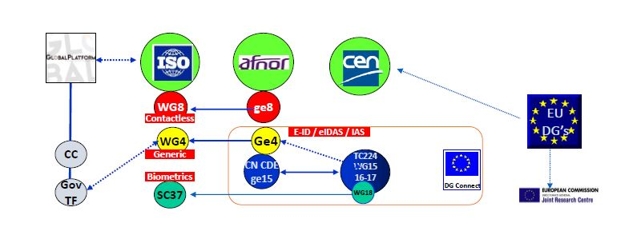

Table of standards at stake in the MOOCTAB project

https://scorm.com/wp-content/assets/scormstats/stats.php

