Water -M Project

D2.2 End-to-End Communication Network v 1.1

History
Date | Version & Status | Author | Modifications
02/03/2017 | v0.1 | Kamal Singh (UJM) | First Draft
27/07/2017 | V1.0 | Kamal Singh (UJM) | Added WiSUN description provided by ITRON
14/09/2017 | V1.1 | Kamal Singh (UJM), Amro Najjar (UJM) | Reorganized sections and added more description
05/12/2017 | V1.2 | Nikesh Man SHAKYA (Itron)  Mehdi Mani (Itron) | Modified WiSUN Protocol description

Contents
1 Introduction 4
2 Communication Protocols 4
2.1 Endpoint to Gateway 5
2.1.1 Wireless network 5
2.1.2 Wired network 9
2.2 Gateway to Head End 9
2.2.1 MQTT (Message Queue Telemetry Transport) 9
2.2.2 HTTP (HyperText Transfer Protocol) 10
3 Conclusion 10
4 References 10

Abstract

This deliverable describes the various wired and wireless communication protocols between endpoints, gateways, and the data storage and processing platform used in Water-M.

It specifically focuses on the communication protocols between sensors (data of several sensors can be concentrated by a local hub before being transmitted to the gateway) with the data concentrator gateway and between gateways with the data platform. The orientation of protocols is to guarantee the integration of existing control, SCADAs and sensing subsystems through either defined interfaces for small devices and/or specific gateways for larger subsystems.

This task provides last mile communication technology and protocols. The last mile technology provides data acquisition between smart-meter (or Home-level Gateway) and data collector application.

Introduction

The rise of the global population and the limited availability of fresh water are key issues of public concern over water availability, water quality, failing water infrastructures, and overall water management complexity. As a result, the market for safe, available water and for the infrastructure and technologies that treat and transport water is expected to grow rapidly as stakeholders look for new solutions and approaches to integrated water resource management. The adoption and integration of ICT to the water sector is one viable solution for a better decision support and improved productivity.

Smart water networks apply ICT to deliver solutions to numerous water-related issues that are currently handled inadequately by inefficient and often manual processes. For example, these systems can remotely and continuously monitor (hydraulic and water quality), report water consumption, and diagnose problems (leakage and burst detections); pre-emptively prioritize and manage maintenance issues, and remotely control and optimize all aspects of the water distribution network using data-driven insights. They can also be used to provide water customers with the information and tools they need to make informed choices about their behaviors and water usage patterns, and to comply transparently and confidently with regulatory and policy requirements on water quality and conservation [1].

Figure 1. General Architecture

Communication Protocols

This section describes the communication protocols. Following Figure 1. showing a general communication architecture, the protocols are divided into two main categories: 1) End point to Gateway 2) Gateway to Head-End System. After that there are sub categories depending on whether they are wireless, wired, long range or short range, etc.

Endpoint to Gateway

The endpoint to gateway communication should be energy efficient as different sensors and devices will be battery operated, which in turn are expected to last for 10 to 15 years.

Wireless network
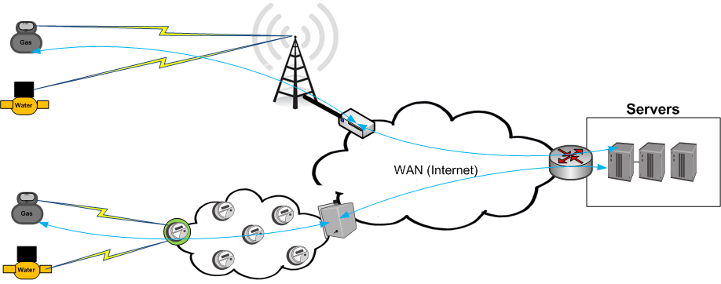

Figure 2. Long range and short range wireless connections
In order to connect different sensors and smart water meters, different solutions exist as illustrated in Figure 2. Long range wireless solutions like GPRS and LoRAWAN [2] can connect the end devices to a given wireless gateway with a range of several kilometers. However, long range wireless solutions have limited bandwidth. On the other hand, short and medium range solutions like Zigbee [3], Bluetooth, WiSUN [4], etc., can connect the end nodes using a mesh network and can support high density of connected end devices. In case of no radio coverage a backup solution, such as GPRS, is needed.
The technologies chosen for Water-M are WiSUN and LORAWAN that are described in the text below. WISUN will be used to connect smart water meters and LORAWAN will be used to connect sensors for water distribution monitoring network. GPRS is used as a backup solution in case of no radio coverage by other technologies.

Wi-SUN
Wireless Smart Ubiquitous Network (Wi-SUN) [4], is a wireless communication technology designed for Utilities, Smart Cities and IoT. Wi-SUN is based on various IEEE, IETF, and ANSI/TIA standards supporting low power and lossy networks. It is supported by the Wi-SUN alliance TM which in turn defines communications profiles based on Open Standards.
Some competitive characteristics of Wi-SUN includes the following:
- Coverage range in kilometers
- Support of IPv6
- Assured interoperability
- High bandwidth up to 300kbps
- Low latency 0.02 seconds
- Supports star, mesh and hybrid topologies
- Highly Resilient and scalable mesh routing
- Secured
- Power efficiency
- Low Operational Expenditure/ low infra-structure cost

Protocol Stack
Figure 1: Wi-SUN Protocol Stack
Profile specification are categorized based on application. Different layer in the protocol stack may use different option depending on the application. Profile specification are categorized based on application. Different layer in the protocol stack may use different option depending on the application. These profiles are developed using the IEEE802 and IETF standards. The stack overview of Wi-SUN FAN is illustrated in Figure 1.
The PHY layer is based on IEEE 802.15.4g, which provides bi-directional communication with high data rate (up to 300kbps) and low latency. The low power consumption permits a battery-powered FAN device to listen frequently while maintaining a lifetime measured in years.
The MAC sub-layer is based on IEEE 802.15.4e along with Wi-SUN defined Information Extensions (IEs). The MAC layer supports channel hopping for both unicast and broadcast frame transmission. The total number of channels available is determined by the regional band and the channel spacing. A node can also choose to exclude a set of channels from its hopping sequence.
The network layer is IPv6 with 6LoWPAN [RFC6282] adaptation. Two methods are available for packet routing: RPL [RFC6550] non-storing mode and MHDS is optional at the Logical Link Control (LLC) sub-layer. The Wi-SUN FAN supports star and mesh topologies, as well as hybrid star/mesh deployments to connect end devices. In star, there is at least one FFD (fully function device) that acts as a PAN co-ordinator which is often mains powered and the communication is established between the devices and the PAN coordinator. In mesh, each node participates in the relaying of data to the network gateway. This has an advantage of having multiple paths without a single point of failure. Such network also has more bandwidth and can support high density of connected nodes. The mesh architecture also allows for distributed computing and local intelligence in the network nodes.
It has integrated a standards-based multi-layer security specification encompassing authentication, authorization, encryption.
Targeting different applications, WiSUN defines different profiles [6] and related technical profile specifications:
- ECHONET profile focuses on smart meters’ communication in home area network (HAN)
- FAN (Field Area Network) profile focuses on communication between several smart meters in a field area network.
A Wi-SUN FAN node can operate in any of the regional frequency bands defined in [PHYSPEC], i.e. 470-510MHz, 779-787MHz and 920.5-924.5MHz in China, 863-870MHz and 870-876MHz in Europe, or 920-928MHz in USA, Canada and Japan. The radio interface is also compliant with local regulations of India, Mexico, Brazil, Australia, New Zealand, Korea, Philippines, Malaysia, Hong Kong, Singapore, Thailand, and Vietnam.
A channel function defines a method used to determine, from the list of available PHY channels, the specific channel upon which a node is operating at a given time [FANTPS]. The resulting hopping schedule is advertised to the neighbors. A variety of channel functions can be implemented, including TR51 [ANSITIA-4957.200], direct hash [FANTPS], fixed channel and vendor defined channel functions. Related information is encapsulated in the unicast/broadcast schedule IE.
Routing
For layer-3 routing, Wi-SUN FAN adopts the non-storing mode of RPL. RPL requires the construction and maintenance of DODAGs (Destination Oriented Directed Acyclic Graphs). RPL uses various ICMPv6 control messages. To build a DODAG, the Border Router multicasts a DIO message to its immediate neighbors. Each neighbor decides whether or not to join the DODAG or not according to the objective function and other criteria. If so, the Border Router is noted as their parent. Each node in the DODAG sets trickle timers [RFC6206] for DIO message transmission. Upon receiving a DIO, if the node is the Border Router or the source node has a higher rank, the message is ignored; if not, in case that the node decides to join in this DODAG, the source of the DIO can be included in the node’s DODAG parent set; the node that has the best objective function value is marked as the most preferred parent, which provides the default upward route from the child node. Thus, the upward packets can be routed hop-by-hop to the root. A neighbor can send a DIS message to solicit the transmission of a DIO message. According to the non-storing mode of RPL, downward packets are routed using source routing from the root. Each node, except the Border Router, sends DAO messages to the Border Router indicating its route to its DODAG parents. When the Border Router receives DAO messages from all node, it can construct source routes to any node in the DODAG. For communication between two peers, in the non-storing mode, the packet goes up to the Border Router at first then sent to the destination node via source routing [RFC6997].
For layer-2 Mesh-under routing, it is based on MHDS as defined in ANSITIA-4957.210
Encapsulation
The Wi-SUN MAC MTU is 2047 bytes as defined in IEEE802.15.4g, satisfying the IPv6 packet length requirement. The header compression and fragmentation in 6LoWPAN [RFC6282] can be applied. Besides 6LoWPAN fragmentation, Wi-SUN FAN supports an optional L2 fragmentation. Wi-SUN FAN defines 7 frame formats, including PAN Advertisement frame, PAN Advertisement Solicit frame, PAN Configuration frame, PAN Configuration Solicit frame, Upper Layer Application Data frame, Acknowledgment frame and EAPOL frame. Detailed information can be found in [FANTPS].

LORAWAN

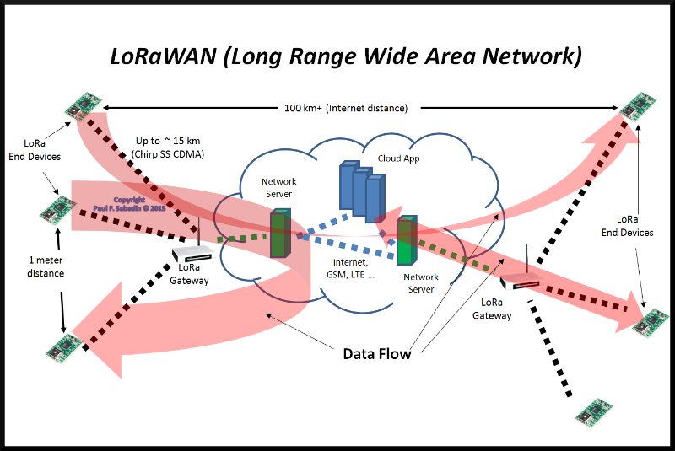
Figure 3. LORAWAN

LoRa is a cellular style wireless system which allows for private deployments. LoRa refers to PHY layer technology and LoRaWAN includes the communications protocols. It enables low data rate, ultra-low power and long-range communications IoT applications and uses the ISM bands (868 MHz for Europe, 915 MHz for North America, and 433 MHz for Asia). As shown in Figure 3, LoRa uses a star topology in which sensors with LoRa chip send encrypted data to the LoRa gateways. Then LoRa gateways relay messages to the servers at the backend which decrypt the data and process it.
Here are the characteristics of LoRa technology:
- A range of 15 - 20 km in environments with less distortions and around 2 km in urban environments
- Data rates of 0.3 kbps to 50 kbps.
- Energy efficient communication with end device batteries lasting up to 10 yrs
- Secure communication

GPRS
GPRS (General Packet Radio Service) is a mobile network service provided by the mobile operator. It requires a SIM card and a monthly fee paid to the operator.
GPRS is chosen in Water-M as the backup service in case of unavailability of other networks.

Wired network
Apart from wireless network, wired network can also be employed in case of availability. Power Line Communication (PLC) is considered as the wired network technology to connect end devices.

Power Line Communication (PLC)
The PLC technology connects the smart meters and end devices using the electricity wires already installed in the buildings. Thus, the electrical wiring is simultaneously used to transfer power as well as data. The data is transported by superposing the data signal over the power wave. PLC can be classified into two main types: broadband PLC and narrowband PLC.

Gateway to Head End
Once the data reaches the gateway then it needs to be sent to one or several servers present in the head end. The issues include elimination of redundancy and sending data to only relevant servers. HTTP is one of the popular protocols. Another protocol named MQTT has been designed for IoT applications.
Note that a bridge is needed to connect for example LoRaWAN plus UDP on one side and MQTT on the other side.
Figure 4. LORA Gateway Bridge

MQTT (Message Queue Telemetry Transport)
MQTT [7] is a publish-subscribe based lighweight protocol used for transmitting relevant data to relevant users based on their subscription. It is an ISO standard and works on the top of TCP/IP protocol.
The working of the MQTT protocol is described in Figure 4. Some clients publish data to MQTT broker which connects all clients. Then some other clients such as Server 1 in Figure 4 can subscribe to specific data or ”Topics” in MQTT language to receive that data from MQTT Broker. For example, a server could subscribe to the pressure data coming from a particular region in the city, etc.
Figure 4. MQTT Broker

HTTP (HyperText Transfer Protocol)
HTTP [8] is the popular protocol used in WWW which can be used by REST ful services. It works on the top of TCP protocol.
It uses a client server model. Where client sends an HTTP REQUESTS (for example using GET method) to get some resource and Server sends HTTP RESPONSE. Thus, in order to pull the data, which in turn is the resource, from a bridge or intermediate server, the requester will have to send a REQUEST message to it.

Conclusion

This report presented the choice of communication protocols for Water-M. Different protocols were classified based on whether they are used for end device to gateway communications or gateway to head-end communications.

References

[1] | Water 20/20 - Sensus, [Online]. Available: http://sensus.com/documents/10157/1577608/Sensus_Water2020-USweb.pdf.
[2] | [Online]. Available: https://www.lora-alliance.org/technology.
[3] | [Online]. Available: http://www.zigbee.org.
[4] | [Online]. Available: https://www.wi-sun.org .
[5] | IEEE Standard 802. 15. 4g, "Part 15. 4: Low-Rate Wireless Personal Arae Networks (LR-WPANs) Amendment 3: Physical Layer (PHY) Specifications for Low-Data-Rate, Wireless, Smart Metering Utility Networks, " April 2012..
[6] | [Online]. Available: https://www.wi-sun.org/images/assets/docs/20160315-Wi-SUN-interoperability-standards-r5.pdf.
[7] | [Online]. Available: MQTT.org, “Mq telemetry transport,” http://mqtt.org/, 2013..
[8] | Fielding, Roy, Jim Gettys, Jeffrey Mogul, Henrik Frystyk, Larry Masinter, Paul Leach, and Tim Berners-Lee. Hypertext transfer protocol--HTTP/1.1. No. RFC 2616. 1999..

