Task 1.1 – Business Models V1
•••••••••••••••••••••••••••••••••••••••••••••

Edited by: Antoine GArnier
Date: December 3rd,2015
Table of Contents
1. Introduction 4
2. Evolution of MOOCs 5
2.1. Where are MOOCs from? 5
2.1.1. Correspondence study 5
2.1.2. The emergence of electronic media 5
2.1.3. Computer: a solution for interacting 6
2.2. The First MOOCs: power of the network 7
2.2.1. The first attempts registered 7
2.2.2. Connectivism 8
2.2.3. Prior this attempt: Khan Academy & ITunesU 9
2.3. Defining a MOOC 10
2.3.1. MOOC are Courses 11
2.3.2. MOOC are Online 11
2.3.3. MOOC are Open 11
2.3.4. MOOC are Massive 12
2.4. Variations of MOOCs 12
2.4.1. cMOOC, xMOOc… 12
2.4.2. SPOC 13
2.5. Aims of a MOOC: what is the Business Model? 13
2.5.1. Reaching new students 13
2.5.2. Recruiting the brightest 13
2.5.3. Brand building 14
3. Revenues of a MOOC 15
3.1. Valuating your MOOC 15
3.1.1. The dropout rate 15
3.1.2. KPI of your MOOC 15
3.2. Revenues categories 16
3.2.1. Known revenues 16
3.2.2. Foreseen revenues 18
3.2.3. Revenues of the major players in the MOOC universe 19
4. Analysis of national policies 22
4.1. FUN: the French Initiative 22
4.2. Turkish policy for MOOCs 22
5. Annex 23

Introduction
Digital Technology has invested the field of higher education and training for several years introducing disruptive effects on teaching and opportunities for transformation and progress. The development of MOOCs reflects this transformation. In this context, universities anticipate a significant change in higher education towards more horizontal and massive practices, made possible by open and online learning. In this context:
- What MOOCs are the name of?
- Which expenses?
- Which models for these new tools?
- Where are the possible costs killing?
- Expensive tools for which purpose?
Businesses in contents are disappearing. More user’s generated contents, more free contents are killing the business of the publishing for education. This evolution is recommended by various French reports ordered by the Prime Minister or the Minister of Education.
- What is the future of paid content?

Evolution of MOOCs

Where are MOOCs from?
MOOCs may have seemed a quite new way of teaching, but if we are looking at history, it appears that it could be easily linked to various and earlier tools for educators. The evolutions of technology and of new learning experiences have always been related. As it has been defined by learning specialists, the field of distance-learning knew three main generations:
- Correspondence study
- Multimedia
- Computer-mediated

Correspondence study
The first steps of distance learning were done after the Industrial Revolution exponentially in Europe and United States, especially because a more skilled work force was needed for the factories. In addition, postal services were becoming faster, cheaper and more reliable. For example, in the 19th century, students from the Commonwealth (Australia) were given the choice to take correspondence courses from prestigious universities, such as the London School of Economics (University of London), one of the first in the United Kingdom to offer distance education. It provided access to higher education to students from less affluent backgrounds, an External Programme was chartered by Queen Victoria in 1858, making the University of London the first university to offer distance learning degrees to students. It was then followed quickly after by the United States and Columbia University at the end of the century where it grew explosively. The coal miners that wanted to become state mine inspectors or foremen subscribed massively to correspondence courses (2500 new students in 1894 and matriculated 72,000 new students in 1895). Correspondence studies were continually improved and reinforced afterwards. The increase of the number of schools and the systematisation of training programs went hand in hand during the first decade of the XXth century (The National Association of Corporation Schools grew from 37 in 1913 to 146 in 1920).

The emergence of electronic media
However, these first generations were far from the massive numbers of students like MOOCs are gathering today. Correspondence study only predominated until the arrival of electronic media, which lead to popularization of radio and television as educational tools in the 20th century. Teachers and learners from all parts of the world took advantage of the new technology. Those who did not have access to formal learning could watch or listen to classes for free, wherever they were. The content was adapted to reach different types of audiences, and even students in remote areas could have access to knowledge in academic subjects. For example by 1938, at least 200 city school systems, 25 state boards of education, and many colleges and universities broadcast educational programs for the public schools in the United States. But despite many efforts, it was largely unsuccessful and lots of programs were stops.
But a main pedagogical factor was still lacking: students had hardly any interaction with professors or other students. Videotape was used by many distance learning initiatives but was criticized because of its passivity. The “multimedia generation” had popularized distance learning and offered new possibilities, but only computers enabled new e-learning infrastructure, mainly built upon networks and online communities.

Computer: a solution for interacting
Meanwhile, another initiative appeared in the United Kingdom in 1969 founded by the government — the Open University. An influence to many other ideas in the future, the Open University revitalized distance education because it combined correspondence instruction, supplementary broadcasting and publishing, residential short courses and support services at local and regional levels. Its founders believed communication technologies could be explored to provide high-quality degrees. It has been at the forefront of developing new technologies to improve the distance learning service as well as undertaking research in other disciplines.
And most importantly, Open University adopted an open policy: it allows more students to have access to academic knowledge. Nowadays, Open University also offers online courses and has a strong community of students in many countries. Much of the MOOC philosophy is based on their special approach to higher education. Open University is currently particularly focused and involved in the development of technology in education (with advanced laboratories on learning analytics for example).
In the 1990’s, educators rapidly took advantage of digital improvements for the purpose of teaching. CD-ROMs could store more information than floppy disks, and user-friendly software changed how we relate to computers. Even regular pedagogy — formal textbooks and written assignments — were influenced by digital technologies such as Blackboard. Leading physical classrooms enable to integrate knowledge with hardware and software interfaces and initiate interactions between professors and students.
An example is Introduction to Biology, from the EdX platform. Professor Eric Lander, famous for his work on the human genome project, chooses to record his regular class and not only addresses his students in the physical room. We see him addressing undergraduates at MIT and from time to time, he looks at the camera and talks directly to students around the world at their computers. Of course, it was still not possible to raise his hand and ask questions. But the MOOC will offer many tools for that kind of interaction, such as forums and study groups on social networks.

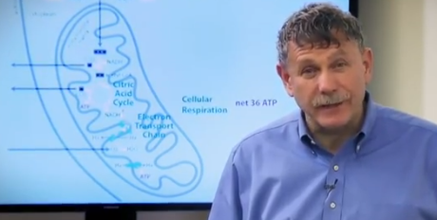
Pr. Eric Lander addressing directly the camera in MIT's class 7.012 “Introductory Biology”

The First MOOCs: power of the network

The first attempts registered
It is within networks that learning can generate quite interesting experiences because it brings a new dimension to courses: interactions. This leads us to the raise of MOOCs. It was first launched in 2008. It was called ‘Connectivism and Connective Knowledge/2008’ (CCK8), created by educators Stephen Downes and George Siemens. Building off a for-credit course at the University of Manitoba, Canada, this was the first class designed with the acronym of “MOOC” and used many different ways to engage students, including Facebook groups, Wiki pages, blogs, forums and other resources. All the main ingredients of a MOOC were already here.
Around 2,200 people signed up for this first MOOC, and 170 students created their own blogs. The course was completely free and open, which meant that anyone could join, modify or remix the content without paying (a paid, certified option was offered yet).
In 2012, another emblematic MOOC occurs in Stanford. Two Pr Sebastian Thrun and Peter Norvig decided to offer “Introduction to Artificial Intelligence” for free online. It was designed to resemble real classroom and offer very high-quality classes for everyone.
With the prestigious names of the teachers and the Stanford University backing the course, more than 160,000 students in 190 countries signed up. For the first time, it was truly “massive” experience. This led Thrun and Norvig to quit their job and build a new business model for online knowledge, the startup Udacity.
It did not take long before others leading minds adapted their ideas using their own resources. Within one year, there were two more start-ups for MOOCs: Coursera and EdX (first one created by ex-professors form Stanford as well). In 2013, the Open University we already spoke about was building its own MOOC platform, Futurelearn, which feature universities from the United Kingdom. The same kind of initiative happens in France: FUN for France Université Numérique was launched in October 2013. We can also quote Open2Study in Australia and Iversity in Germany for top European universities.
MOOC start-ups might have different goals, but what they all share is the connection between learners and teachers. We’ve come a long ways from the one-way conversation of correspondence courses and educational videocassettes, but whatever is eventually written about the history of MOOCs, academic knowledge will probably never be seen the same way. More and more, knowledge and information can be easily reduced into small bits and rapidly transmitted to anywhere in the world, to anyone. The knowledge becomes more and more shareable.

Connectivism
A short definition of connectivism could be sum up as: a hypothesis of learning which emphasizes the role of social and cultural context.
The central aspect of connectivism is the metaphor of a network with nodes and connections. In this metaphor, a node is anything that can be connected to another node such as an organization, information, data, feelings, and images. Connectivism sees learning as the process of creating connections and expanding or increasing network complexity. Not all connections are of equal strength. They altogether constitute the network that represents the learning context of each student.
Connectivism is often associated with and proposes a perspective similar to Vygotsky's 'zone of proximal development' (ZPD), an idea later transposed into Engeström's (2001) Activity theory.
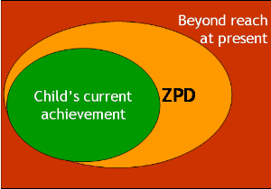
In his theory of the "Zone of Proximal Development" (ZPD). "Proximal" simply means "next". He observed that when children were tested on tasks on their own, they rarely did as well as when they were working in collaboration with an adult. It was by no means always the case that the adult was teaching them how to perform the task, but that the process of engagement with the adult enabled them to refine their thinking or their performance to make it more effective.
Vygotsky's Zone of Proximal Development (ZPD)
Some principles for connectivism were developed afterwards. They could be summarized as:

- Learning and knowledge rests in diversity of opinions.
- Learning is a process of connecting specialized nodes or information sources.
- Learning may reside in non-human appliances.
- Capacity to know more is more critical than what is currently known
- Nurturing and maintaining connections is needed to facilitate continual learning.
- Ability to see connections between fields, ideas, and concepts is a core skill.
- Currency (accurate, up-to-date knowledge) is the intent of all connectivist learning activities.
- Decision-making in itself is a learning process. Choosing what to learn and the meaning of incoming information is seen through the lens of a shifting reality. While there is a right answer now, it may be wrong tomorrow due to alterations in the information climate affecting the decision.
Related to MOOCs, the cMOOC (for connectivist MOOC) bring a connected aspect of learning in course. It could be a chaotic experience and is very personal and subjective, as participants create their meaning and build and navigate their own web of connections. The best way to understand a connectivist course remains to participate in one.
cMOOCs are not proscriptive, and participants set their own learning goals and type of engagement. They won’t necessarily walk away with a fixed and tested set of specific skills or competencies, or knowledge of a set body of content. That’s why cMOOCs are tricky to grade or assess or certify. Combined with the fact that the platform is completely open, it means that a business models based on cMOOCs only would be very unstable.

Prior this attempt: Khan Academy & ITunesU
Meanwhile, another branch of online education attracted attention of the media’s with its specific way to build resources. Using basic tools on his home computer, Salman Khan began making short math tutoring videos, first for his younger cousins and then for anyone following his YouTube account and eventually for millions of students around the world. It was then called Khan Academy, a non-profit provider of video lectures and exercises on a variety of subjects and now, although Khan isn’t a formally trained educator, he is one of the best-known teachers in the world. It also attracts the attention of governments and some NGOs that decided to translate the whole corps in other languages (in French with the support of “Bibliothèques sans Frontières”, in arabic with "Taghreedat" the largest Arabic crowdsourcing initiative in the MENA region.

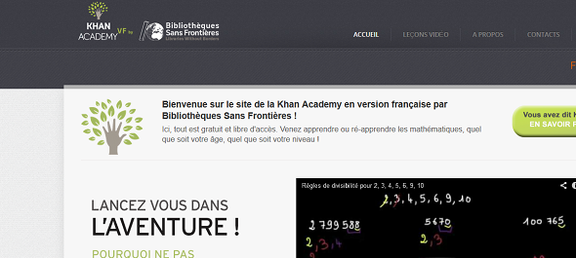
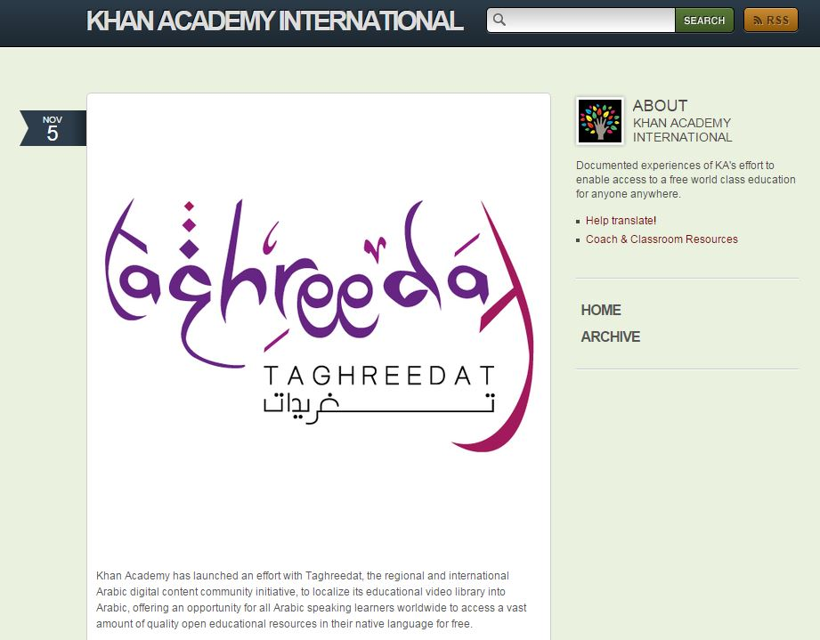
Initiatives for the translation of Khan Academy contents in French and Arabic

Another antecedent to the MOOC is iTunes U, launched by Apple in 2007 to offer education materials for download. Most of the contents were available for free. Many colleges and universities joined the website, created courses especially designed for the format or simply posting podcasts, video lectures or textbooks for free download by anyone in the world.
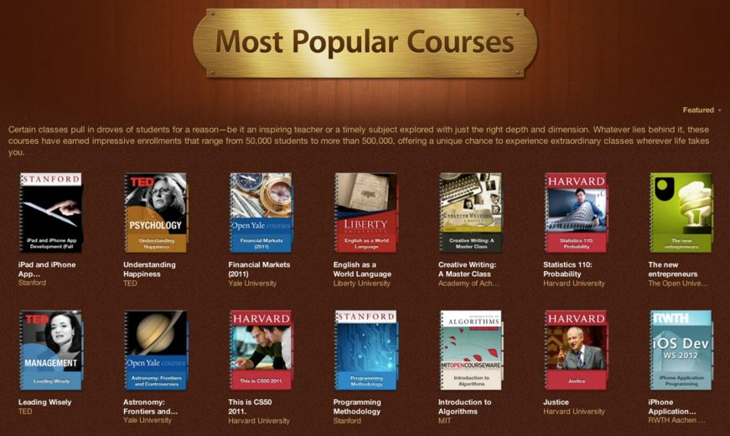
Courses available on ITunes U
Those initiatives influenced most MOOCs offered nowadays. After a quick browsing of the courses on any MOOC provider, it is visible that many have characteristics of iTunes U’s classes, of Khan’s videos and also of Connectivism and Connective Learning/2008. Over the next few years, many individual teachers around the world were experimenting with bringing together these different ideas into online classes that they made freely available on various platforms that let them create their own course material.
Nor should we forget that online resources have already been offered by teachers and integrated in their classes for the use of their own students. For many years now, most colleges and universities have offered at least a few of their classes in online formats for tuition-paying students and for credit. You can even earn an entire online degree this way from a growing number of programs. While these are not massive and not free, they demonstrate that online learning is possible, and much of the technology that go with these classes are part of how MOOCs function now.
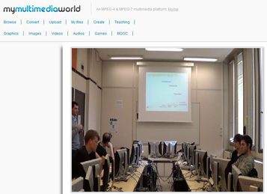
Example of a course on Augmented Reality taught both in class and available online, Telecom Sud Paris, France

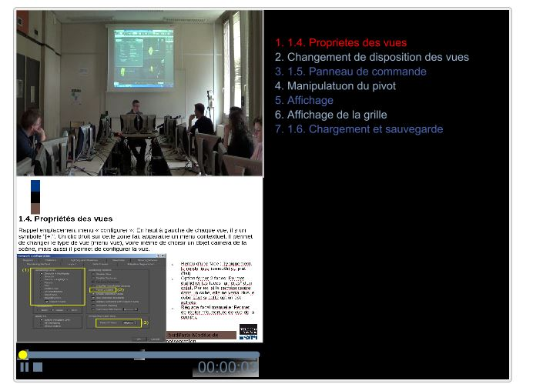
Custom player developed by the teacher a table of contents (right) and the pictured slide (down)
Then, in 2012, when MOOC initiatives appeared many were already familiar with such kind of resources. Educators, social entrepreneurs, charitable foundations, universities and venture capitalists began forming initiatives to unite the best online tools with the best — or, at least, the most prestigious — teaching available. This was how Udacity, Coursera and edX (the only non-profit among those major MOOC platforms) were founded. The response they got was enormous, with tens of thousands students signing up for each class. But still, what do make MOOCs different from previous online resources?

Defining a MOOC
In what way differs a MOOC from others forms of distance learning? Let’s explain the sense of the abbreviation and detail the meaning of the different letters to get an overview of the matter.

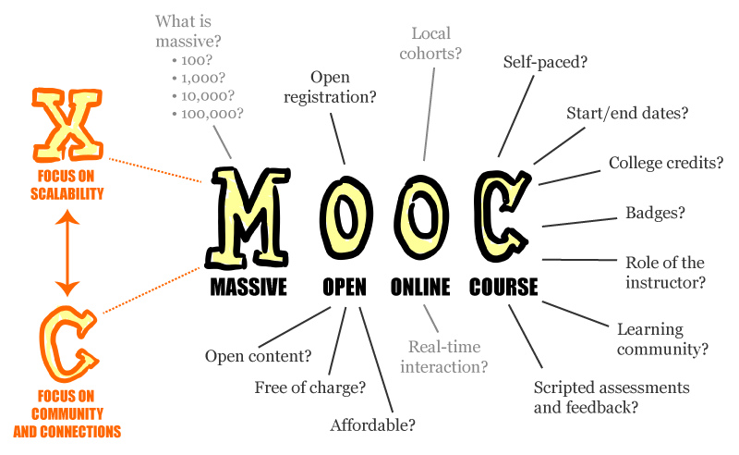
MOOC: every letter can be negociated

MOOC are Courses
A MOOC is a course in two important senses. First of all, it has assignments and evaluations built in the way that a college class has assignments and exams. Most MOOCs have quizzes along the way and exams at the end, but more subjective assignments, such as written essays or creative projects, are also possible (especially for cMOOCs if evaluated). The evaluation may be done by the teacher, by software (proctoring services) or by peers. Having assignments and evaluations distinguishes a MOOC from a number of universities initiatives that offer free lectures but don’t have any way of assessing a visitor to the site.
Second, MOOCs are courses in the sense of having a completion point. Khan Academy has exercises along the way, but if you jump in to start learning, for example, elementary school arithmetic, you’ll never reach a last day of school. Somehow, a lesson will be recorded from time to time that enriches the course in a related topic. MOOC courses are designed to come to a conclusion, usually after 4 – 12 weeks.

MOOC are Online
It’s pretty obvious what online means, but one thing to keep in mind is that some forms of distance learning are hybrid, where students do part of their work online and meet with the teacher at school part of the time. Increasingly, hybrid classes use materials from a MOOC to support the class, but the class itself isn’t what we would call a MOOC. One example of this hybrid format is the on-campus version of Professor Mohamed Noor’s “Introduction to Genetics and Evolution” class at Duke University. He teaches it in MOOC form and he uses the MOOC materials in a hybrid or flipped class for his on-campus students. The same situation happens in Grenoble in France where professors of the first year decided to switch lessons and questions where the lessons were digitalised in MOOCs and made available on the Web and the classes became a time for questions with the professors.

MOOC are Open
This is the part of the definition that is most in dispute. Lately, most people refer to something as a MOOC when it is free for anyone to participate in without a fee and without any admissions process. It’s open in the sense of being no-cost, and it’s open in the sense of having no application requirements. All you need is a username and password.
Moreover the original designers of MOOCs meant for them to be open in two other important senses. MOOCs were originally open (and many still are) in the sense of open-access, much like creative works under a Creative Commons license can be open. These instructors use materials in the public domain with no copyright restrictions, so as to keep them freely available for others to reuse and adapt. That definition was embraced after them by open resources such as OER (Open Educational Ressouces).
That’s not how today’s major MOOCs providers work, though. On websites like Coursera and edX, anyone may enter, but the materials a visitor will find there are under copyright and can’t be removed or modified. Actually contents are owed or co-owned by the platforms that host them. Plus, after those classes are completed, the materials are often closed from public view until the university decide to play them again, whereas on many independent MOOCs outside those major platforms, even after they are inactive, the materials remain available for anyone to access and complete the course without the evaluation obviously. Nevertheless it is interesting to underline that Udacity keeps access to all the contents for free.
Second, the original MOOC concept was open in the connectivist sense. The boundaries between teacher and student and between students themselves are much more open than in a traditional classroom, and the creation of knowledge happens through connections that are unexpected and unplanned (creation of blogs for example). Some critics of the most popular MOOC platforms say they establish traditional flows of information from the teacher to the student. The class is less open to interaction among its participants and to letting them introduce their own knowledge brought in with them from the outside. At the opposite it enable a better evaluation.
People who promote open education resources (OER) are disappointed that the term MOOC is being applied to classes without open access. However, a word is more commonly defined by its usage, and, right now the term is mostly used in a way that includes classes that don’t have an open-access or connectivist approach.

MOOC are Massive
The massiveness of a MOOC is a natural result of being an online course open for anyone to enter. What counts as massive varies quite a bit. Some MOOCs have a few hundred students and a few have had more than 100,000 students. But one good way to look at it is to consider a course massive when it has more students than the teachers and assistants can themselves interact with. When machine grading, peer assessment and other peer support become not only desirable but necessary, that counts as massive from the teacher’s perspective. Thus the exact number of students is no point of fixation anymore and could be used to adopt a new point of view on dropout rate as well as we will see below.

Variations of MOOCs
The development of MOOCs has produced different types of MOOCs depending mostly of the usage.

cMOOC, xMOOc…
cMOOC, xMOOC, iMOOC... MOOCs refer to many different realities.
If the two main pedagogical strands of MOOCs are the cMOOCs (network-based) and the xMOOCs (content-based; most of the MOOCS created at present are xMOOCs), a lot of variations are coming to light. Research is being conducted to define a shared typology of MOOCs. Derived from the “massively multiplayer online role-playing games” (MMORPGs), the term connectivist MOOC (cMOOC) was first used to describe the 12-week online course entitled “Connectivism and Connected Knowledge” and offered by Siemens & Downes, to an audience of 25 students for credits and to an additional 2,300 enrollees who participated without paying or receiving credit. In 2011, the MOOC on Artificial Intelligence offered by Stanford University professors attracted 160,000 students. As it was quite different in form from the previous one, it was called xMOOC, “x” denoting “exponential” and massive participation, or “extented” (like in HarvardX and MITx).

SPOC
MOOC variations also include the SPOC (small private online courses). It could have been viewed as an answer to the MOOC and its lack of real interactions – and a possible way to make revenue. The approach is also known, less acronymically, as “hybrid” or “blended learning.” The basic idea is to use MOOC-style video lectures and other online features as course materials in actual, normal-size college classes. By assigning the lectures as homework, the instructors are free to spend the actual class period answering students’ questions, gauging what they have and haven’t absorbed, and then working with them on projects and assignments. Actually some of them have been directly integrated in curriculums like in Harvard University. Usually students consistently outperformed their peers in the non-flipped classroom on the evaluations. The blended learning could be seen lately as one of the major disrupting points in education introduced by the “MOOC revolution”.
Others variations of MOOCs include POOC, Participatory Open Online Course: a course where participants are invited to share, collaborate and create knowledge (close to the cMOOC), SMOC, Synchronous Massive Online Course: a course that features live, synchronous broadcasts to students or tMOOC (task-based) MOOC. This presentation doesn’t inventory national declinations with specific abbreviations – even if we will focus on French and Turkish policies below.

Aims of a MOOC: what is the Business Model?

Reaching new students
MOOCs attract a huge variety of students of different ages, nationalities, backgrounds, abilities, interests and English-language literacy. Its flexibility makes it very attractable. Very few of them are people who might or could actually be going to the particular college offering the MOOC or to any college at all.
There are many reasons colleges and universities provide free online classes in the form of a MOOC to audiences beyond their own students. One important reason is that they are hoping to reach new audiences outside the boundaries of the university. In some cases, they want to reach people who can’t have access to a full degree or any other university course, either because of distance, cost or a lack of time.
In other cases, they hope to influence students who may enroll in their institution. (The point will be specifically treated below). An example of that is the MathMOOC at the University of Wisconsin – La Crosse, which attracted students from around the world and every state in the U.S. but most especially from “feeder schools” around Wisconsin whose students may end up at La Crosse. MOOC could be seen here as a simple (doing a course for a university) but very effective marketing action.

Recruiting the brightest
The MOOCs offer the possibility to evaluate a group of attendees at the same moment under the same criteria on the same course. Its result is a classification where the brightest would be offered the possibility to join the university that proposes the course.
As an example Pr. Sebastian Thrun and his team observed that 411 online students do better in their assignments than the first graduate of the Artificial Intelligence course ran at the same time in Stanford in 2008. These best ones students were from everywhere in the world. This result gave Thrun the idea to offer these brightest students the possibility to join the university. This is a win-win model and probably the most innovative approach for the creation of a totally new business. It’s a long term model where the bright students recruited by this way could bring back some value for the university as a student or a future researcher.
In the case of one computer-science course offered through Udacity, the online students took the same quizzes and tests as a group of students enrolled at Stanford University at the same time. The top 411 students all came from the thousands of students who took the course online, with the strongest-performing Stanford student ranking 412th in the final standings, said Mr. Thrun. (That Stanford student earned a 98-percent score in the course.)
"There are a huge number of people out there who are extremely skilled but happen not to have the Stanford degree," said Mr. Thrun.
Moreover employers may be interested to access to the student data. This model could keep courses free of charge. They work as global exam that could be used for recruiting. Unfortunately this dimension has been tested but didn’t deliver the expected results as we will see below (3.2.3.3).

Brand building
A third reason for offering MOOCs is “brand building.” Some universities have pointed out that by raising the profile of the school through a MOOC they are increasing the value of their degree for past and future graduates. For example regularly attendees of MOOCs said that they were unsure about signing up for the MOOCs offered by some less known universities, because they had never heard of them even if the reputation is excellent in the country. But if convinced by the content of the course or the reputation of the professor, the student could become a new brand ambassador for this precise less known university.

P&L of a MOOC

Valuating your MOOC

The dropout rate
There is a significant dropout rate in most MOOCs, from the “come once” attitude to the “get certified” objective, plus the learner may encounter obstacles during the course, such as the “watch video”, “video quizzes”, “turn in assessment” and “do quizzes exercices”. Only 10% of the initial enrollees complete a course. However, the real significant figure should not be the number of initial enrollees, but the number of people who complete the first quiz. It is reasonable to redefine the terms “dropout”, “completion” and “success” which cannot be compared between higher education and online offers. From the early analyses of completion rates, it has been shown that a learner’s objectives and achievements depend upon his or her demographics and time constraints. One should offer the learners several different ways to experience a MOOC – different certificates associated with different workloads – reminding one that the ultimate goal is not necessarily a certificate or a diploma. Participating by helping other students to learn or by proposing use cases may be as rewarding as doing all assignments and quizzes.

Recent research based on interviews of MOOC participants have shown than “dropout means achieving their aims (or not) in a course rather than finishing it by completing all parts”. Two solutions for reducing the dropout rate which come from reasons like lack of satisfaction or misunderstanding the course environment can be offered. The first one is mechanical: compute from the learner activity features the warning signs and patterns that can predict a possible dropout, and alert the instructor. These patterns are known either from the ongoing engagement of the learner (eg, time spent, frequency of interaction), or from a mandatory pre-survey about the learner’s motivations (eg, interest on the matter, reasons for choosing the course). But the dropout rate seen as a fail signal should be abandoned since the satisfaction of learners can be achieved through various KPI (learning, getting certified, helping others…).

The second way to reduce the dropout rate is to engage learners in the community of learners. Large masses of participants must be divided into small cohorts of people with the chance that some will act as tutors for their peers. The first week of a MOOC is, in this respect, critical. A community of learners must be built and the forums, or writing a common Community Rule are among the tools that enable to forge one.

KPI of your MOOC

Where are the expenditure for a good MOOC?
It is considered that major cost drivers in MOOC production and delivery were:
- The size of the teamwork, faculty members, administrators, and other instructional and support personnel involved both in the production and the delivery of a MOOC. This is barely less than five professionals per course, and in extreme cases this can go up to 30 members. Each of them spending several hundred hours for every phase of the course.
- The quality of videography, sound records, interactive materials and graphics design: this was estimated at an average of $4,300 per hour for finished videos in a simulation in France.
- The nature of the delivery platform
- The technical support provided for the participants
- The development, maintenance and delivery of special features such as computer code auto-graders, virtual labs, simulations, or gamification
- Analysis of platform data

Cost estimation for one MOOC
Assuming personnel costs account for 75% of total costs once facilities, equipment, and overhead expenses are considered, the survey estimated that the total costs per MOOC are around $39,000 and $325,300. This gives a cost per completer between $74 and $272. However, completion data, and otherwise revenue data from MOOCs are rarely made public and it is not easy to yield and accurate estimation. Also little is known about the reduction cost for a re-run MOOC. A case study showed that a re-reun of a MOOC cost 38% less with some of the cost-savings described below.
These costs fit with those found on the edX or Coursera platforms usually particularly expensive (around $250 000 for a complete creation).

Potential cost savings from MOOCs
So far MOOCs have been a source of costs for higher education institutions, but savings are envisioned.
- Re-using MOOC materials multiple times
- Sharing MOOC materials across instructors and campuses
- Developing common courses to offer across institutions
- Replacing on-campus courses with MOOCs
- Faculty time savings
- Reducing the need for facilities
- Recruitment efficiencies
- Less costly student support services provided by non-faculty members
- Increasing student throughput
Reusing courses materials became a common practice from schools and universities where they used former materials to play again in a new “season”, with some minor improvements if needed (i.e; integration of quizzes during videos).

Revenues categories

Known revenues
Current and future potential sources of revenues are mentioned in agreement such as the Coursera contract:
• Offering credits and charging tuition in exchange of a certification
• Creating new courses and programs for universities
• Drawing MOOC participants into full-tuition degree programs (with potential full-certification)
• Increasing class sizes
• Licensing fees for the use of MOOC materials by other institutions
• Fees for additional services
• Grant revenues
• Matchmaking for employers
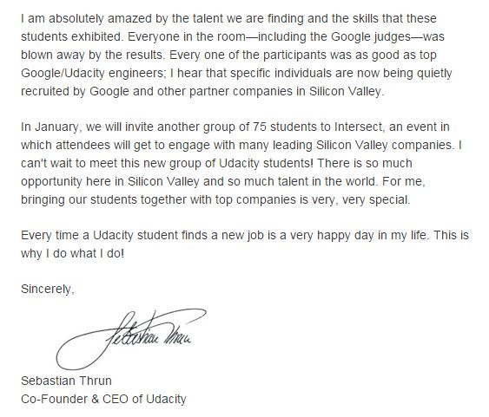
Most of these options have been tested since the emergence of MOOC in 2012. A few of them appear to be real streams of revenues. Today major players concentrate their efforts on certification and match making not for employers but for learners that expect to find a job after graduating. It becomes a true goal for MOOC platforms to be considered as a real help to find a job. Udacity is a perfect example of this trend with their “nanodegree programs”. The team of the platform multiplies exchanges with tech companies that could employ the graduate from the different programs.

Extract of an Udacity newsletter

But certification remains the main revenue for these platforms, with various types of degrees (for one course only or an aggregation of courses that could form a full degree).

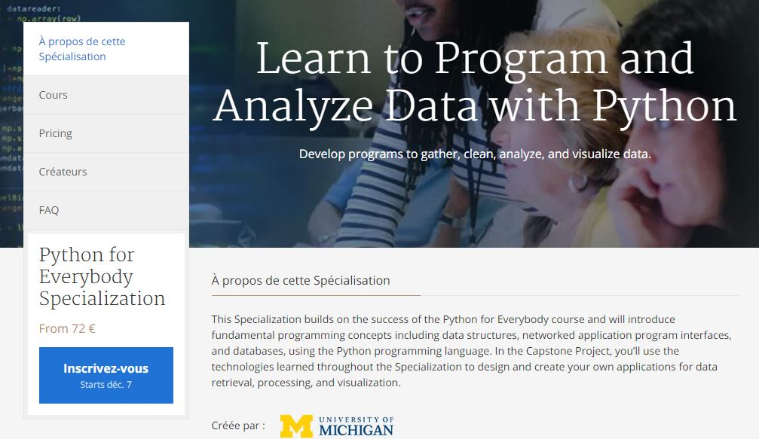
Example of paid certification of Coursera

Foreseen revenues
The business model of online courses is still far from being known. It may be due to the fact that new types of MOOCs are invented every day and that research and experiments are still underway. Yet Higher Education institutions invest their own funds or produce MOOCs through research projects or with the help of donors. They should build on the achievements of startups issued from their research on pedagogy, insofar as these startups will soon find the most effective business models.

In this respect, Udacity, one of the first educational startups, pivoted last year and focused explicitly on disrupting job-training. Their MOOCs are now designed for the private sector (SPOCs) and not on disrupting university education. Unlike Coursera that only works with prestigious universities, Udacity creates its own content and rarely cooperates with universities. In addition, Udacity decided to tackle the problem facing all MOOCs – the dropout rate.

This may be an option... Inventing a business model in which the entity that produces the course is not the same as the one that delivers or certifies the course. Coursera and even EdX seem to look more and more at the corporate training as a mean to achieve solid growth. They recently developed their own degrees with a more professional orientation.
Even if not directly developed by EdX, the non-profit platform participates to an American program to fight unemployment. Called “Rework America”, it associates various state organizations (in Arizona where the experiment takes place) and companies such as LinkedIn of Walmart. The program should help employers to find fitted profiles to their needs and job seekers places to learn missing skills. Edx offers its platform to be a resources platform for the experiment.

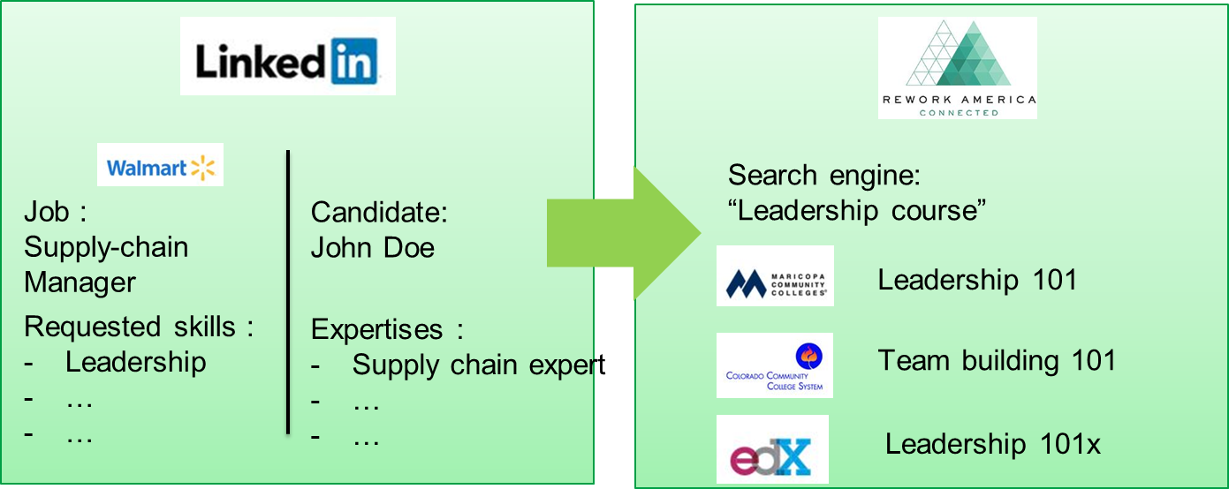
Rework America intends to help job seekers and employers to meet

Institution Brand Visibility as a Driver
In a global competition model, building, reinforcing or protecting its brand is a major goal for High Education institutions. Through their MOOCs, elite institutions protect their global ranking among top universities, whereas second ranking universities try to gain national or international recognition. For European universities which must generally educate domestic students for free or at very low tuition rates, MOOCs may help attract international students which could be an important source of income. Brand development is indeed a tool for recruitment, both for the domestic audience and the global community. This could even initiate a virtuous circle with alumni from abroad willing to finance future research and courses of the university they discovered online.

From the Learner’s Point of View
“Is crowdfunding a viable solution to the problem of students’ debt?” This question is now seriously asked in the United States, and there are numerous cases of teaching or research which have now been financed by sponsors found on a crowdfunding platform. In France, Jean-Mark Nourel, founder of Eduklab, is developing such a crowdfunding platform dedicated to education. According to him, helping students to finance their education is an act of citizenship. Launched in late 2013, the plaform allows students to collect money in order to carry out humanitarian, community or professional projects or to finance all or part of their graduate studies.
The next question will soon be: “is this diploma worth the cost?”. Antoine Amiel, founder of Learn Assembly, a French digital university for entrepreneurs asks himself: “Why study 5 years, going into debt over 10 years to get a degree while it is now possible to achieve the same result in three months, for a very small fee?”. The first trainings that are currently impacted are those about digital literacies. The so-called “BootCamp”, launched by startups like DevBoot- Camp, Wagon or Simplon in France, are already a success. Learners are searching for immediate employablity. “Recruiters, whose needs for developers are growing, often seek versatile profiles, truely flexible Swiss Army Knife. This ability to be independent and keen on lifelong learning is an essential criterion for startups and innovative businesses”, says Amiel.
Higher education institutions should think about it. What is the purpose of education? It was previously to teach the working force, it is now to teach how to learn, unlearn and relearn in an adaptive way. Both objectives can be pursued if institutions can unlearn themselves and reinvent efficient ways to teach the next literacies.

Revenues of the major players in the MOOC universe

Business model EdX

Creating MOOCs
University self-service model: once a self-service course goes live on the edX Web site, edX will collect the first $50,000 generated by the course, or $10,000 for each recurring course. The organization and the university partner will each get 50 percent of all revenue beyond that threshold.
The courses developed under that model will be created by "individual faculty members without course-production assistance from edX," and will be branded separately in the edX catalog as "edge" courses until they pass a quality-review process, according to a standard agreement provided to The Chronicle by edX.
Another model is the edX-supported model, where the edX team (education and technical) helps the university in the creation of a course. In this case edX takes $250 000 for the first year and $50 000 for each year of renewal.
The business model of edX also includes some others revenues such as book sales related the course. edX will be entitled to all net profits from agreements with third parties not directly related to College/UniversityX courses," the standard agreement stipulates, "including, for example, book sales on the site, proctoring services, and any sitewide employee-recruiting services”.
edX also has a deal with Pearson VUE, a company that runs a worldwide network of testing centers, to hold proctored examinations for its MOOCs. Announced in 2012, this partnership enables students the option of taking a final proctored exam.
“Our online learners who want the flexibility to provide potential employers with an independently validated certificate may now choose to take the exam at a proctored test site”.
Anant Agarwal, president of edX
This option increases the value of edX courses giving them the acknowledged validation from the real world. It develops the accessibility of edX courses transforming them into true components of every potential degree.

Licencing MOOCs
EdX also develops MOOCs licenses where they sell the courses and possibly the whole platform to third parties. EdX sold the courses and the platform to Jordan in 2013 with a partnership around Edraak and to Saudi Arabia in 2014. The courses form Harvard ant the MIT were completely translated.

Verified Certificate
For a moderate amount of money, each learner can get a verified certificate from his course. The amount varies around $50 on edX. edX developed special degree with four or five courses . A verified certificate can be obtained for $500 (495$ for Silicon Photonics Design, Fabrication and Data Analysis).
Illusatration
Verified certificates remain the main regular revenue for the platform even if it seems that the model is still non profitable as some EdX members told us last year during an edX hackathon organized in France.
Finally edX develops a new concept with a Freshman year program in collaboration with Arizona State University for the price of the verified certificate on each course composing the year. EdX offers to its learners to take a whole first year of college for a moderate price. Each credit hour costs $200 and the whole year need 50 of those hours meaning that the year costs $10 000 globally. Moreover some companies decided to support students that enroll in this kind of program and pay for the tuition (i.e. Starbucks and its partnership with Arizona State University).
This program with the support of companies could be really disruptive and open new propositions in the higher education sector with the empowerment of a generation in accessing college studies.

Coursera

Creating MOOCs
Coursera gives back between 6 and 15% of the revenues generated by each MOOC, plus 20% from license of the courses they manage to sold. We can imagine that it is also true for translated courses by the platform abroad (that keep a total control on the decision of translation). The business model of Coursera offers universities to earn money from the first cent even if in small quantities.
The Coursera platform also offers to to access to users data. They could be sold by the platform but would be exploited on an anonymous basis and become a good way to discover patterns and uses of learners.

MOOCs Certifications
With its own process, Coursera certifies course on its platform with “Signature track”. Certifications cost $50 on average.
As EdX, Cousera developed different degrees composed of several courses and certifies the whole thing. Degrees in business or computer science are available. These courses are built with companies such as Snapdeal or Shazam which reinforces the value of the certification a professional warranty.
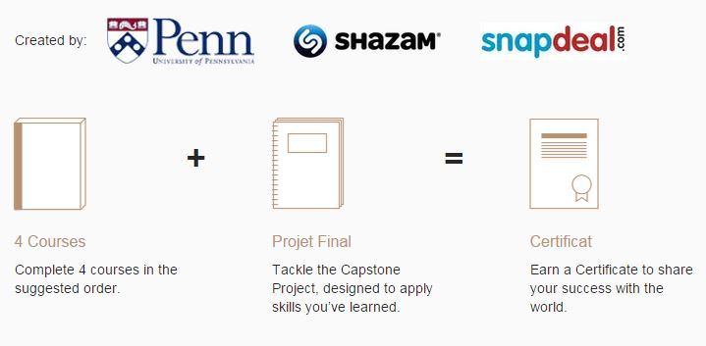
Business degree built with Shazam and snapdeal

Head hunting
Head hunting was another of the initial ideas that Coursera added in each of its contract with universities. The company pays a flat fee to Coursera for each introduction, and the college offering the course gets a percentage of that revenue, typically between 6 and 15 percent. As it is a very common aspect of partnerships between universities and companies (access to the best students), it’s logical to find such a concept developed on the platforms of digital education.

Udacity

Head hunting
Probably the most advanced platform concerning head hunting, the service of Sebastian Thurn signed partnerships with 350 companies for a price “significantly less than you'd pay for a headhunter, but significantly more than what you'd pay for access to LinkedIn” meaning that an educational platform could have find a complete new stream of revenue with this profiling industry plus they aggregate a lot of data on each students helping recruiters in their “shopping”. Both Coursera and Udacity show employers more than just student grades. They also highlight students who frequently help others in discussion forums. Mr. Thrun, of Udacity, said those "softer skills" are often more useful to employers than raw academic performance.
This orientation was taken by Udacity from the time of its foundation by Sebastian Thurn, former professor at Stanford University. In the case of one computer-science course he ran, the online students took the same quizzes and tests as a group of students enrolled at Stanford University at the same time. The top 411 students all came from the thousands of students who took the course online, with the strongest-performing Stanford student ranking 412th in the final standings, said Mr. Thrun. (That first Stanford student earned a 98-percent score in the course). The conclusion was quite obvious for Mr Thurn, these 411 should be reached and offered a possibility to join the university. "There are a huge number of people out there who are extremely skilled but happen not to have the Stanford degree," said Mr. Thrun. These observations were the bases of the foundation of Udacity.

Verified Certification
As its other competitors, Udacity perform verified certification with the support of the Perason VUE and ProctorU, in certification centers and online with now a clear orientation corporate training.

Creating MOOCs
On the contrary of its competitors, Udacity do its own contents. They pay professors to build degrees and make the videos. Nevertheless the contents are not modifiable or shareable. All the courses materials are access free, but the support and the certification remain payable. It costs around 200$/month for various degrees, most of them concentrated on computer science. Degrees last 6-9 months or 6-12 months.
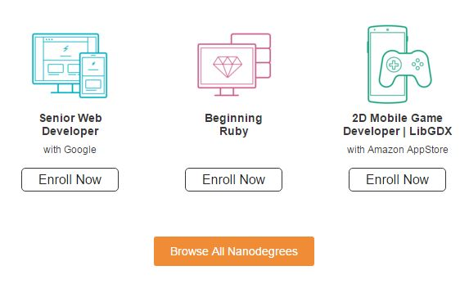
Nanodegrees: corporate programs developed by Udacity

Moodle

An open source platform
Moodle develops a complete different approach as it is an open source software. Developed by an Australian university and now maintained by a company (Moodle HQ) supported by a network of sixty Moodle Partner service companies worldwide. A lot of forked variations of the platform exists around the world such as the one developed by Immanens available in its box.

Over the top approach
Above the open source code maintained by the foundation, companies can develop payables modules for module. Editors have an “over the top approach” consisting in developing and selling modules dedicated to Moddle platform. Around 1 000 modules (both private and open source) are currently available for the Australian platform.

Analysis of national policies

FUN: the French Initiative

Foundation
Founded in 2013 and launched by the former French Minister of the Higher Education, FUN was online in the beginning of 2014. The platform owns 50 more than fifty partnerships with some of the most prestigious universities throughout the world. They now have more than 150 courses available and already 1 million subscribers (500 000 active learners). This initiative aims to federate all the digital projects from universities in France. From 10 MOOC at the beginning, the catalogue of courses has been enriched on various topics. FUN is now a GIP (Groupement d’Intérêt Public), a kind of association which is now financed by the Minister and the main contributors.

Objectives
Build to keep hold of the development of MOOCs in France, the missions of the platform are:

- Supporting the development of massively open training
- Incentive to place digital at the heart of student backgrounds and professions of higher education and research
- Provide facilities and services shared in support of digital initiatives in universities
- Promote the visibility of the French offer in training and digital resources

Futur

Development of the platform
A new version of the platform was deployed in November 2015 especially to improve the user experience. This objective will be supported by a joint project where some of the most prominent Edtech start-ups in France will implement their tool.
FUN also wants to improve its offer towards the professional training with tools and collaborations with corporate sector:
- Generalizing certification, today tested with several MOOC, to meet expectations of learners who need to enhance their careers;
- Suggest these online courses to employees, job seekers, companies a continuing education perspective;
- Deploy white label platforms to meet the needs of companies who wish to deploy in-house continuing education tools and other actors
- Involved in training throughout life (large companies, branches professional and OPCA, Pôle Emploi, the actors of vocational training in the public and the private ...).
It could make FUN as other initiatives throughout the world a more integrated tool serving job seekers and fighting unemployment (Rework America, …).

Proximity with EdX Foundation
Using the OpenEdX technology since the beginning of the platform, FUN thinks now about selling the white label version of the platform for companies as said above.
As an important user of the technology, a first Open-EdX hackathon was scheduled in France in May 2015. Team members of EDx, Boston were in Paris to attend and support the meeting and one of the objectives was to develop the OpenEdX code.
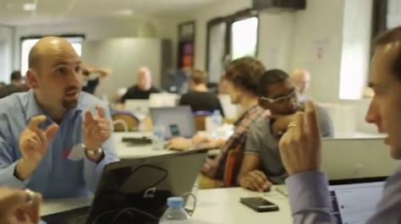
Hackathon OpenEdX in Paris, 30 teams and 7 projects rewarded
The hackathon enables for example to develop a new Xblock focused at easily create interactive videos with problems and an implementation of learning analytics from a French start-up.

Institut Mines-Telecom policy for FUN
As one of the first entity in France throughout one of its schools (Telecom Bretagne) that built one a MOOC, Institut Mines-Telecom is important partner of the FUN initiative. With 15 MOOC available on the website, IMT is the second largest institution represented on FUN. The courses of IMT are focused on science as most of the schools that compose the network of the IMT are schools of engineers.
IMT has now its own team dedicated to the creation of MOOC with an equipped studio for recording videos. The increase in the number of MOOCs will continue and accelerate in 2016.

Turkish policy for MOOCs
XXX

Annex
Annex 1: extract of the Coursera agreement, foreseen revenues
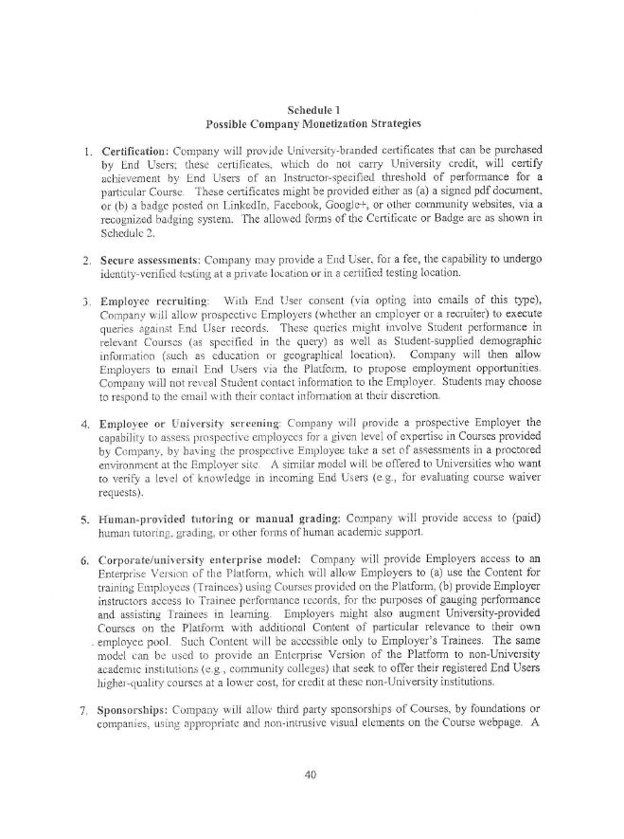

Joseph F. Kett, Pursuit of Knowledge Under Difficulties: From Self-Improvement to Adult Education in America (1996)
William Millikan (2003). A Union Against Unions: The Minneapolis Citizens Alliance and Its Fight Against Organized Labor, 1903-1947
Tyson, Levering (1936). "Ten Years of Educational Broadcasting". School and Society 44.
Christopher H. Sterling; Cary O'Dell (2011). The Concise Encyclopedia of American Radio. Routledge.
Bizhan Nasseh. "A Brief History of Distance Education".
http://www.open.ac.uk/iet/main/research-innovation/learning-analytics
Fry, Heather; Steve Kerridge; Stephanie Marshall (2003). Understanding Student Learning
https://books.google.com.au/books?id=SDgxCgAAQBAJ&pg=PA607&lpg=PA607&dq=grenoble+blended+learning&source=bl&ots=956gyoSajg&sig=U9ncY1BcLt7q3h3Wui67hkF3_AA&hl=fr&sa=X&ved=0ahUKEwiBlIib5u3JAhUCFqYKHciwDgYQ6AEIKjAA#v=onepage&q=grenoble%20blended%20learning&f=false
https://www.academia.edu/11056576/Trends_in_Distance_Education_Research_A_Content_Analysis_of_Journals_2009-2013
“A Typology and Dimensions of a Description Framework for MOOCs”, by Marilyne Rosselle, Pierre-André Caron, Jean Heutte, in the Proceedings of EMOOCS2014
http://www.thecrimson.com/article/2013/6/21/new-edx-fall-2013/#
http://chronicle.com/article/Providers-of-Free-MOOCs-Now/136117/
See Annex 1
http://chronicle.com/article/Providers-of-Free-MOOCs-Now/136117/

