Press release
ITEA Event 2016 as part of the EUREKA Innovation Week, 26-29 April

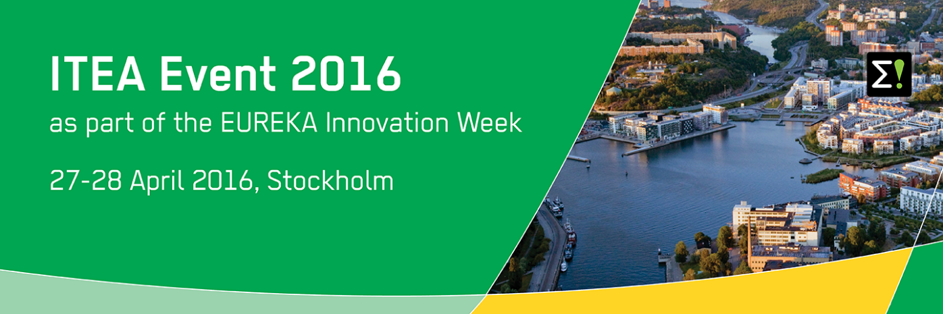

ITEA, the EUREKA Cluster on Software-intensive Systems and Services, organises its ITEA Event 2016 on 28 April 2016 in Stockholm, Sweden. The event is co-located with the EUREKA Innovation Week 2016 (26-29 April), organised and hosted by the Swedish EUREKA Chairmanship at the Stockholm City Conference Centre.
Smart Cities – Sustainable & Attractive Communities
The EUREKA Innovation Week 2016 combines the strategically important areas of the EUREKA Network including international collaboration with a specific focus on Smart Cities. The keynote speakers will highlight the Smart City and its interaction from different perspectives. Innovative concepts will be coupled with concrete solutions during parallel sessions on themes that are highly relevant to urban development around the world.
A week full of innovation, collaboration and interaction
During the Innovation week, including the ITEA 2016 Event on 28 April, you will have the opportunity to meet, share ideas, interact and discuss with over 1000 attendees from the ITEA Community and stakeholders from the full EUREKA network: international industry, SMEs, academics, policymakers, representatives from funding agencies and public authorities.
Programme highlights are:
26 April | Global Collaboration Day  Panel session on global collaboration, break-out sessions with representatives from Canada, South Africa and South Korea
27 April | EUREKA Innovation Event  Keynote speeches, panel discussion, EUREKA innovation award, B2B meetings, thematic parallel sessions, exhibition including 10 ITEA project booths
28-29 April | EUREKA Cluster Conferences  During these days, the EUREKA Clusters will organise various meetings and participate in the exhibition, including:
28 April | ITEA Event 2016  Messages from the ITEA Chairwoman and Vice-chairman, ITEA Awards of Excellence, visionary keynote speeches, joint EUREKA Intercluster session, exhibition

ITEA Event 2016 - 28 April
Thursday 28 April will focus on the EUREKA Clusters with a joint Clusters’ session in the morning, followed by the ITEA Event 2016. This specific ITEA session will consist of a warm welcome message from the new ITEA Chairwoman Zeynep Sarılar, exciting programme highlights by the ITEA Vice-chairman Philippe Letellier and three project presentations of the winners of the 2016 ITEA Awards of Excellence. This year’s winners are:
- ADAX: Cyber-attack detection and countermeasures simulation, winner in the category ‘business impact’;
- H4H: Hybrid programming for heterogeneous architectures, winner in the category ‘business impact’;
- RECONSURVE: A reconfigurable surveillance system with smart sensors and communication, winner in the category ‘user focus’.
In the afternoon, there will be a common session held together with the EUREKA Telecom Cluster Celtic-Plus including a joint opening message and two visionary keynote speeches from:
- Lena Carlsson, Chief Digitalisation Officer at the Swedish Agency for Economic and Regional Growth
- Daniele Quercia, Leader of Social Dynamics group at Bell Labs in Cambridge
Meet innovative Smart City projects on 27 & 28 April
During 27-28 April, visitors will be able to roam around the exhibition and share insights with key representatives from about 25 leading European R&D&I Smart Cities projects, including 10 ITEA projects. The three winners of the ITEA Awards of Excellence will present themselves together in a stand next to that of ITEA.

For more details and the full programme: https://itea3.org/itea-event-2016/index.html

Note for editors, not for publication:
For interview requests, questions and additional information about ITEA, please contact:

ITEA Contact person:
Kay van Ham, Tel: +31 88 003 6136, kay.van.ham@itea3.org

About ITEA
ITEA is the EUREKA Cluster programme supporting innovative, industry-driven, pre-competitive R&D projects in the area of Software-intensive Systems & Services (SiSS). SiSS are a key driver of innovation in Europe’s most competitive industries, such as automotive, communications, healthcare and aerospace
There is a wide consensus that from now to 2030 change and disruption will be permanent features in society, with the way of living and doing business becoming fundamentally different from what it is today. Digital Technology has a major role to play in mastering the changes. And it is within this domain of Digital Technology that ITEA is addressing innovation in Software, IT Services, Internal IT and Embedded Software, collectively denoted as ‘Software innovation’. For Europe, an industry strong in Software Innovation is a prerequisite for maintaining global competitiveness and in securing high-value jobs in Digital Technology and in other, more traditional industries that are dependent on Digital Technology.
ITEA stimulates projects in an open community of large industry, SMEs, universities, research institutes and user organisations. As ITEA is a EUREKA Cluster, the community is founded in Europe based on the EUREKA principles and is open to participants worldwide.
Each year, ITEA issues a Call for projects starting with a two-day brokerage event. Each Call follows a two-step procedure, in which the quality of the project proposal is evaluated and improved, finally leading to a selection of high quality project proposals that receive the official ITEA label.
ITEA’s mission is to be the recognised partner for European industry, optimising support for companies and R&D actors active in ITEA projects in the area of SISS, thus making best use of funding made available by the ITEA supporting countries. Following the EUREKA structure, each ITEA project partner can apply for national funding in their own country – allowing a project idea to attract funding from all participating countries.
More information: https://itea3.org

