A new Chairwoman for ITEA 3
Eindhoven, 1 February 2016

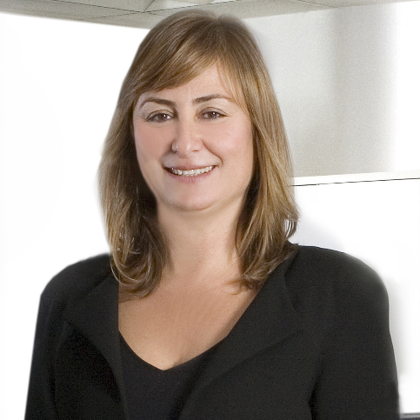
As of 1 February 2016, Ms. Zeynep Sarılar is the new ITEA Chairwoman. She is the successor to Rudolf Haggenmüller who has been at the helm since 2005.

Zeynep Sarılar, born in Izmir, Turkey, received her degree in 1989 from the Electric and Electronics Engineering Department of Dokuz Eylul University.
She has broad software engineering experience in several major companies on three continents, as engineer, business consultant and manager focusing on embedded systems, wearables and mobile applications.
In 2001, she co-founded Mobilera, a leading CRM based mobile marketing and advertising company. She managed Service and Product Development till 2013 when she initiated GEMİM, a Centre for Entrepreneurship Training and Incubation.
She can draw from her extensive experience in ITEA due to her participation in several ITEA projects and ITEA Boards. On her future as chair of the ITEA Board, Zeynep Sarılar stated:
“ITEA is the place for Software Innovation and Software Innovation addresses the global market. My ambition is to make ITEA more global and to support our countries and companies in mastering the Digital Challenges.”

Note for editors, not for publication
For interview requests, questions and additional information about ITEA, please contact:

ITEA Contact person
Kay van Ham
Tel: +31 88 003 6136
kay.van.ham@itea3.org

About ITEA
ITEA is the EUREKA Cluster programme supporting innovative, industry-driven, pre-competitive R&D projects in the area of Software-intensive Systems & Services (SiSS). SiSS are a key driver of innovation in Europe’s most competitive industries, such as automotive, communications, healthcare and aerospace.

There is a wide consensus that from now to 2030 change and disruption will be permanent features in society, with the way of living and doing business becoming fundamentally different from what it is today. Digital Technology has a major role to play in mastering the changes. And it is within this domain of Digital Technology that ITEA is addressing innovation in Software, IT Services, Internal IT and Embedded Software, collectively denoted as ‘Software innovation’. For Europe, an industry strong in Software Innovation is a prerequisite for maintaining global competitiveness and in securing high-value jobs in Digital Technology and in other, more traditional industries that are dependent on Digital Technology.

ITEA stimulates projects in an open community of large industrial players, SMEs, universities, research institutes and user organisations. As ITEA is a EUREKA Cluster, the community is founded in Europe based on the EUREKA principles and is open to participants worldwide.

Each year, ITEA issues a Call for projects starting with a two-day brokerage event. Each Call follows a two-step procedure, in which the quality of the project proposal is evaluated and improved, finally leading to a selection of high quality project proposals that receive the official ITEA label.

ITEA’s mission is to be the recognised partner for European industry, optimising support for companies and R&D actors active in ITEA projects in the area of SISS, thus making best use of funding made available by the ITEA supporting countries. Following the EUREKA structure, each ITEA project partner can apply for national funding in their own country – allowing a project idea to attract funding from all participating countries.

More information: https://itea3.org

